Accountholder Instructions
This guide provides information needed for an accountholder to manage transactions. Within this guide, you will learn how to:
- Allocate or edit a transaction
- Add imaged receipt to transaction
- Sign off on a transaction
- Mass allocation
Each of the above topics includes step-by-step instructions for performing a specific task.
Allocate or Edit a Transaction
Procedure:
- On the Home Page under Action Items>Current Status, click on the Pending link.

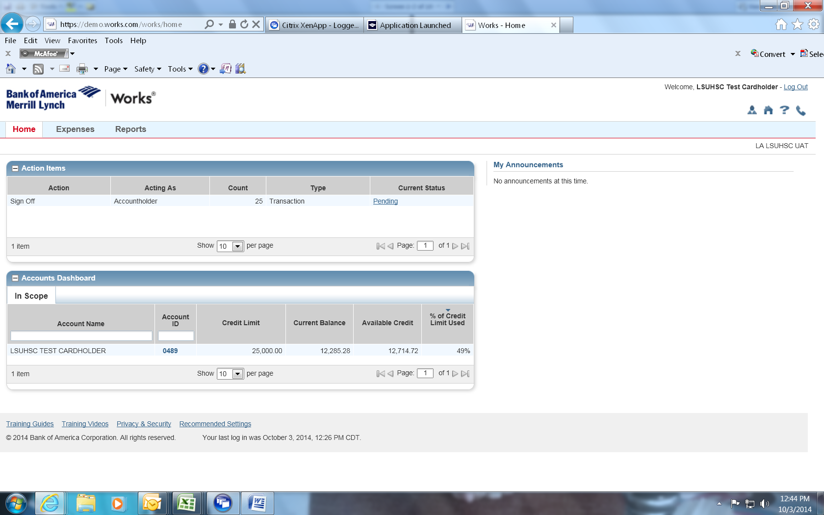

These are the transactions ready for accountholder or approver sign off.

- Click the desired Document number. A menu displays.
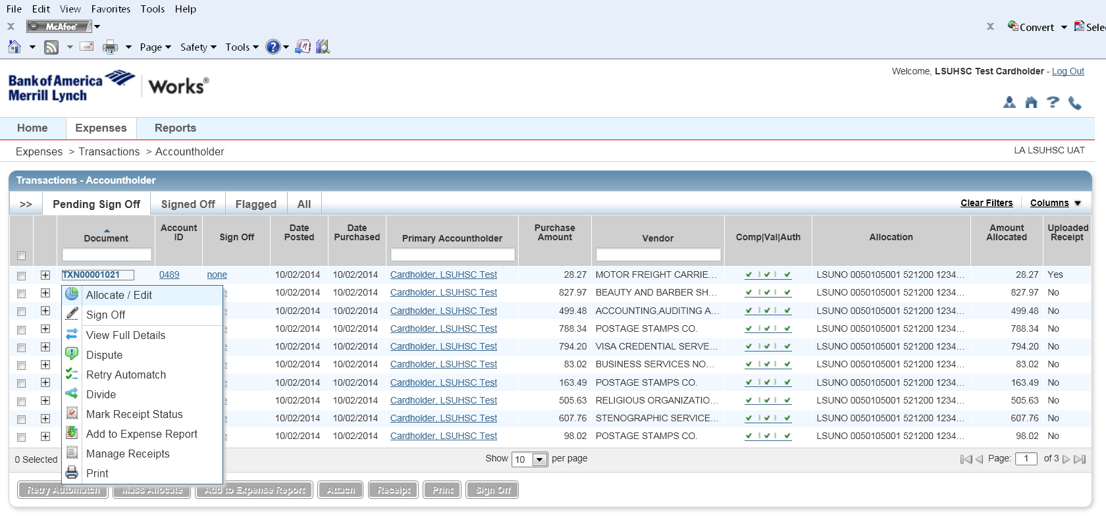
- Select Allocate/Edit and the following window appears
The (GL02) Cost Center and (GL03) General Ledger data fields should be reviewed and allocated appropriately. REMEMBER-all NON-Fedex transactions must be allocated from suspense account 547250 to the appropriate account code.
To add additional lines of funding, click on the Add button and choose how many additional lines you need. Add Comments as appropriate (recommended but not required).
Click Save
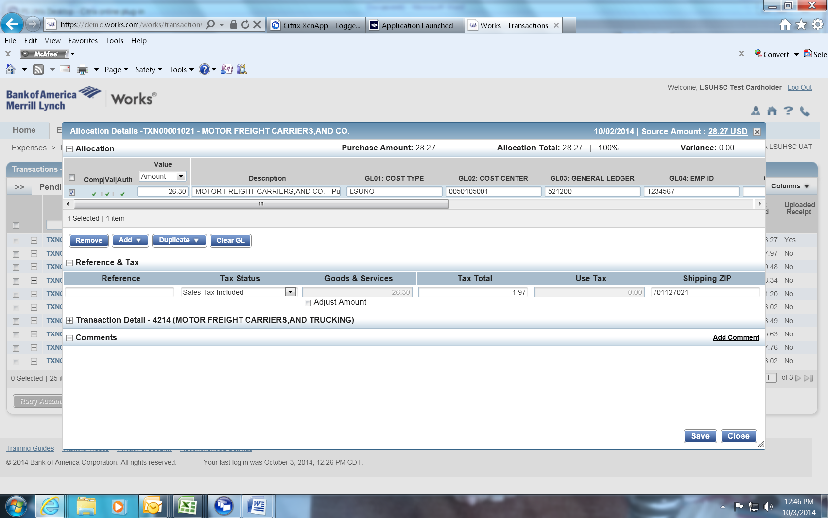

Add imaged receipt to transaction
Select the document number and click manage receipts.
Click Add>New Receipt
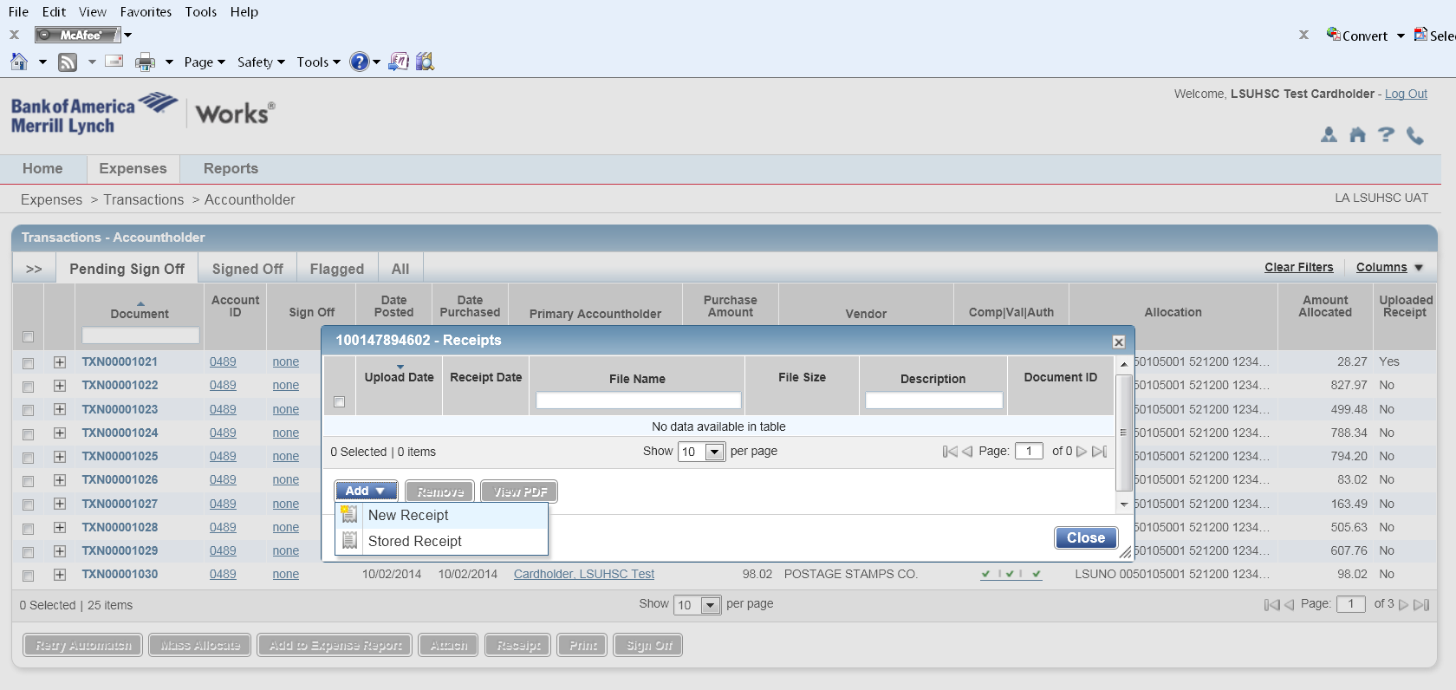

Click the Browse button and select the imaged receipt that matches your transaction. NOTE- imaged receipts must be prepared and saved prior to attachment to p-card transaction in WORKS. Receipt date and description are not required fields.
Click OK
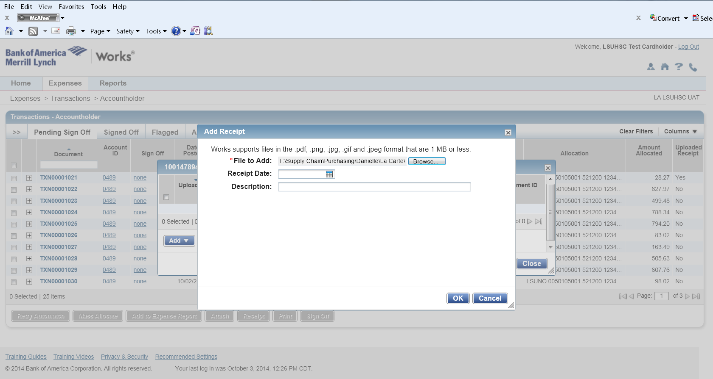

Accountholder Sign Off
Transaction sign off can be accomplished individually or in mass.
To sign off individually- select the check box in the left hand column next to the transaction.
Select the sign off button
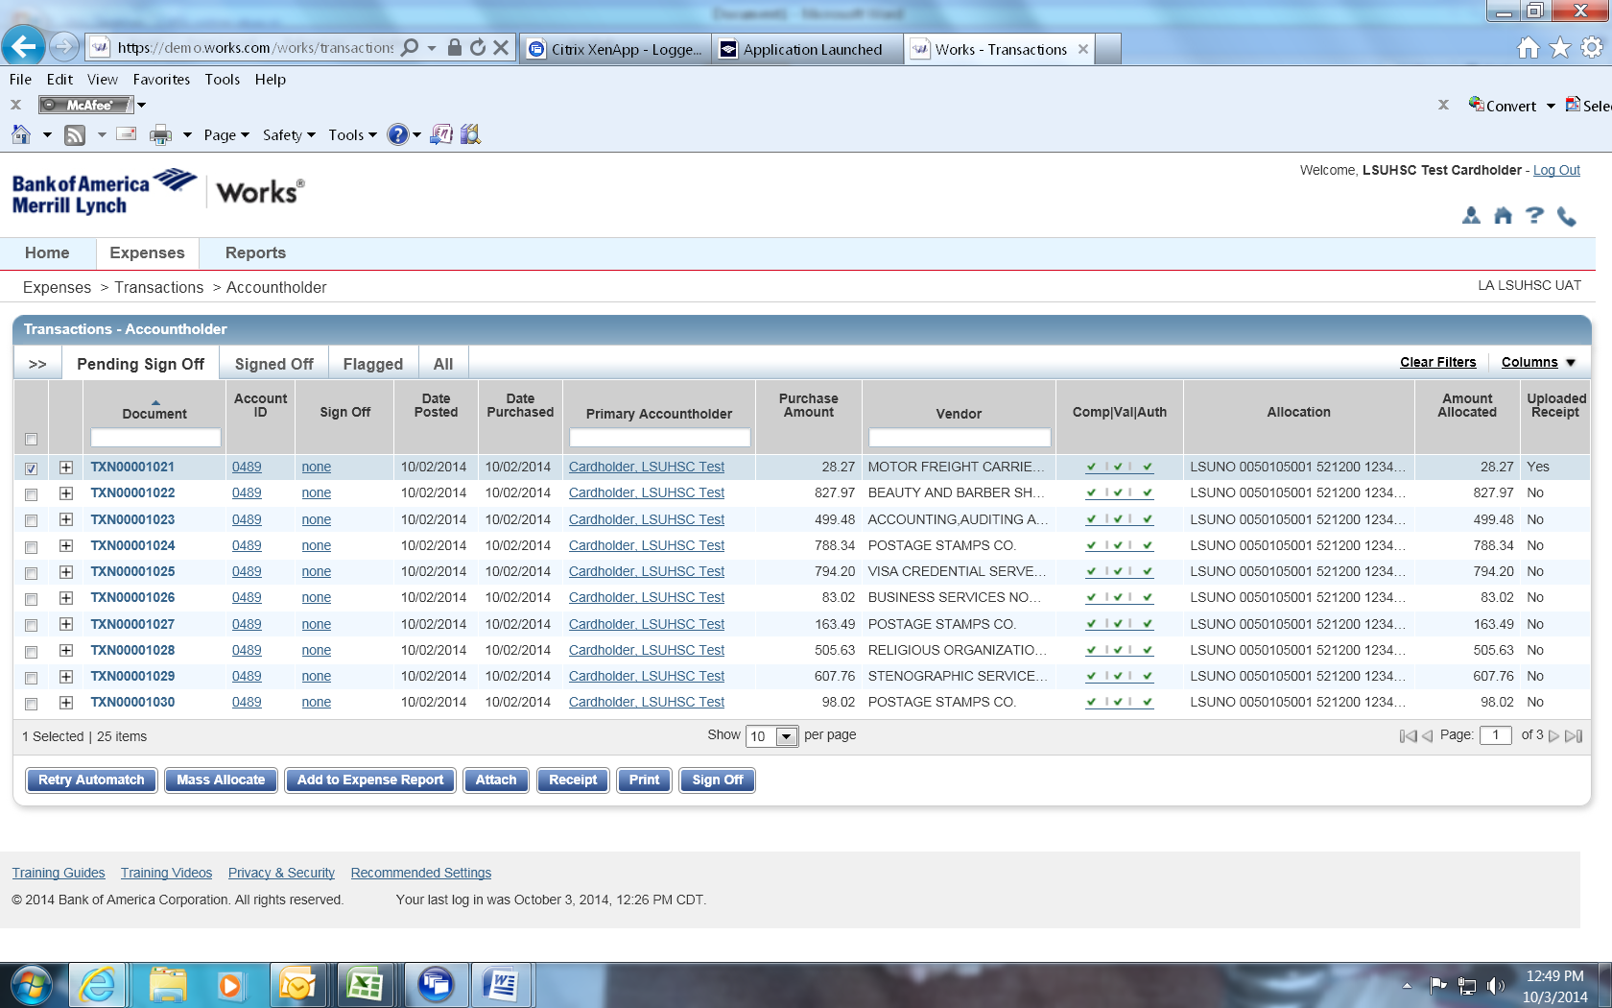
To sign off in mass- select the check box in the header column (on the left hand side)
Select the sign off button
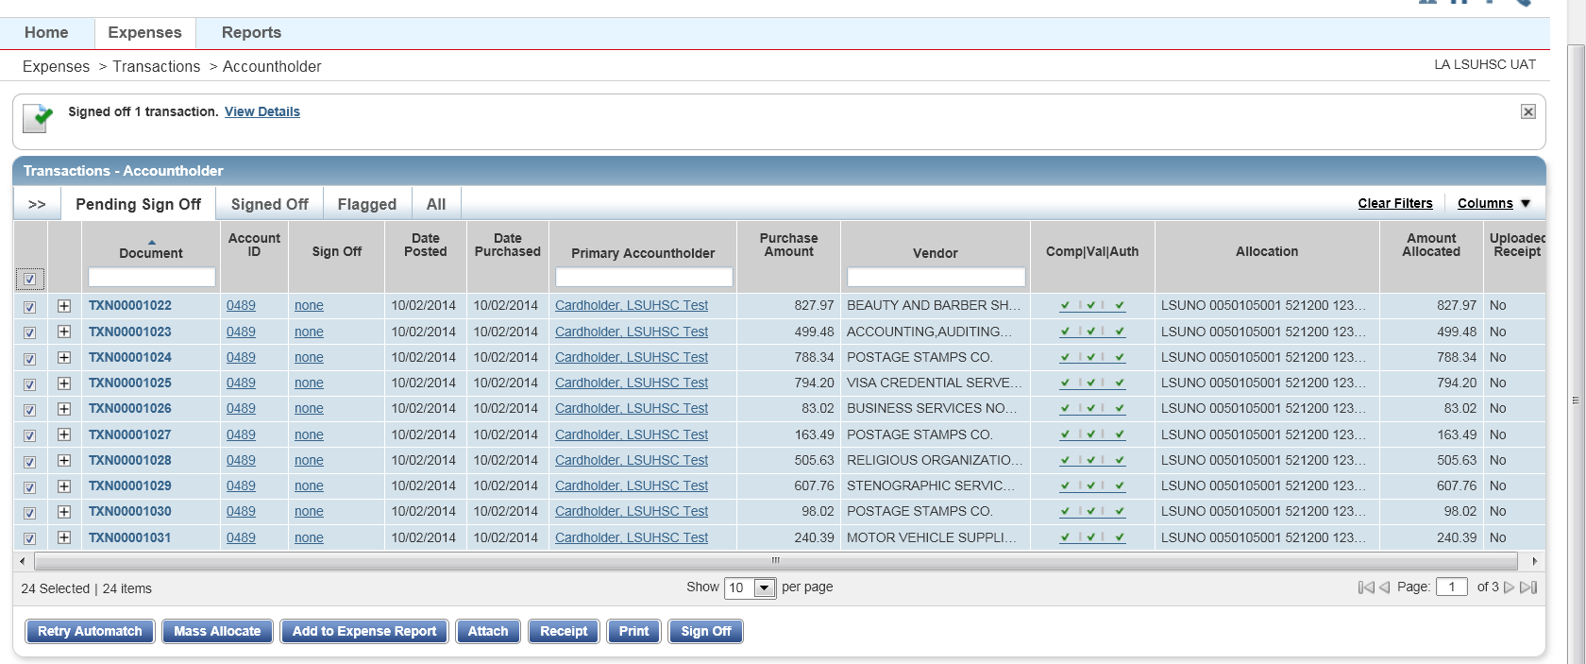

Mass Allocation
Mass allocation allows you to reallocate several transactions at once. This is an effective tool if you have several transactions that should be reallocated to the same cost center and/or account code.
Select transactions by clicking on the check boxes in the left hand column.
Click on the mass allocate button

For mass allocation, enter the cost type (LSUNO for all) and the appropriate cost center (PS speedtype) and general ledger (account code).
Click OK
