Scoped Accountant/Approver Instructions
This guide provides information needed for those managing the receipt scanning AND reallocation steps on behalf of another cardholder.
Within this guide you will learn how to:

- Sweep transactions
- Allocate or edit a transaction
- Add imaged receipt to transaction
How to “sweep” a transaction
In the acting as Accountant role, click the pending link
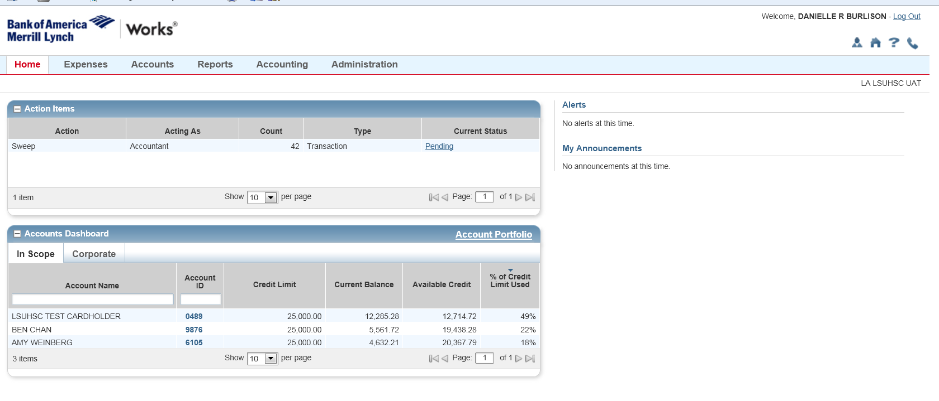
Select the transactions you’d like to work by clicking on the individual box in the left hand column or select the header checkbox at the top of the column.
Click Sweep
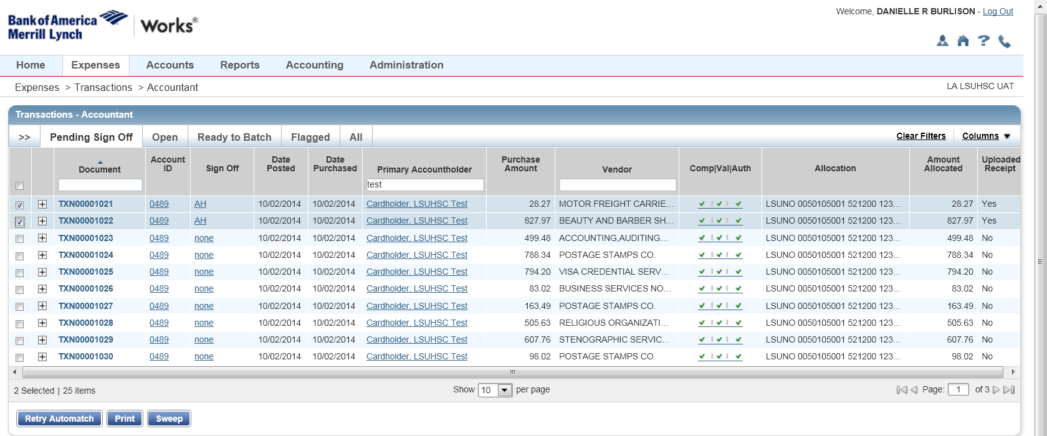
The following pop-up window will display. Click OK to proceed.
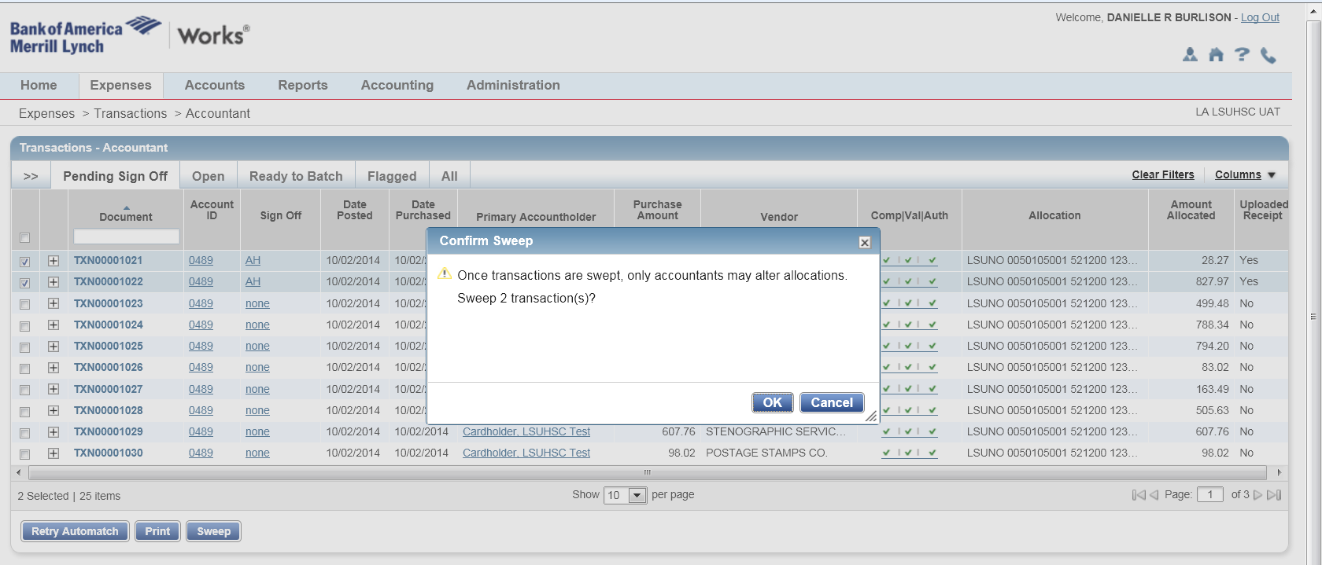
Follow this navigation to access the transactions:
Expenses>Transactions>Accountant
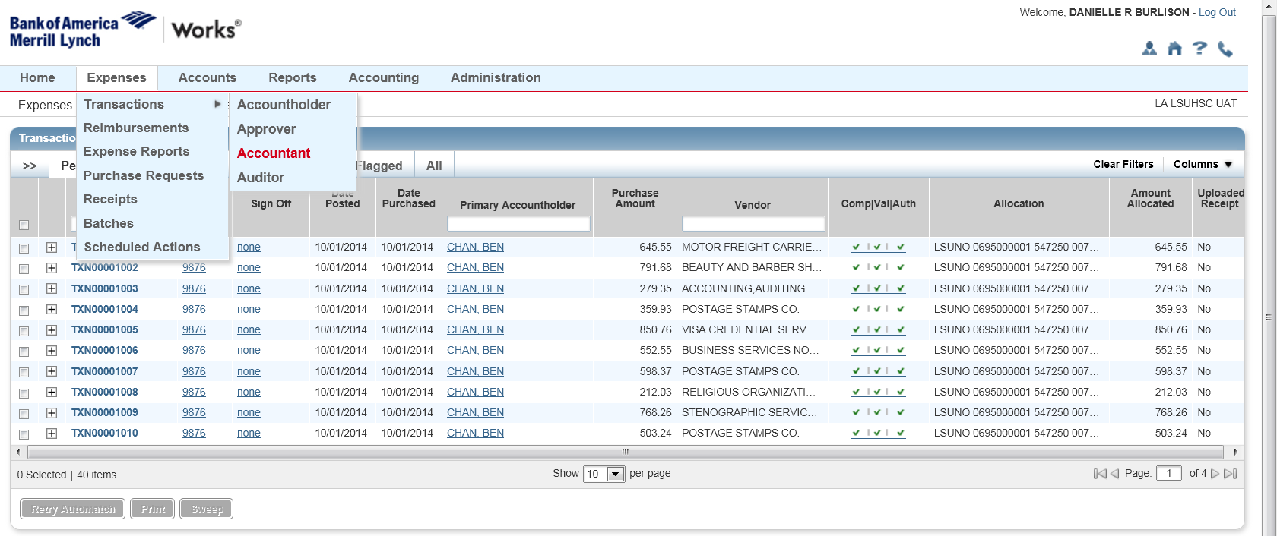
Click on the Ready to Batch tab

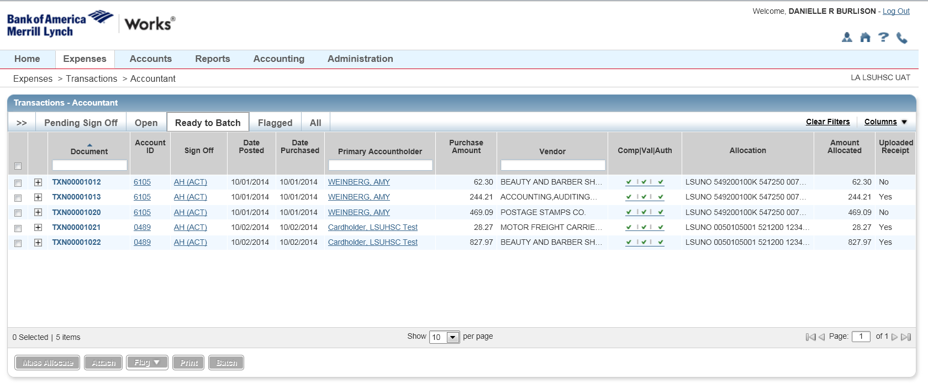
From here, you will be able to reallocate (allocate edit) AND attach receipts (manage receipts) on behalf of cardholders within your department
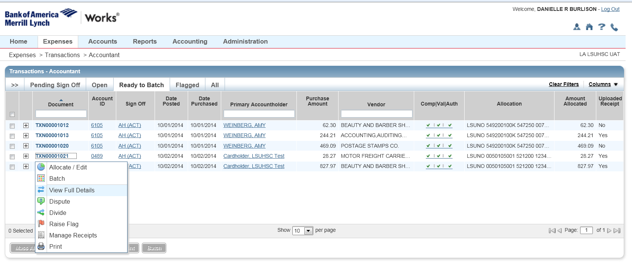

Sign off in Approver role
Click on the pending link under acting as Approver
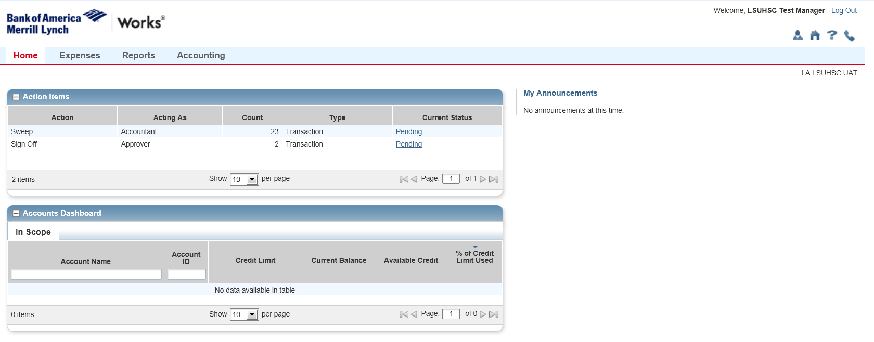

Make sure receipts are uploaded and allocations are correct.
Select transactions on the left hand column and click sign off

