Adding Zoom in a Moodle Course
- Sign in as an instructor, go to the course, and turn on editing in the course.
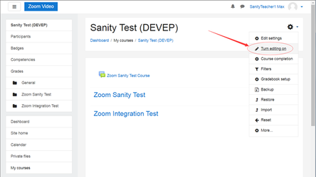
- Add an activity to the course.
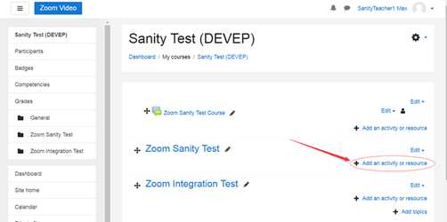
- Choose External tool.
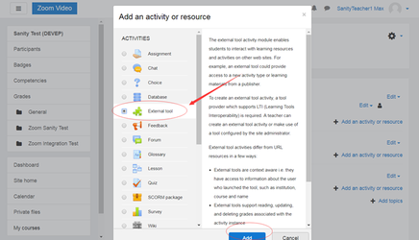
- On the adding a new External tool page, choose the existing Zoom Video Conferencing and save the setting.
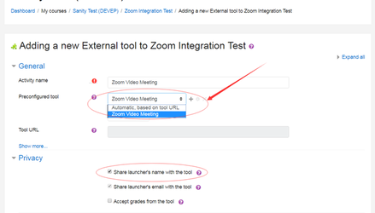
- Click **Save and return to course **
After saving the configuration, the instructor can click the activity to launch Zoom LTI Pro.
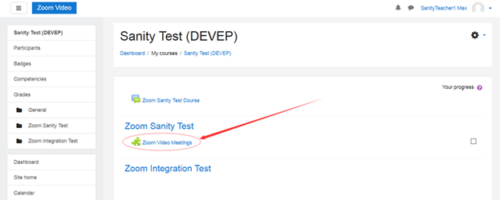
With Zoom LTI Pro, the instructor can schedule course meetings and view their meeting list. The students will be able to view the meetings that are scheduled for the specific course.

