LSU Health Sciences Center New Orleans
School of Medicine
www.lsuhsc.edu/orgs/camptiger

Dear Incoming Medical Student,

On behalf of the Camp Tiger staff and the Class of 2020, congratulations on your acceptance to medical school! We are very excited to welcome you into the LSU School of Medicine family.

We would like to invite you to join the Class of 2020 in the 32nd anniversary of Camp Tiger! Camp Tiger has been a proud tradition of LSU School of Medicine since 1985. As a first year class, we organize, staff, and fund the entire camp; however, there is also another crucial component essential to making Camp Tiger a success – YOUR brand new class of 2021. For the past seventeen years, the incoming medical student class has been invited to participate in this incredible week, each year becoming a more integral part of the camp. Last year, over half of the incoming L1’s participated as counselors, and virtually all students of the current first year class participated as well.

The week is a fun and rewarding experience for campers and counselors alike. Activities of previous camps have included a Saints and Pelicans experience, trips to the zoo, the aquarium, the Global Wildlife Center, Louisiana Children’s Museum, Storyland and Amusement Park at City Park, laser tag, bowling, and other fun adventures in the New Orleans area. While this year’s activities schedule is still being finalized, we are still missing an important element of the camp – you! Participation in Camp Tiger is one of the most outstanding opportunities to kick off your career as a medical student and physician – a career that will be dedicated to improving the lives of others. It will be a unique experience allowing you to meet your new classmates, new professors, and current medical students, all while making an incredible impact on the lives of our beautiful campers.

Camp Tiger 2017 will be held Monday, May 22nd through Friday, May 26th from 7:30 am until 4:00 pm. Each day will begin and end at the medical school campus in New Orleans. Breakfast, lunch, and camp activities will be free of charge for both campers and counselors.

If you choose to participate, you are in for a busy, yet incredibly rewarding week. You and a current first year medical student will be assigned to one camper for the week. All counselors will be required to attend a mandatory orientation session on Sunday, May 21st. On this day, you will learn proper techniques to care for these children and will receive Basic Life Support (BLS) training through the American Heart Association. This training is required of all medical students whether it be completed in May or in the fall semester as an educational requirement. If you receive BLS training for Camp Tiger, you will be ahead of the game! We recommend that everyone be trained unless you have recently (within the past year) received certification by the American Heart Association. For participation in Camp Tiger, you will also receive 20 Community Service Elective (CSE) credits. CSE credits are a component of the Service Learning Elective (SLE) for medical school and will be included in your application for residency. You will learn much more about these credits when you begin classes next fall, but Camp Tiger is one of the best opportunities to “rack up” on CSE credits before you even begin school!

In addition to a fun, activities-filled day with your camper, there will also be a different social event planned each night of the week at various venues across New Orleans for all counselors. This is a great opportunity to interact with your classmates and the current medical students in an informal environment. These will be optional, but you will see first-hand that, while medical students do work incredibly hard in school and in the community, we have fun too!

If you are in need of housing accommodations for the week of Camp Tiger, a current first year student will be more than happy to host you. This is another great opportunity to connect with a current medical student. Please be sure to mark that space on your form if needed.

As an incoming L1, Camp Tiger seemed intimidating to me and many other classmates. Please know that we will do everything possible to make you feel comfortable. If you have never worked with special needs children or even children in general, we will make sure that you are well prepared and are paired with someone with experience. I could not have started my medical school career in a better way. Camp Tiger helped ease my mind of the many apprehensions of starting school. Not only was I able to develop great relationships with the class above, Camp Tiger was the beginning of the incredible bond with my own classmates and future colleagues. Feel free to read some thoughts from other medical students that participated in past Camp Tigers on the following page.

We all have something unique to offer to these wonderful children, and we hope that you will consider being a part of this great tradition at LSU School of Medicine. If you are interested in becoming a counselor, please complete the counselor registration form embedded in the last page of this packet. Submission of the form is due by Friday, April 14th, 2017. Please contact me (fhigg1@lsuhsc.edu) with any questions at all regarding schedule conflicts, comments, or anything else. We look forward to meeting you and wish you the best of luck in your last months before medical school!

Sincerely,
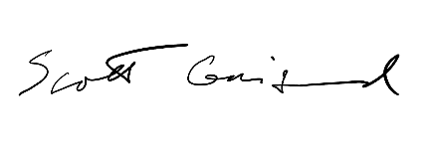
Scott Gaignard
Camp Director
Camp Tiger 2017
sgaign@lsuhsc.edu

Frank Higgins
Counselor Coordinator
Camp Tiger 2017
fhigg1@lsuhsc.edu

Previous Counselor Testaments from Medical Students

“Camp Tiger was incredibly enjoyable and rewarding; it's hard to say who had more fun, the campers or the counselors. Also, it can't be overstated how nice it is to show up on the first day of class already having made several friends.”

~Mark Hoppens (Class of 2018)
2014 Camp Tiger Counselor

“I loved Camp Tiger. It was a great experience to show medical students how a small good deed can make a big impact on a child and family’s life. Not to mention, it is a great time with your new classmates.”

~Timur Alptunaer (Class of 2015)
2011 & 2012 Camp Tiger Counselor

“Camp Tiger was a great experience for many reasons. Great times, great weather, and the opportunity to make new friends with campers and fellow classmates. Plus you get to explore all kinds of places in New Orleans and share that opportunity with very amazing people.”

~Martin Marak (Class of 2017)
2013 & 2014 Camp Tiger Counselor

“Personally, I think Camp Tiger is a great time for the campers and counsellors alike. This past year, my camper was someone whom I have known for years and it made my week that much more memorable. It can be hard work at times, but that is hardly a concern when you
see how much fun the kids have, and you have the opportunity to join in. I was a counsellor for two years, and participating in Camp Tiger was the right decision.”

~Scott Rooney (Class of 2017)
2013 & 2014 Camp Tiger Counselor

“Camp Tiger is a great way to start medical school with a meaningful contribution to the New Orleans Community. It is pretty impressive the number of activities the campers get to do around New Orleans in just a single week. Your time and attention during these activities will mean the world to these kids. It is a really fun week that will not only be the highlight of your camper’s summer, but likely the highlight of your own!”

~Heather Barnes (Class of 2019)
2015 Camp Tiger Counselor

“Camp Tiger was the perfect start to my medical school journey. I got to begin to learn what being a physician was like while also getting great information from my co-counselor. I also got to meet a bunch of my classmates, helping ease the transition. Lastly, it was a week of fun, grueling, and fulfilling work helping these children. I came home exhausted everyday, but I wouldn’t trade the experience for anything.”

-Brett S. 2016 (Class of 2020)
Camp Tiger Counselor

Visit our website: www.lsuhsc.edu/orgs/camptiger

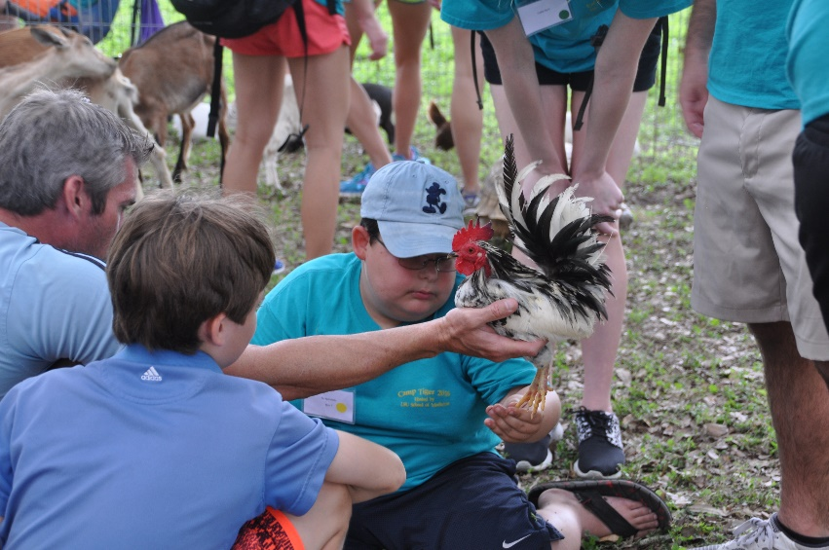
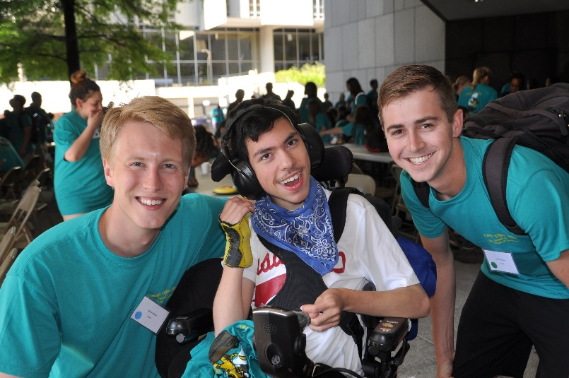
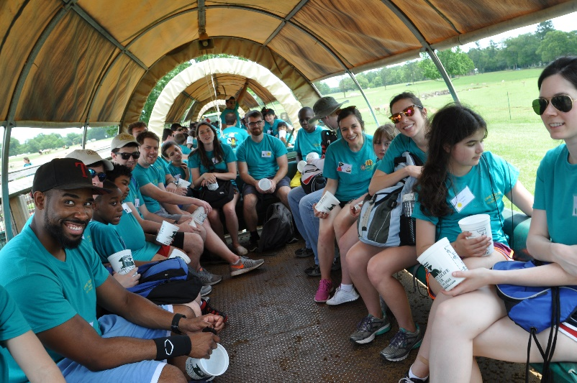
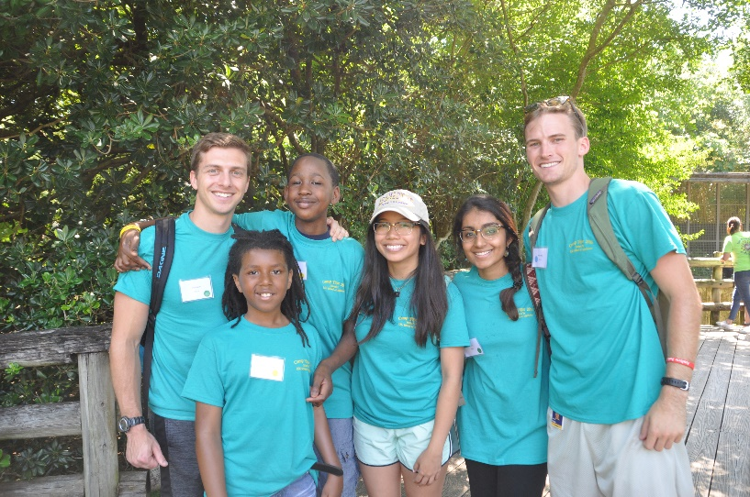

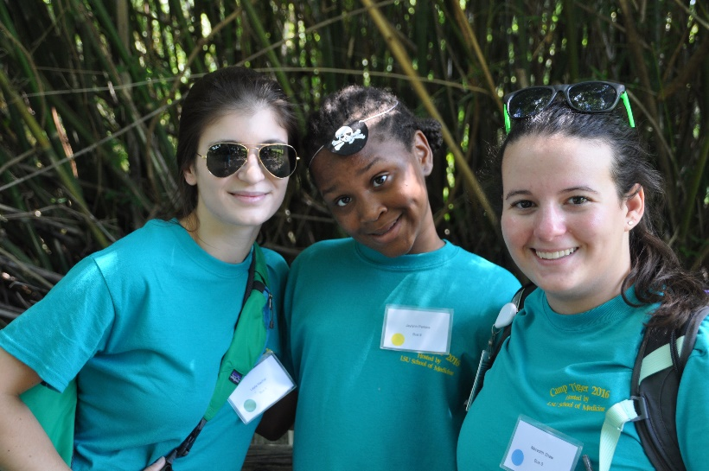
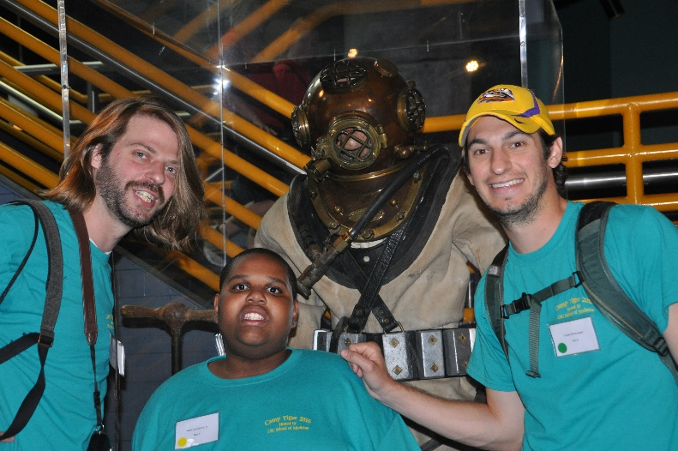

Please be sure to read the Invitation Letter on the first page of this packet before registering.

The Counselor Registration Form for incoming medical students can be found at the following hyperlink:

Link to L1 Counselor Application

- Electronic submission of this form is due Friday, April 14th, 2017at 11:59pm.

- Counselors are expected to be available Sunday, May 21st – Friday May 26th, 2017.
  - Please email Frank Higgins directly (fhigg1@lsuhsc.edu ) to discuss any scheduling conflicts.

- Also let Frank know if you are having issues accessing the form or need to edit your submission.

