LSUHSC nVision Reports Catalog

Business Unit: LSUSH
Report Description: Accrued Payroll
Layout: LSUSH –Accrued Payroll.xnv
Report Request: ACCRPAY
Dashboard Page/Button: N/A
nVision Scope: N/A
Report As of Date: Default from Business Unit

This report provides a mechanism to determine the Payroll Accrual Allocation. The data in the report is based on the query LSUSH_ACCRUED_PAYROLL. The query is written on the JRNL_LN table. The fields included in the query are: Business Unit, Journal id, Journal date, Account, Fund Code, Department, Program Code, Class Field, Budget Period, Project id and Monetary Amount. The query criteria are built to specifically pull data for LSUSH. The query criteria specify several journal ids that are HR journals. These will be updated by the user as needed. Additionally, the query specifies that the accounts included in the report exclude 110101 and 110103. The report layout includes a series of data specified on the rows of the report. The rows are specified by Account and Fund and Class. The Account field is derived from the EXPENSES node of the ACCOUNT_RANGES tree. The Fund Code values are specified by row. On the rows that utilize the Class field, the values are nodes from the ANALYSIS_C1B_C2B tree. On the rows that include department values, those are specified by department number. The COMM TECH row of the report layout also specifies several Project ids as criteria. Below these value rows are rows for totals for the Clearing Funds, and Agency Funds that are from the EXPENSES node on the ACCOUNT_RANGES tree and the funds are nodes in the FUNDROLLUP tree, CLEARING_FUND and AGENCY_FUND, respectively. The last row is called General Ledgers. This value on this row is from the ALL_ACCOUNTS node of the BAL_SHEET_ACCT tree. The first result column of the report is used to display the query results. The layout includes 3 calculated columns to determine the amount of the Payroll Accruals. The first of these is a Ratio column. This is simply a percentage calculation of the value in the query results column divided by the total of the query results column. The next column is called General Ledger Allocation. This column multiplies the value in the Ratio column by the sum of the Clearing Fund, Agency Fund and General Ledgers rows at the bottom of the report. The Accrued Payroll column is the sum of the value in the query results column plus the value in the General Ledger Allocation column.
Report Example:
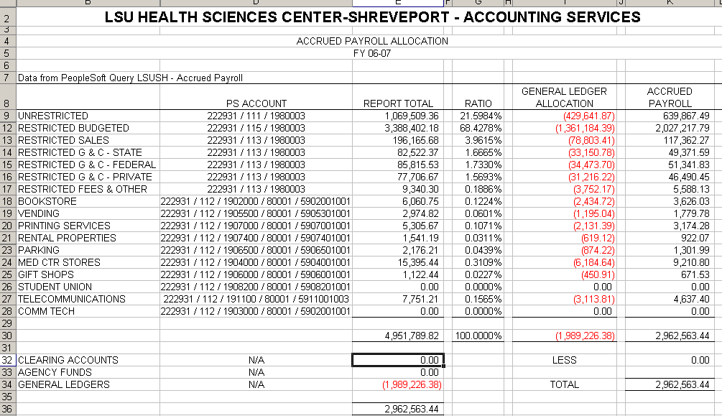.
Query Fields
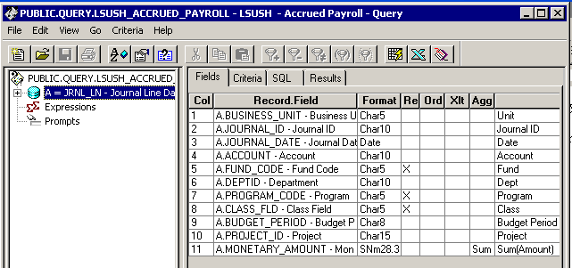

Query Criteria
