LSUHSC nVision Reports Catalog

Business Unit: LSUSH
Report Description: Expenditure/Budget Comparison
2-tier Layout: Sch of Rev, Exp, Budget wPrompts.xnv
Web Layout: W Sch of Rev, Exp, Budget wPrompts.xnv
Report Request: RVEXBUDP
Web Report Request: WRVEXBDP
Dashboard Page/Button: N/A
nVision Scope: N/A
Report As of Date: Default from Business Unit

The report produces a fiscal year schedule of revenue and expense activity nploded by account. The columns display budget, current month actual, year to date actual, project to date actual, encumbered and pre-encumbered amounts. The available balance column is a value calculated by subtracting actuals, encumbered, and pre-encumbered amounts from the budget. A calculated percent used column completes the report. The data for each column is derived from several queries that are included in hidden columns of the report. All of the queries are built using the LEDGER_KK table and pull in the Posted Total Amount field. The criteria fields that are prompted are: Fund Code, Department, Program Code, Class Field, and Project Id. The criteria specified for each of the queries is used to differentiate the queries by specifying the Ledger names that the data is allowed/disallowed to be pulled from. The queries and the pertinent details of each are: AM090_BUDGET for budget data, AM090_PROMPT– data from Actuals Ledger, AM090_PROMPT_EN – data from encumbrance ledgers that include _EN as part of the name, and AM090_PROMPT_PR – data from pre-encumbrance ledgers that include _PR as part of the name. Each of the hidden columns in the report include a timespan to identify the current period, year to date and inception to date values. The displayed columns of the report include formulas that reference the hidden columns. The rows of the report are grouped into the major breakdowns of Revenues and Expenses. Within each of these categories, there are several account groupings defined. These groupings are nodes from the ACCTROLLUP tree. Each of these account groupings nplodes when the report is produced to display the detailed information. At the bottom of the report is a calculated Surplus/Deficit Row. Note: LSUNO also uses this report. The web based report relies on the queries WAM090_PROMPT, WAM090_BUDGET, WAM090_PROMPT_EN, and WAM090_PROMPT_PR. These queries include the ZZNVISIONPROMPT table. The prompt criteria are replaced by an expression to enable web prompting.

Report Example:
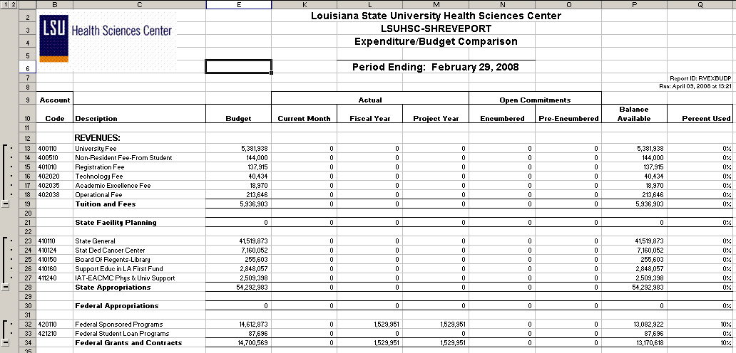
Query Fields – AM090_BUDGET
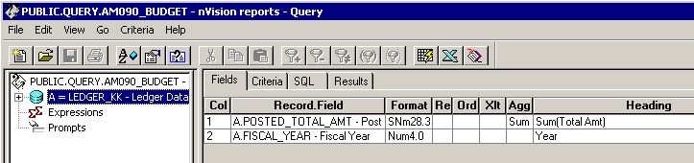

Query Criteria
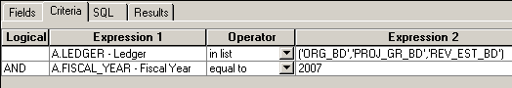

Query Fields – AM090_PROMPT
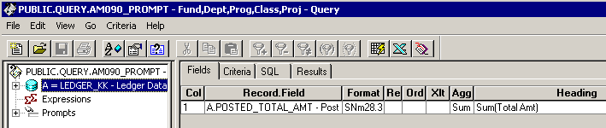
Query Criteria
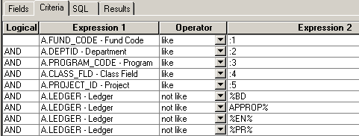

Query Fields – AM090_PROMPT_EN
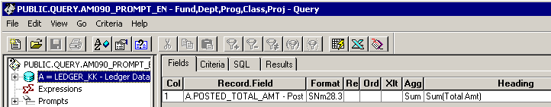
Query Criteria
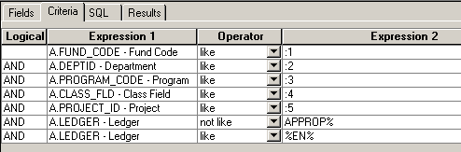

Query Fields – AM090_PROMPT_PR
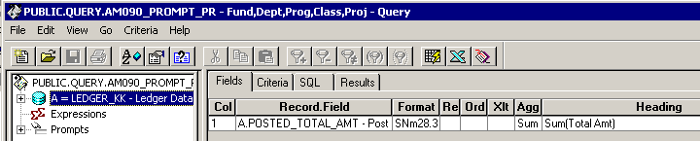
Query Criteria
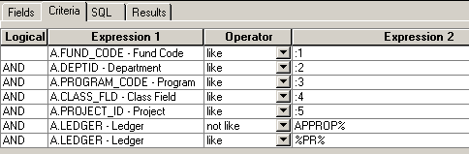

Web based Query Criteria WAM090_PROMPT
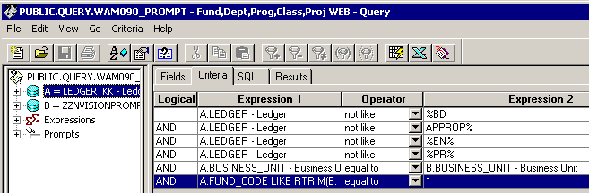

Web based Query Criteria WAM090_BUDGET
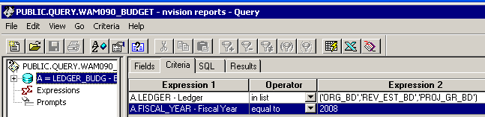

Web based Query Criteria WAM090_PROMPT_EN
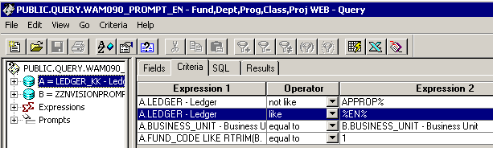

Web based Query Criteria WAM090_PROMPT_PR
