LSUHSC nVision Reports Catalog

Business Unit: LSUSH
Report Description: Project Grant Summary
2-tier Layout: LSUSH – Project Activity - ITD.xnv
Web Layout: W LSUSH – Project Activity - ITD.xnv
Report Request: PROJSUM
Web Report Request: WPROJSUM
Dashboard Page/Button: LSUSH/Project/Grant Summary for a Fiscal Year
nVision Scope: N/A
Report As of Date: Main As of Date from Business Unit

The report produces a listing of Revenues and Expenditures by Account for a Specified Project Grant. This report is based on the query called LSUSH_PROJ_GRANT_SUMMARY that is written against the JRNL_HEADER, JRNL_LN, GL_ACCOUNT_TBL, and the PROJECT table. The columns of the report display the Business Unit, Project Id, Project Description, Account, Account Description, Fund, Department Id, Program, Class and Amount. Each row will be for a distinct account number. The query used as the basis of the report prompts on Project Id, Journal Begin Date and Journal End Date. The query also requires that the business unit is LSUSH, the account numbers are greater than 400000, and that the journal status may be “P” or “U”. The criteria also require that the Ledger not be PROJ_GR_EN or PROJ_GR_PR.

The web based report utilizes the query called WLSUSH_PROJ_GRANT_SUMMARY. This query includes the additional table ZZNVISIONPROMPT and replaces the criteria prompts with expressions to enable web based prompting.

Report Example:
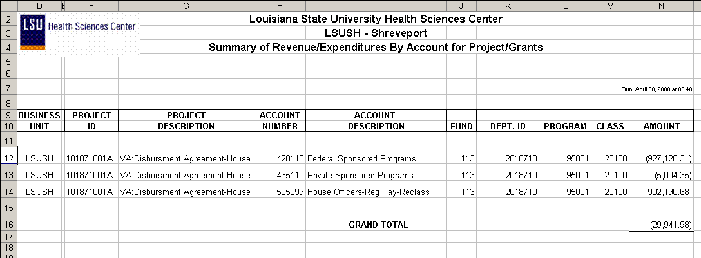
Query Fields
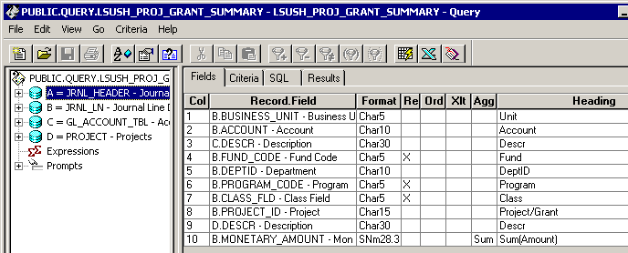
Query Criteria
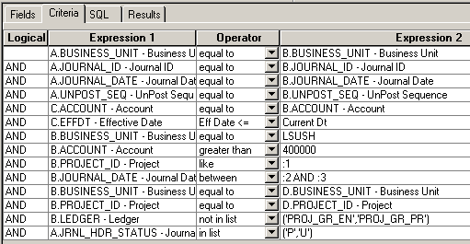

Web Based Query Criteria
