LSUHSC nVision Reports Catalog

Business Unit: HCSDA
Report Description: Hurricane Project Report
Layouts: HCSD – Disaster Recovery Costs.xnv
HCSD – Disaster Recovery Costs08.xnv
HCSD – Disaster Recovery Costs09.xnv
Report Request: PROJ_HUR, PRJ_HUR8, PRJ_HUR9
Dashboard Page/Button: N/A
nVision Scope: N/A
Report As of Date: AS of Date from Business Unit table

This report provides Hurricane Project data analysis and projections for the HCSD Hospitals. This report allows the analyst to review Budget, Pre-Encumbrance, Encumbrance, Expended, and Total amounts. The analyst may then enter projections for upcoming expenditures which will then be included in the Total Estimated Expenditures and Balance calculations. The report is divided into 2 sections, one for Hurricane Katrina projects and the other for Hurricane Rita projects. The Budget column specifies the PROJ_GR_BD ledger, ITD timespan, Posted Total Amount (reverse sign), fund code 116, and Account node STMTREVEXP from the ACCTROLLUP tree. The next three columns select the YTD timespan, fund code 116, Posted Total Amount, and the Account node STMTREVEXP from the ACCTROLLUP tree. The Pre-Encumbrance column specifies the DETAIL_PRE ledger. The Encumbrance column specifies the DETAIL_ENC ledger. The Expenditures column specifies the DETAIL_EX ledger. The Total Obligations to date totals the three previous columns. The Projected Expenditures column allows the user to enter a value for a specific Hospital/Project. The Total Estimated Expenditures column adds any projected values to the Total Obligations column. The Balance column is a calculation that subtracts the Total Estimated Expenditures column from the Budget column. The rows of the report for each fiscal year section specify detail values for Business Unit and Project Id. The reason for multiple report requests is that each subsequent year report utilizes its own unique layout.

Report Example:
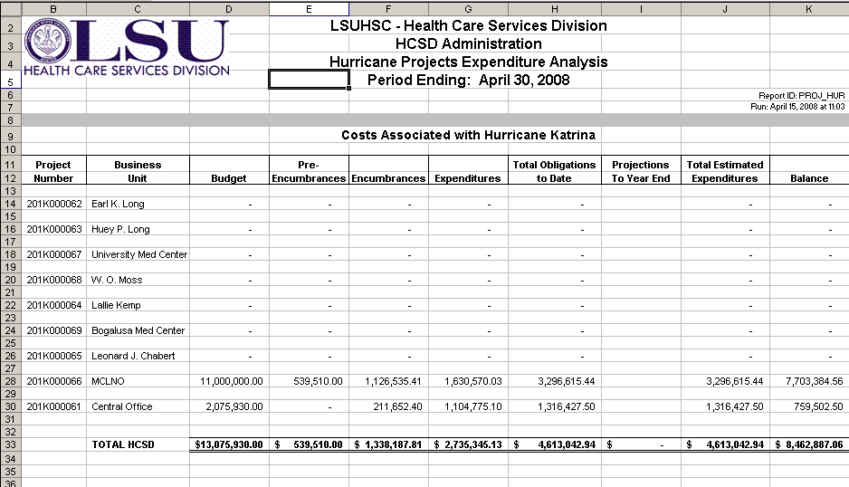

PRJ_HUR8 Example
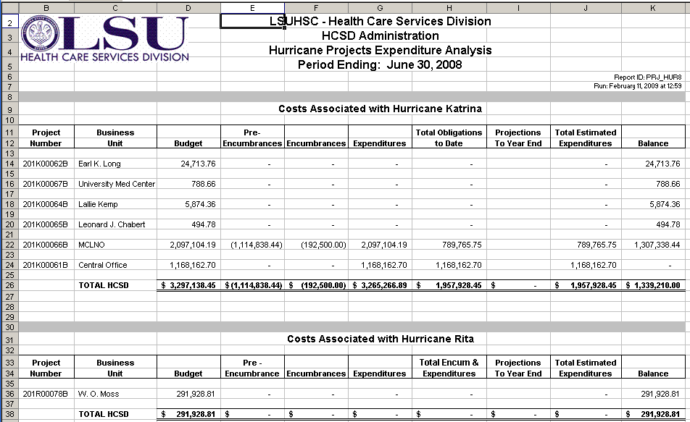

PRJ_HUR9 Example
