Park N Fly website navigation instructions:

Login to www.pnf.com/book/0050056.
Enter arrival date and time; enter departure date and time.
Click search rates
Under self-park uncovered, click the blue arrow next to the $5.67 rate.
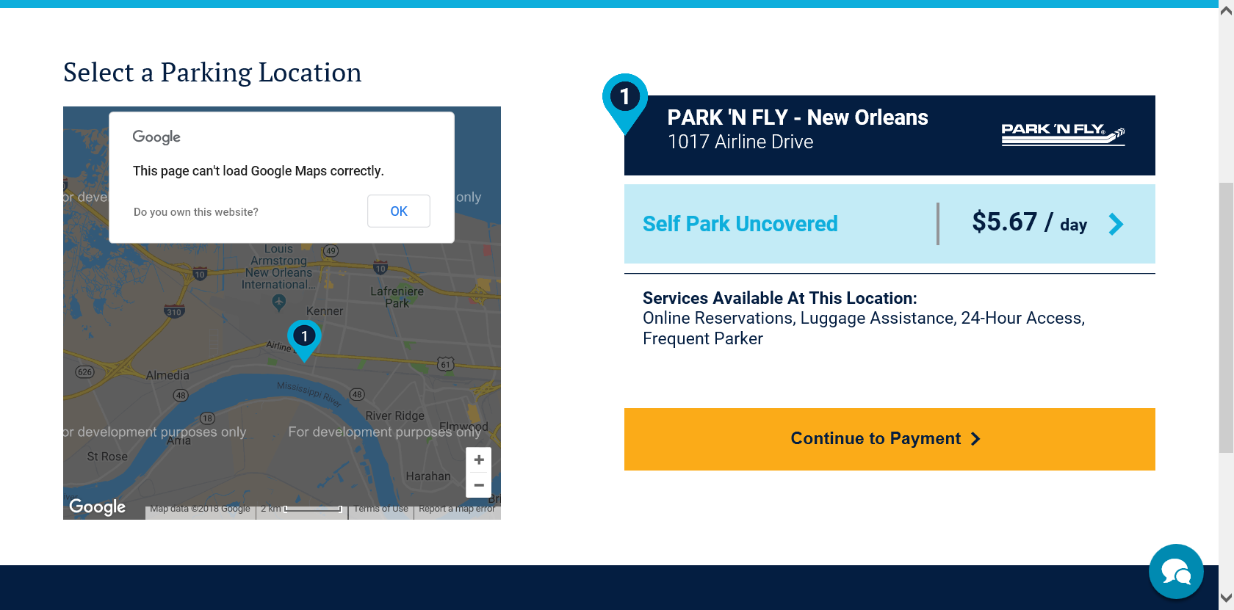
Click continue to payment
Sign in or click continue as guest
Enter customer information and payment information
**taxes and fees displayed on the website are inclusive of the State’s $7.00 per day rate.
**DO NOT apply discounts or coupon codes.

