Summary:

The Payment Request allows users in self-service to submit a non-purchase order invoice very easily. Utilization of the Payment Request feature allows users outside of the Direct Pay department to initiate and submit non-purchase order invoice payments and reimbursements.

The Payment Request is composed of four steps:

- Step #1- Summary Information Page
- Step #2- Supplier Information Page
- Step #3- Invoice Details Page
- Step #4- Review and Submit Page

The summary page allows the user to detail the payment requested. The user will attach supporting documents (required), indicate the amount, vendor to be paid and any other pertinent information. The second step is called supplier information and will default in with 999999999 vendor number assignment. Per LSUHSC procedure, the requestor may skip this step. The invoice detail step will allow the user to enter the PeopleSoft chartstring and account code. Finally, the review request stop allows the requestor to review everything before sending to Direct Pay.

Types of Users Involved:

Three types of users can access the Payment Request Center:

- Requestors-create payment requests

- Reviewers- review/edit submitted requests (Direct Pay)

- Approvers- approve submitted requests

The Direct Pay office is involved at the level of reviewing, correcting and auditing transactions prior to payment.

Access is to the requestor role and approver role are determined at the department level.

Procedures:

Log into PeopleSoft Financials Navigation: Main Menu>Employee Self-Service>Payment Request Center

Click “Create”

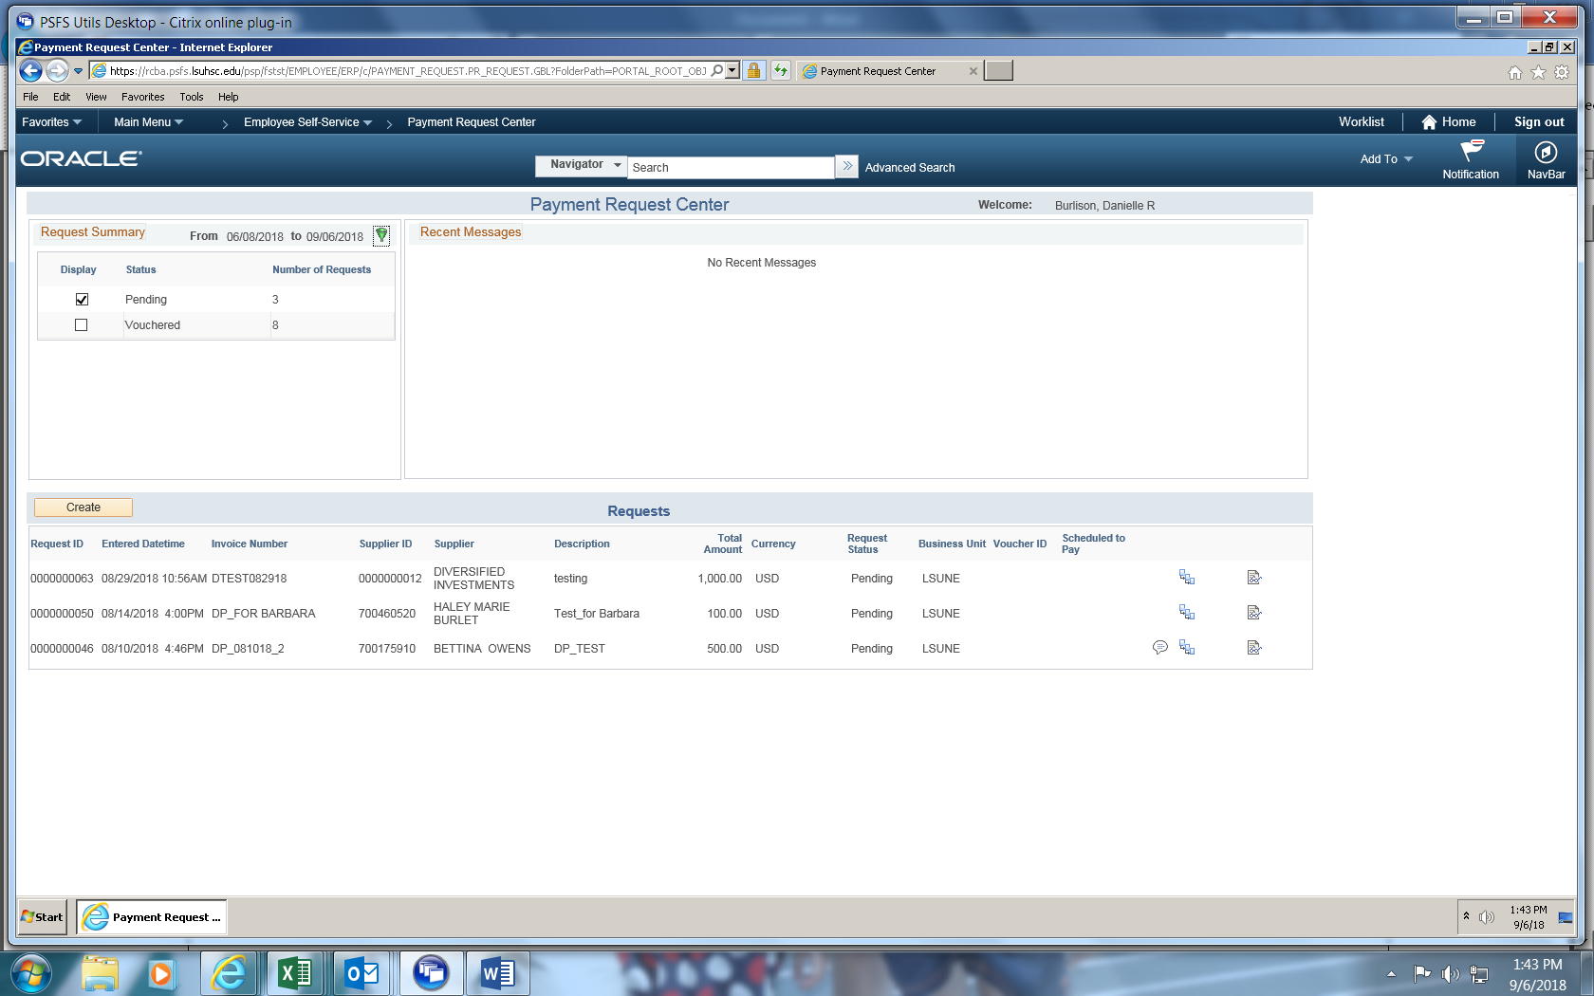

Summary Information – Step 1 of 4
- Business Unit: LSUNE
- Invoice Number: This is the Direct Pay number that will be recorded in PeopleSoft. The Invoice number should be formatted as follows
  - DP/DEPARTMENT NUMBER/4 DIGIT SEQUENTIAL OF YOUR CHOICE
  - EXAMPLE: DP1651000A001 (DIRECT PAY REQUEST A001 FROM ACCOUNTING SERVICES)
- Invoice Date: Use the date you are entering the payment request.
- Description: Brief description/purpose of what you are processing.
- Attachments (0): Attach your invoice or document. THIS IS REQUIRED. Note this will change to (1) after you have attached the documentation.
- Cost Sub-Total: Enter Total amount to pay.
- Notes/Comments: Add the payee name and address, employee id (if you are reimbursing an employee) and any comments you’d like to appear on the check (i.e. invoice number, name reference etc.)

Click “Next”

Supplier Information – Step 2 of 4
The default supplier number is 9999999999. This default is setup specifically for the payment request functionality. Upon review by the Direct Pay office, the named vendor on the notes/comments field in Step #1 will be populated in this data field. This will eliminate the need for end users to search for the correct supplier name and address.
Click “Next”

Invoice Details – Step 3 of 4
Click on “Add Lines”
Enter the following:
- Description: List any details

- Line Amount: Amount of payment (this should equal the amount you entered on step #1).
- Accounting Details: Amount, Speed Type and Account Code

If you have different funding sources or different account codes you are using click “OK” to “Add Lines.”

Review and Submit – Step 4 of 4
Click “Review” before you submit the payment request.
Verify all information is accurate and click on “Return” to submit your Payment Request. Be sure to check the following:
- Attachment is provided
- Review supplier and address indicated on notes/comments section is accurate
- Invoice (DP) number and date are correct
- Amount is correct
- Funding source and account code are correct
Click “Submit” to process your Payment Request.

Workflow:

Once the Payment Request is entered by the department, it will then be routed to Direct Pay for review. Once reviewed by Direct Pay, the payment request will enter into workflow for approval. After all approvals are met within the department, the status will change to “approved”. Next, the Payment Request will be updated to “Vouchered” after it runs through the voucher build process in PeopleSoft. After the voucher is budget checked as valid and the paycycle successfully runs, the Scheduled to Pay column will change to “paid”.

Status (and their meanings):
- New- payment request that has not been submitted by the department (save for later)
- Submitted- once the department requestor enters the payment request, it will appear as submitted.
- Pending- once reviewed by Direct Pay, the payment will enter into approval workflow and will appear as pending.
- Approved- department approval(s) are complete.
- Vouchered- once Direct Pay creates the voucher in PeopleSoft; the voucher id will appear. Scheduled to Pay column will change to “paid” once the paycycle runs.
- Denied- payment request denied by department approver. If at any point in time the Payment Request is denied, the requestor gets an email stating why it was denied.

Approval:

Approvers can access the payment request in four different ways:
- Via email
- Via the PS worklist
- Via PS navigation- Main Menu> Accounts Payable> Payments> Payment Request> Payment Request Approval
- Via push notifications (see screen shot below)

Approvers can:

- Approve a request
- Deny a request (with comments)
- Place request on hold

***Approvers are not able to modify the request. If changes are needed, the approver must deny the request and enter a comment. Changes such as amount, chart string information and payee information will be modified by the Direct Pay office. Once changed, the Payment Request will be re-entered into workflow for approval. If the payment is not approved, the request should be denied and a request to cancel should be detailed in the comments.

Email

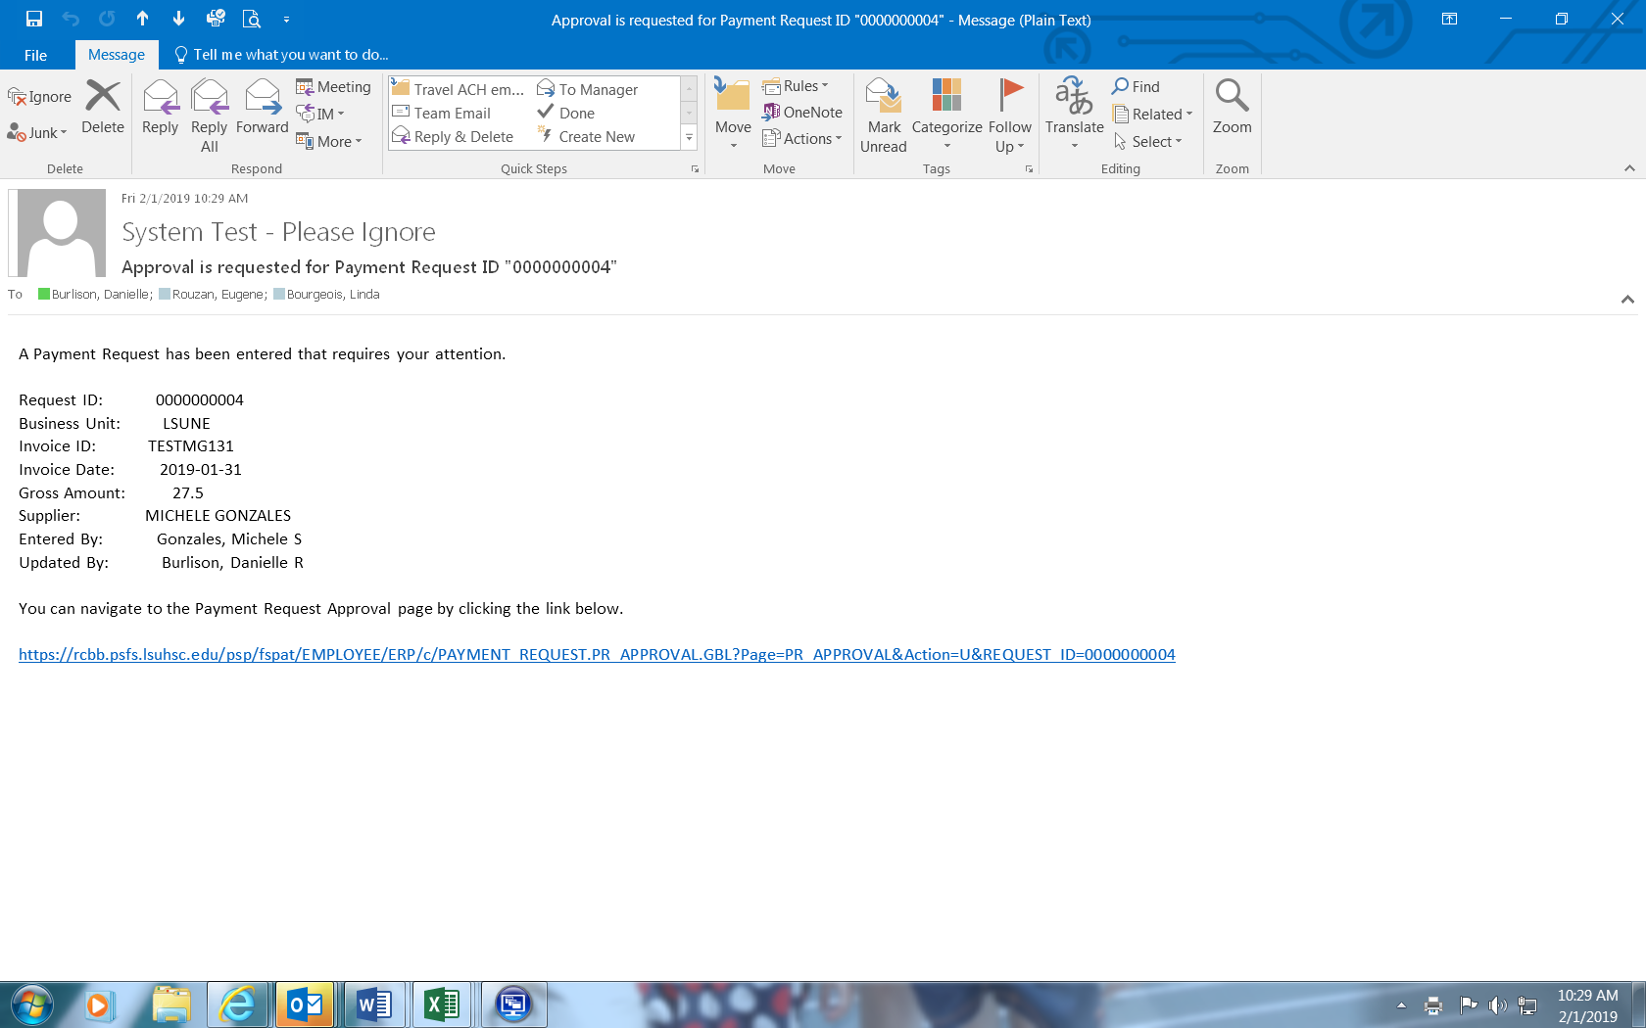

Worklist

Approval Screen (main menu>AccountsPayable>Payments>Payment Request>Payment Request Approval)

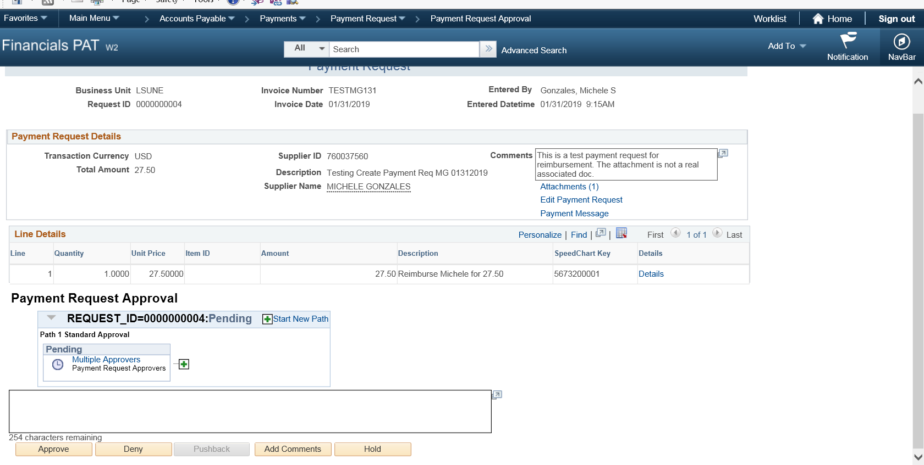

Push Notification (in upper right hand corner)

