Visit our web site to locate the most recent version of the routing sheet:

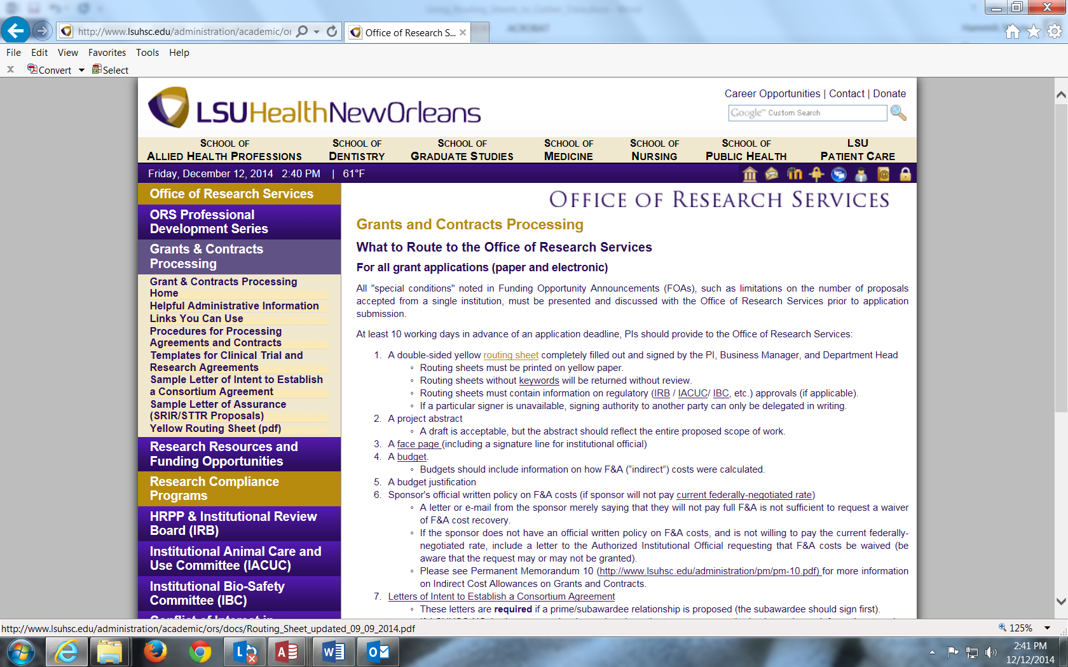

Open the document:

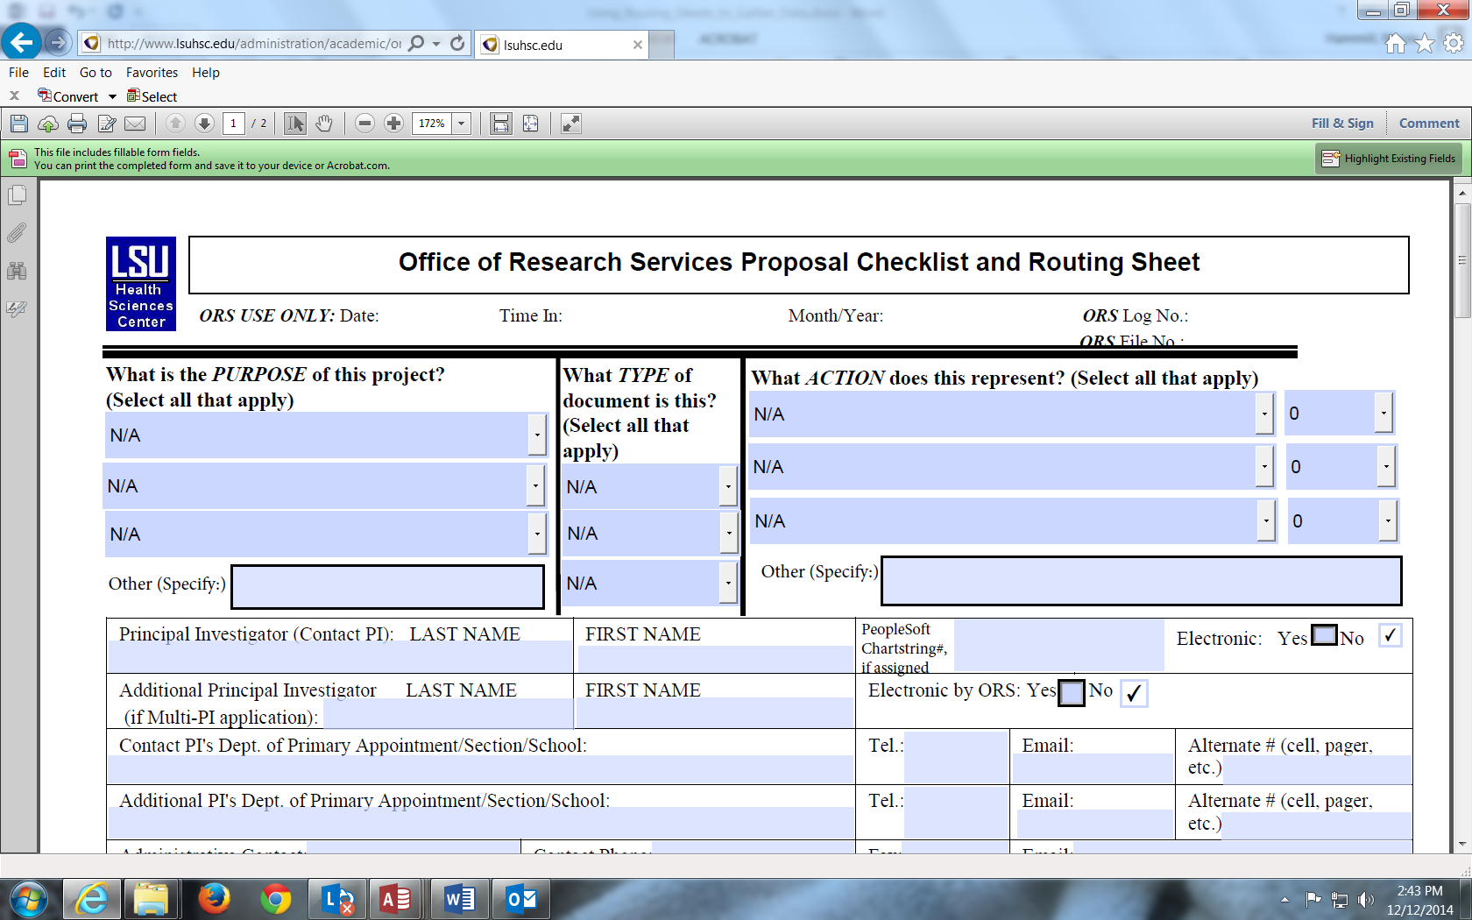

Select “file” and “save as” to save a copy of the document on your local drive, naming it whatever you wish:

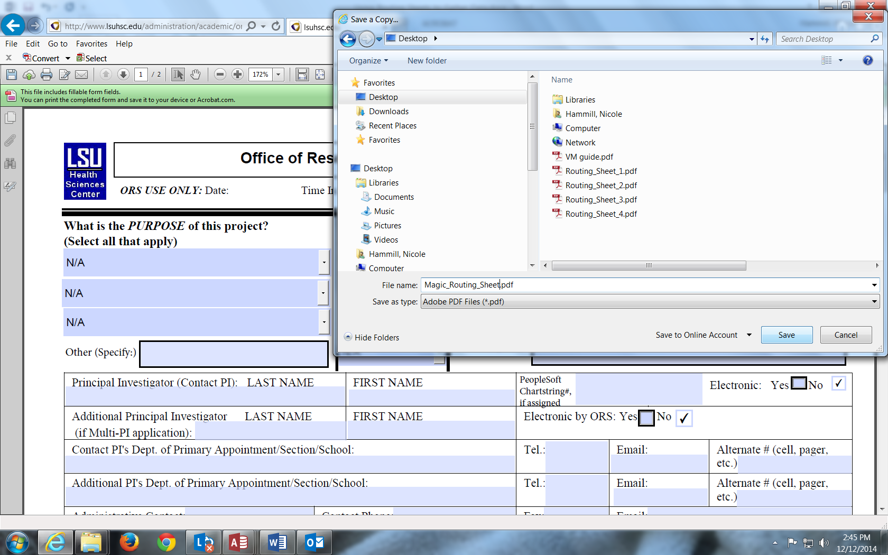

Close the document:
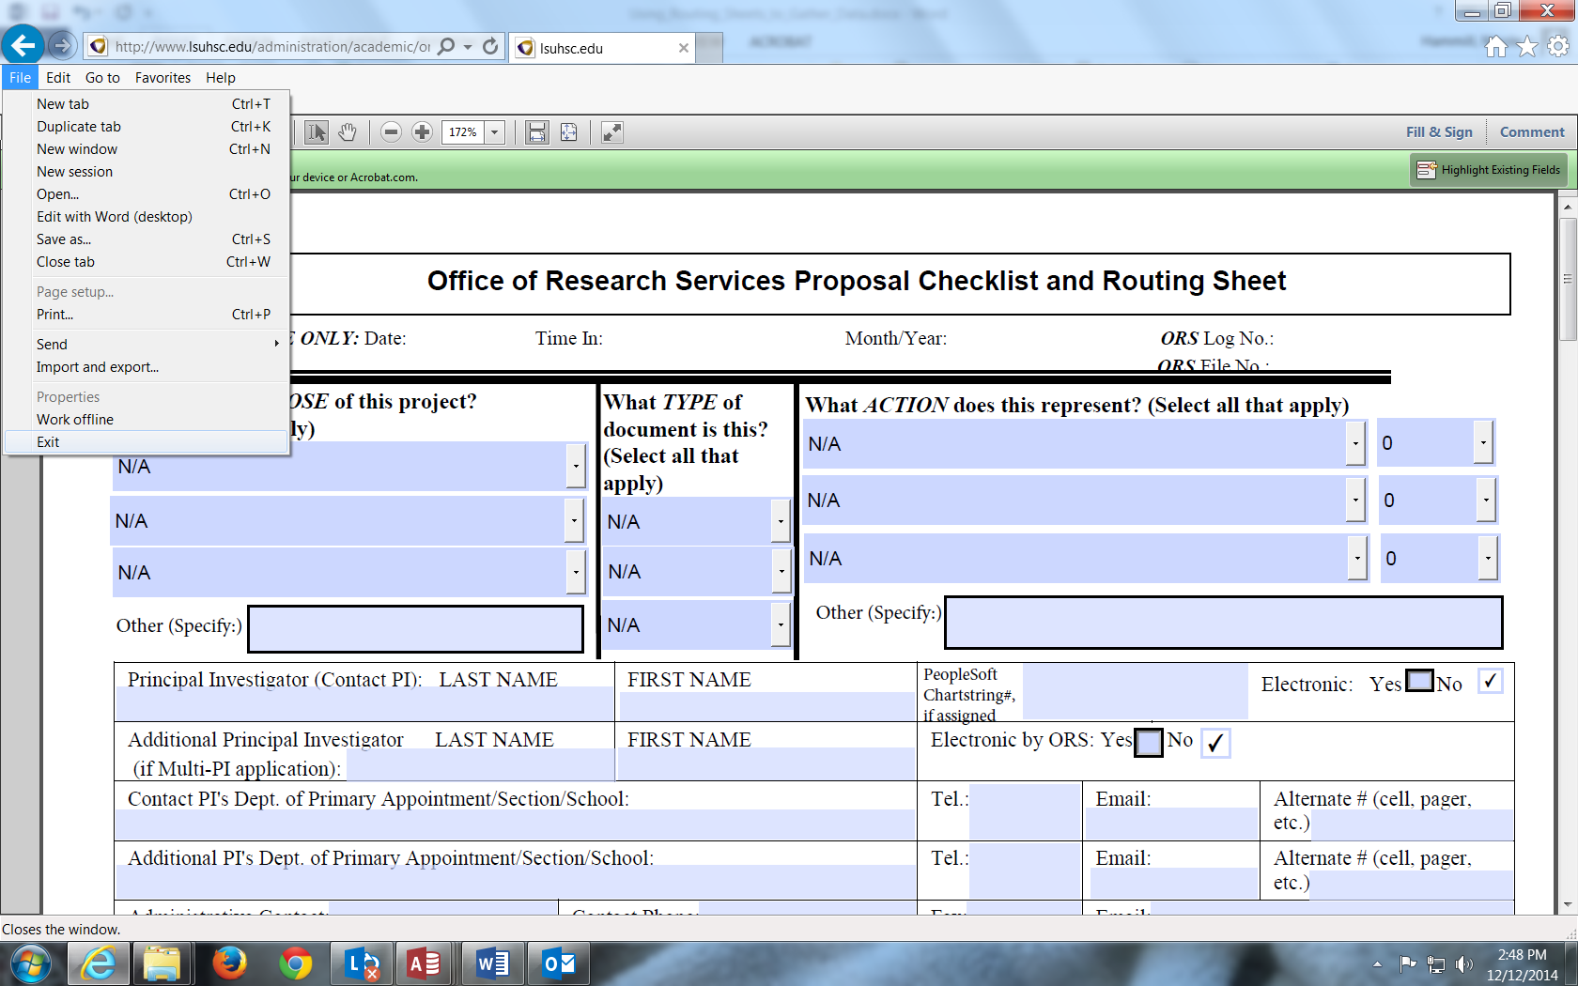

Using your professional version of Adobe (not just your Adobe reader), reopen the document from your local drive:

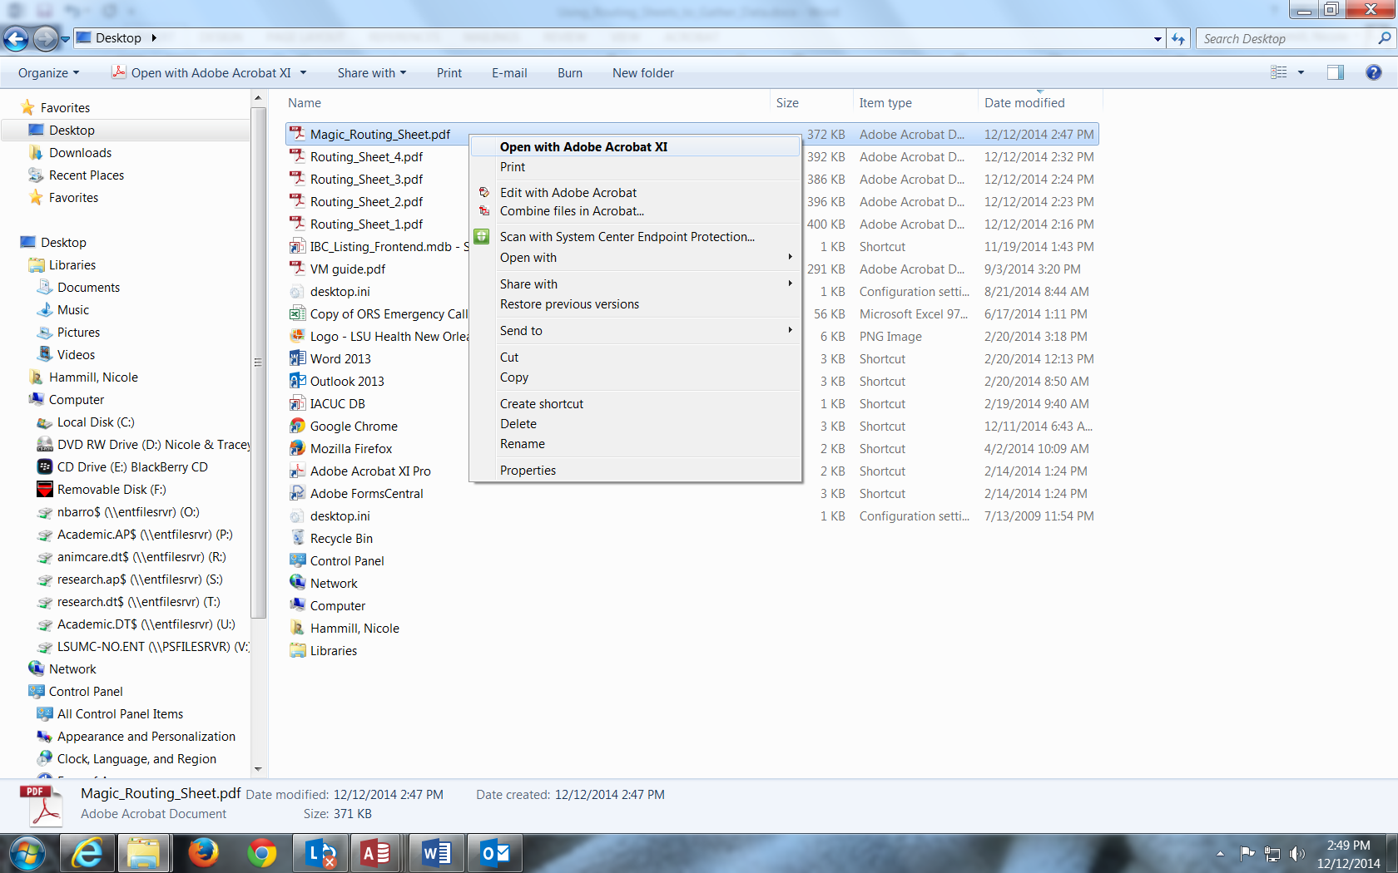

Select “tools”, then “forms”, then “more form options”:
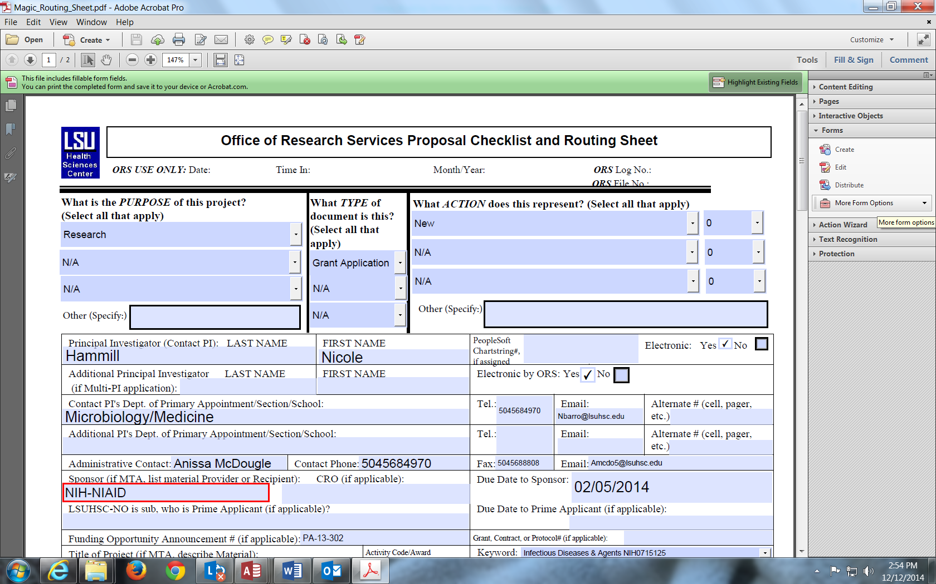

Select “merge data files into spreadsheet”:

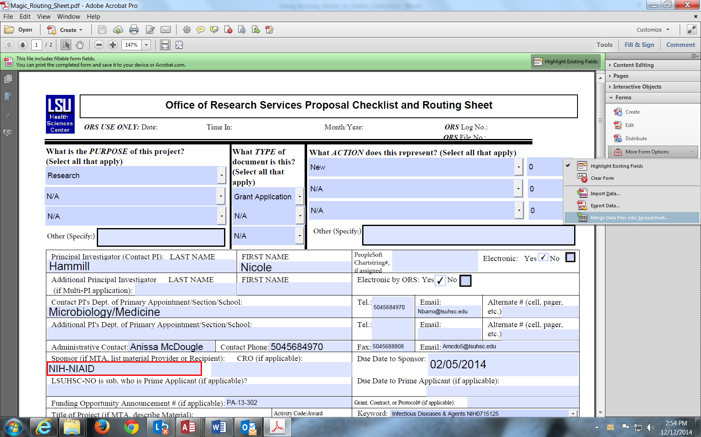

Select “add files”:
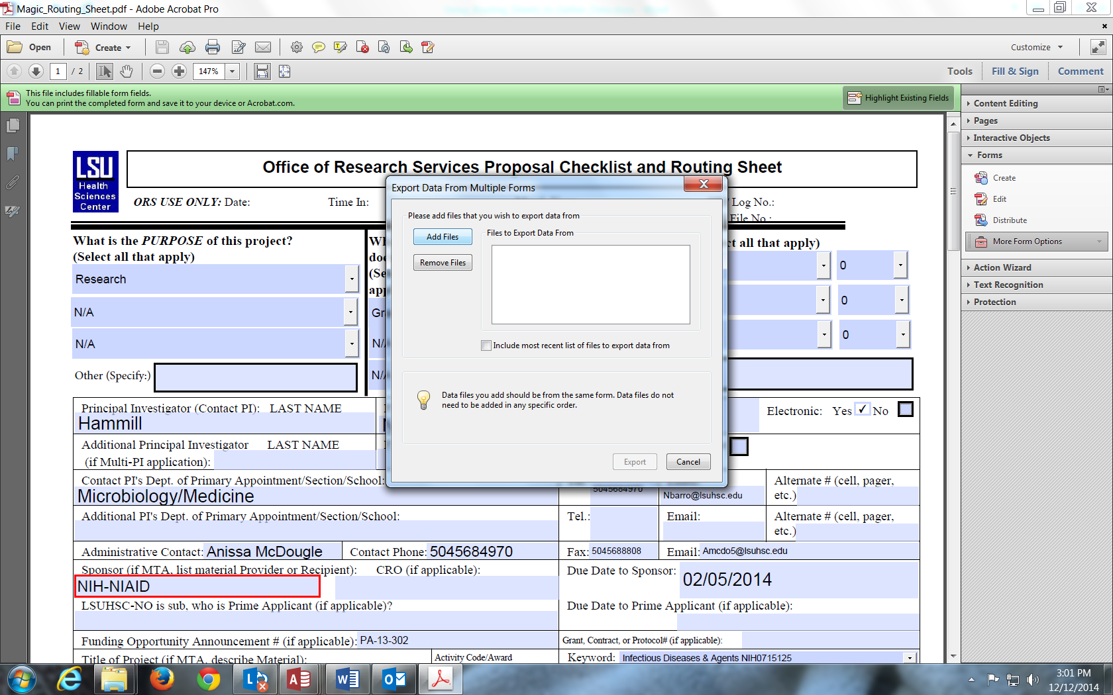
Select the routing sheet, along with any other routing sheets you want in your report, from their location(s) on your local drive:
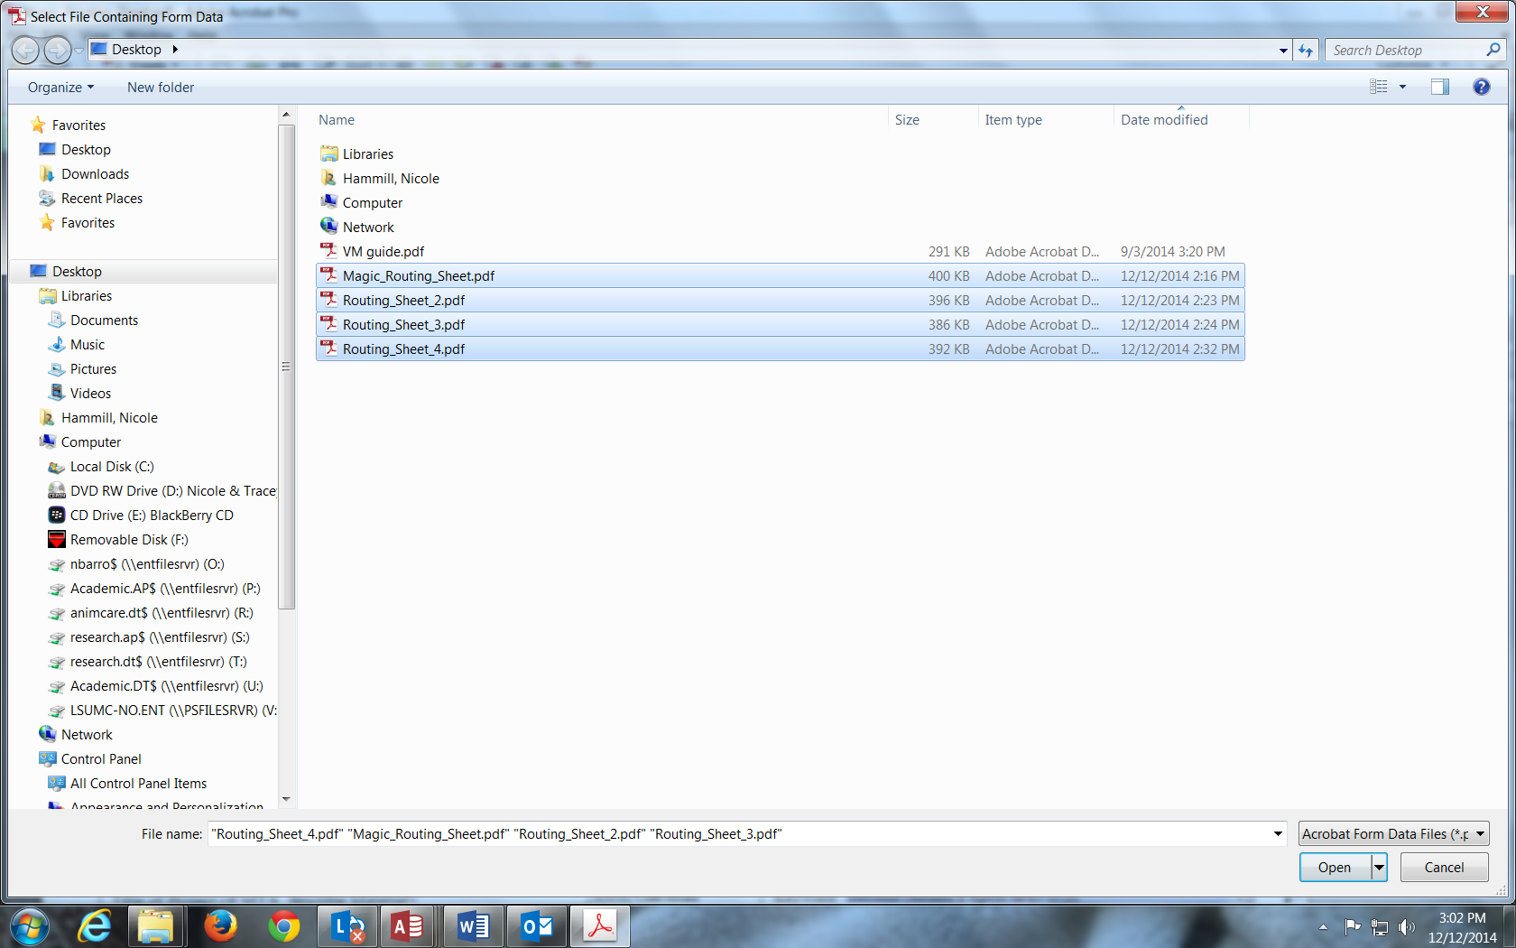

Select “export”:
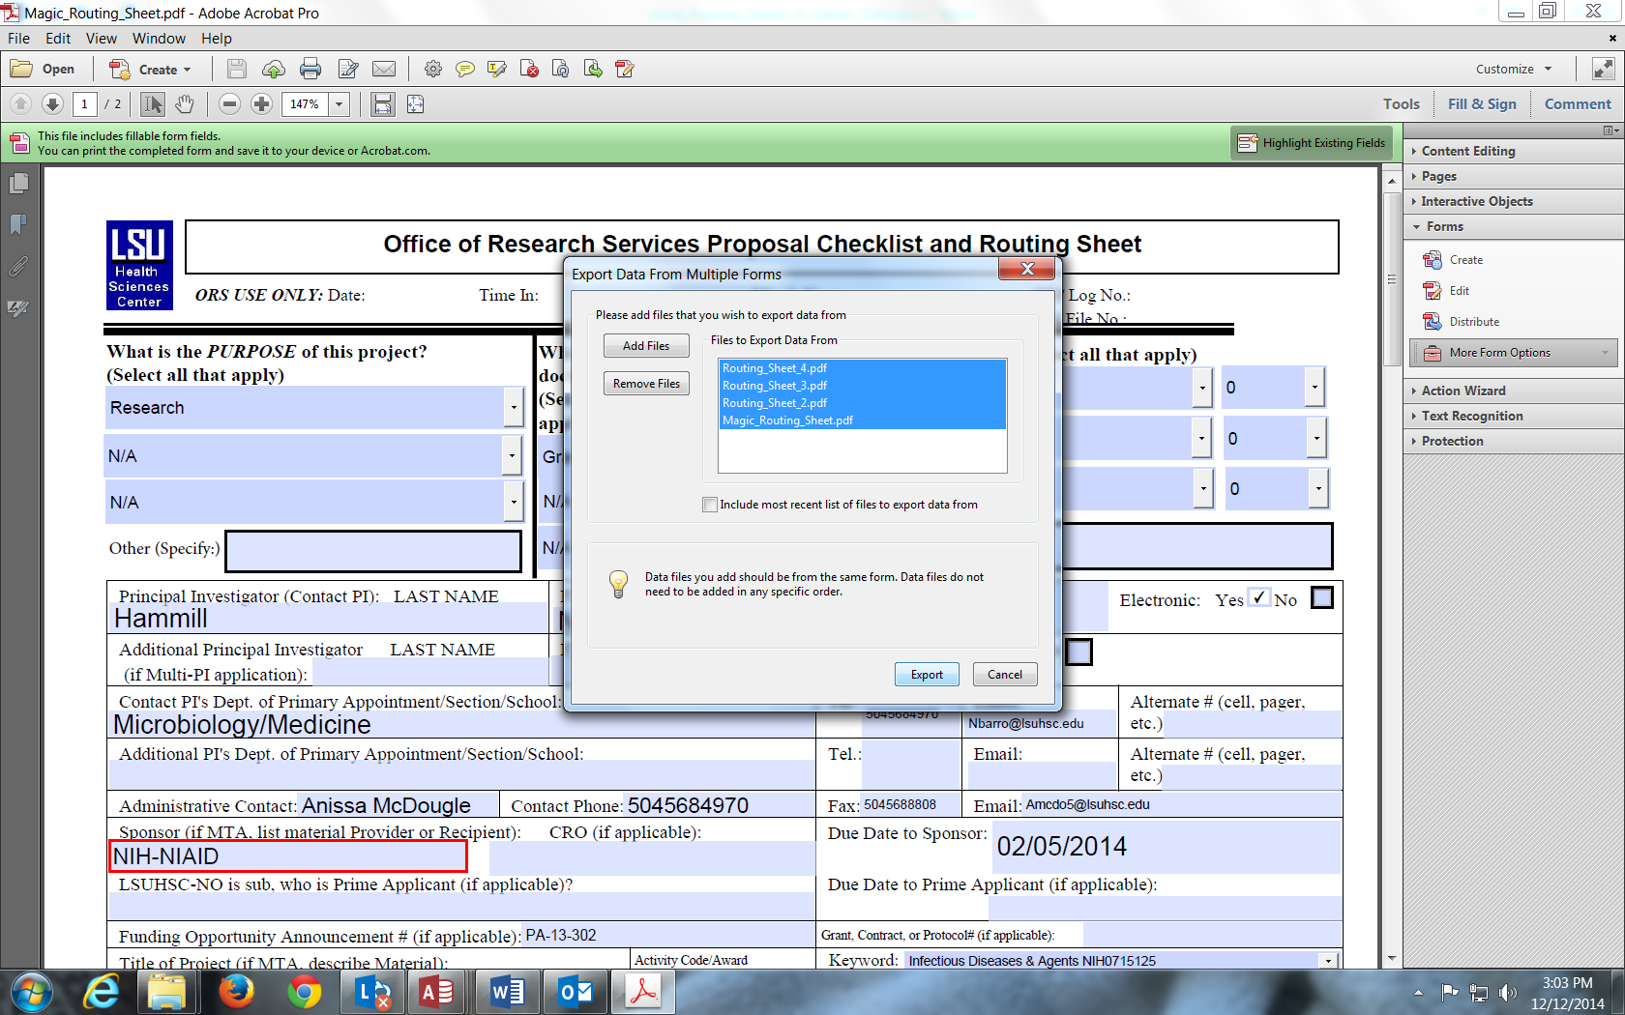
Name the file (example: Routing_Sheet_Data_2015), and save as a “comma separated values” (CSV) type:
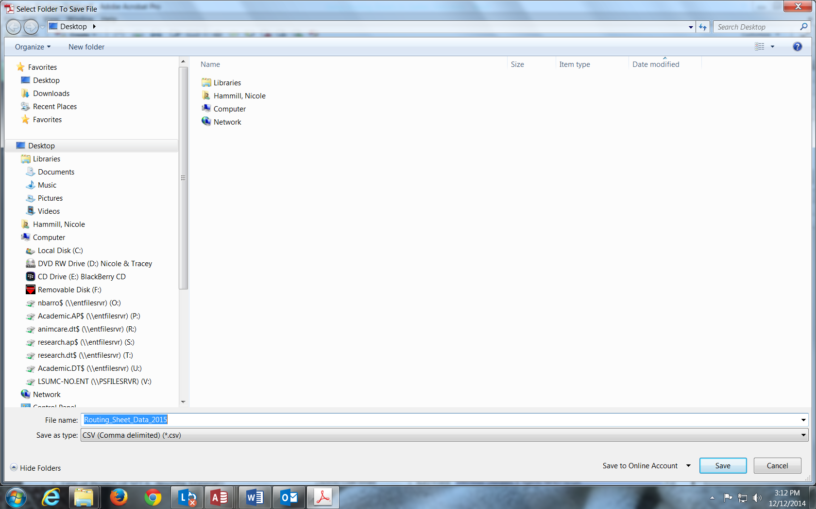
Select “view file now”:

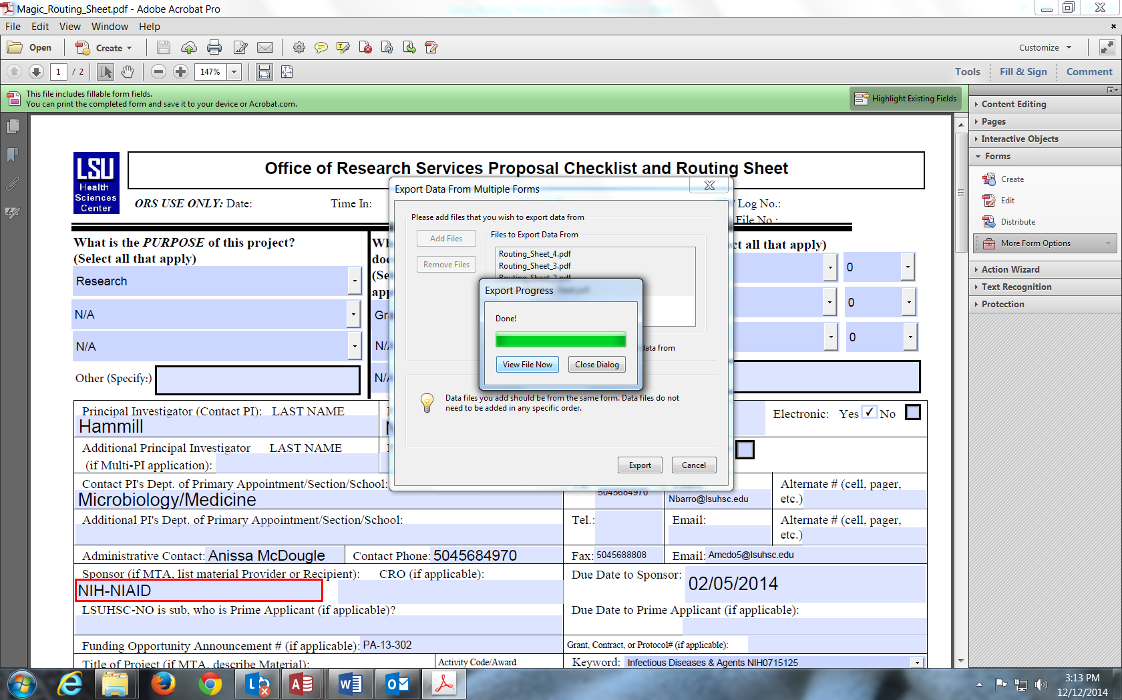

Viola! A spreadsheet is created showing each data element from your routing sheets!
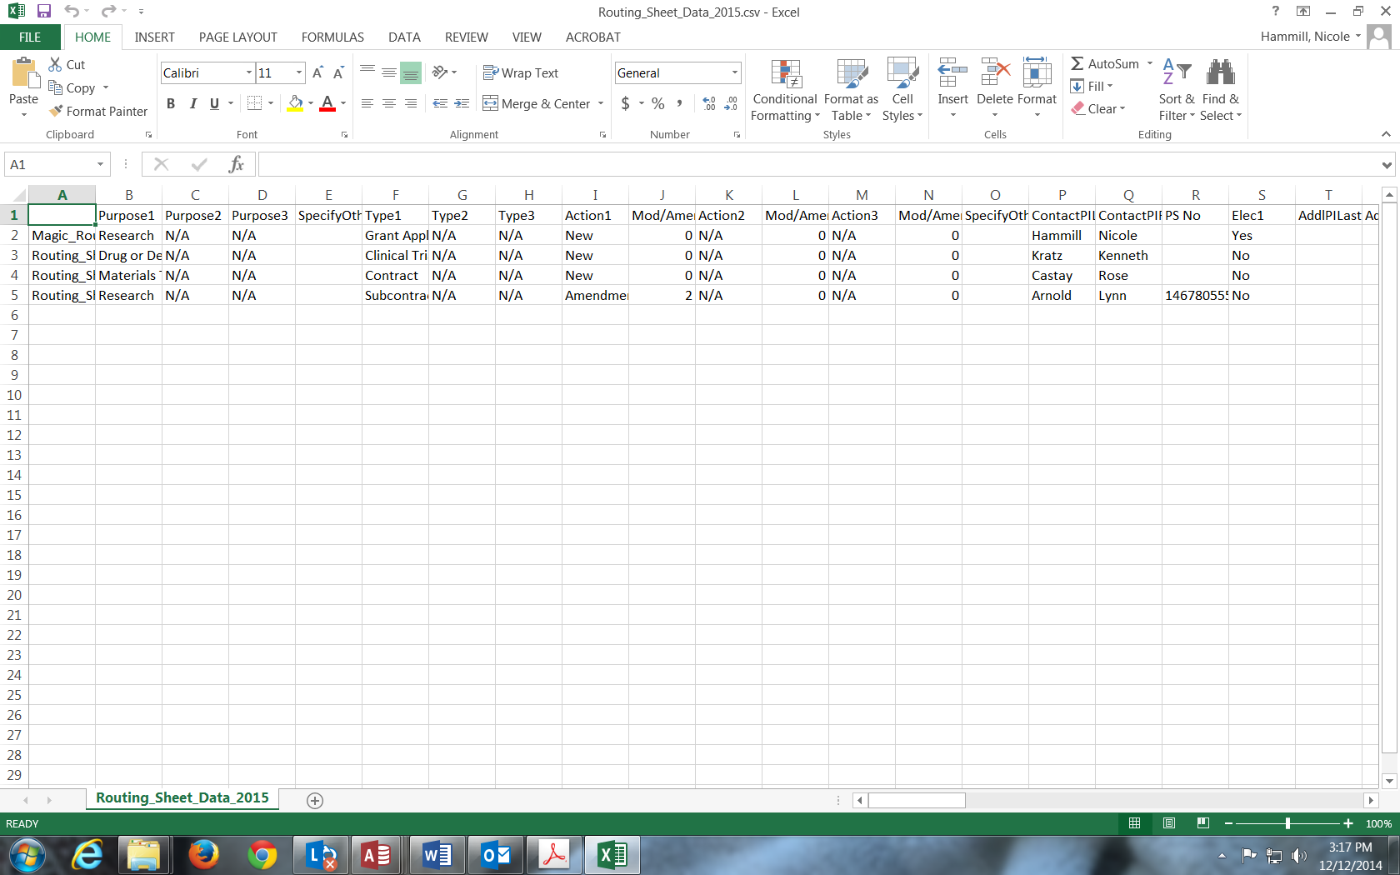
Save this spreadsheet as an excel workbook:

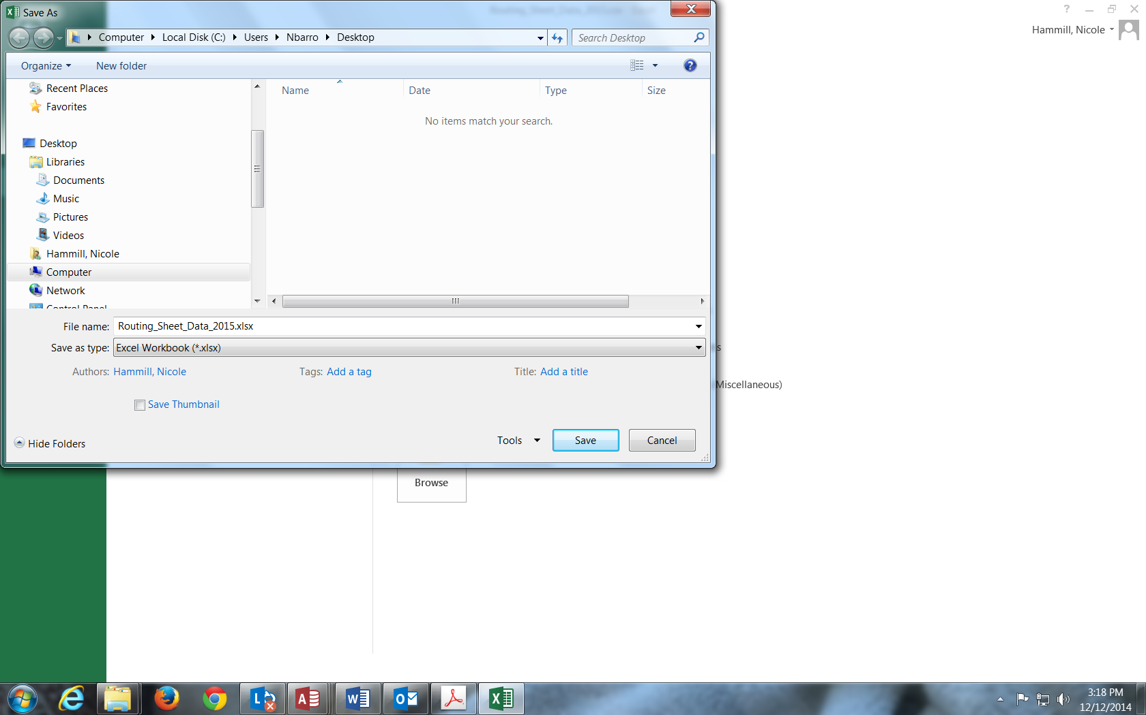

And then enjoy using pivot tables to generate various reports, like this one:

