Logging in and Taking a CITI Course
Instructions for LSUHSC-NO Investigators
- Go to CITI Program: https://about.citiprogram.org/en/homepage/
- Click Log In.
- Click LOG IN THROUGH MY INSTITITION.
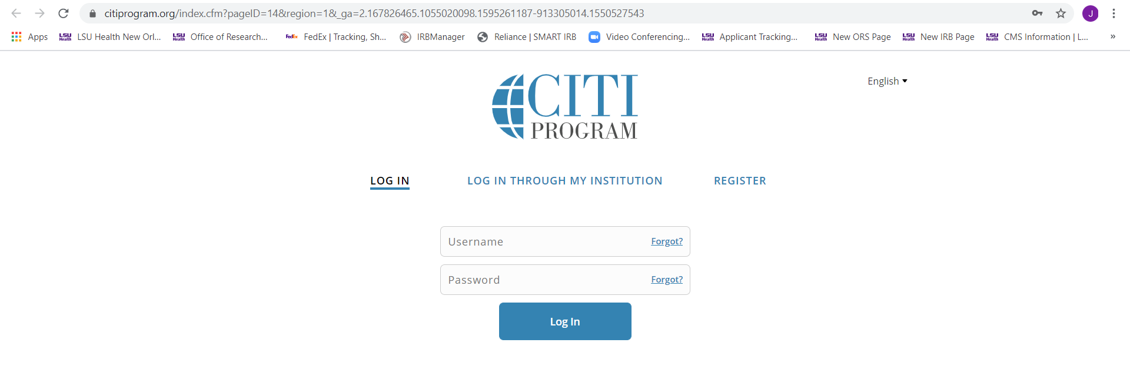
- Scroll down through the list of institutions and click on LSUHSC-NO.
- Enter your LSUHSC-NO credentials on the LSU Health Sign In page and click Sign In.
- Update your Profile if necessary or click on Courses.
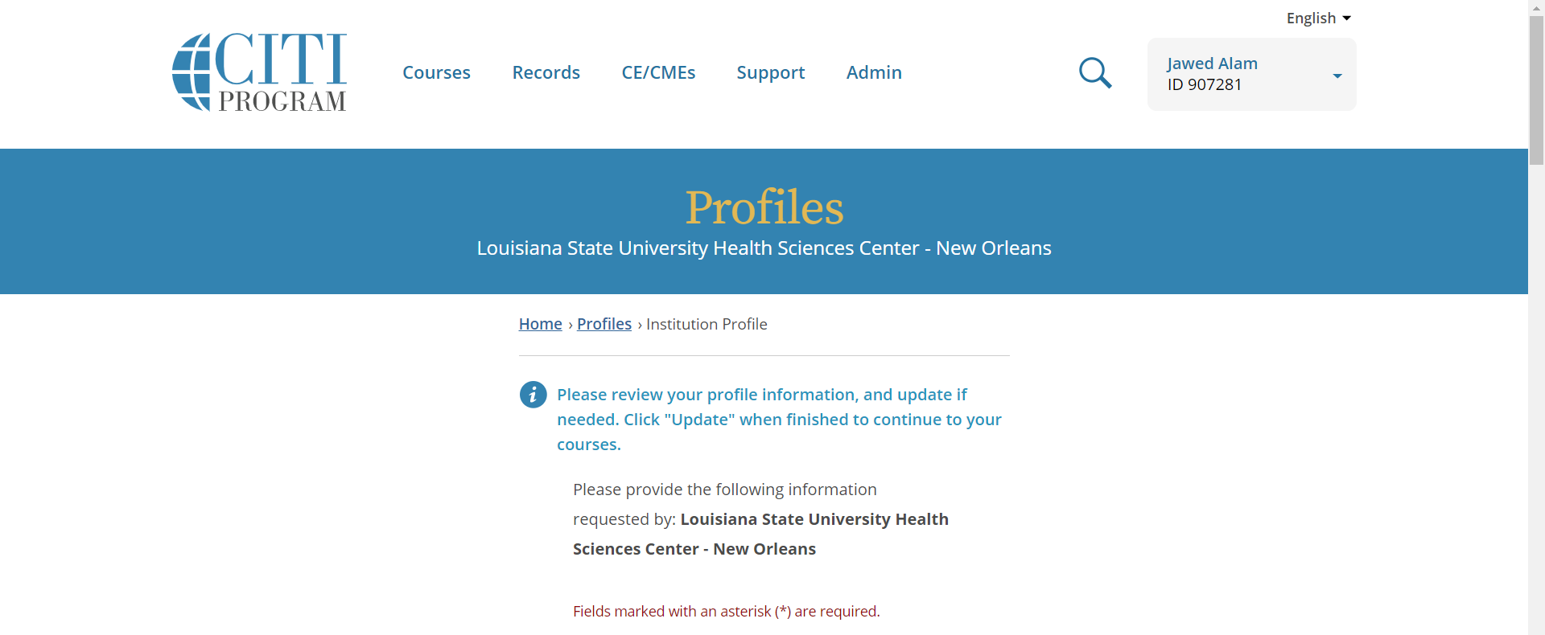
- Start a Course Ready to Begin, or
- Click Add a Course.
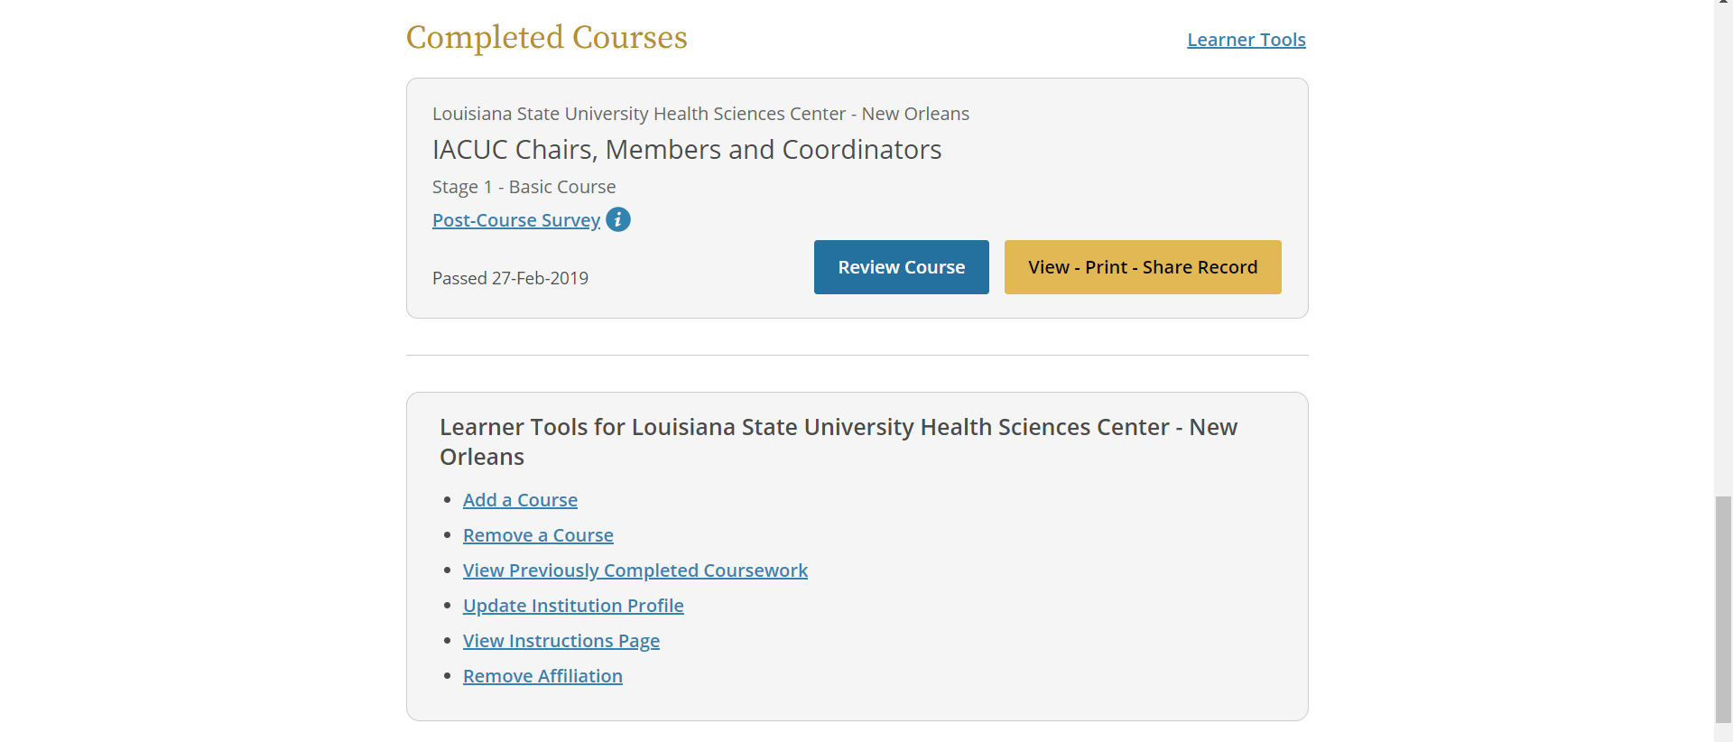
- Complete the Questionnaire to identify courses of interest and click Submit.

- The selected course(s) will be added to your Courses Ready to Begin list. Click Start Now to begin the course.
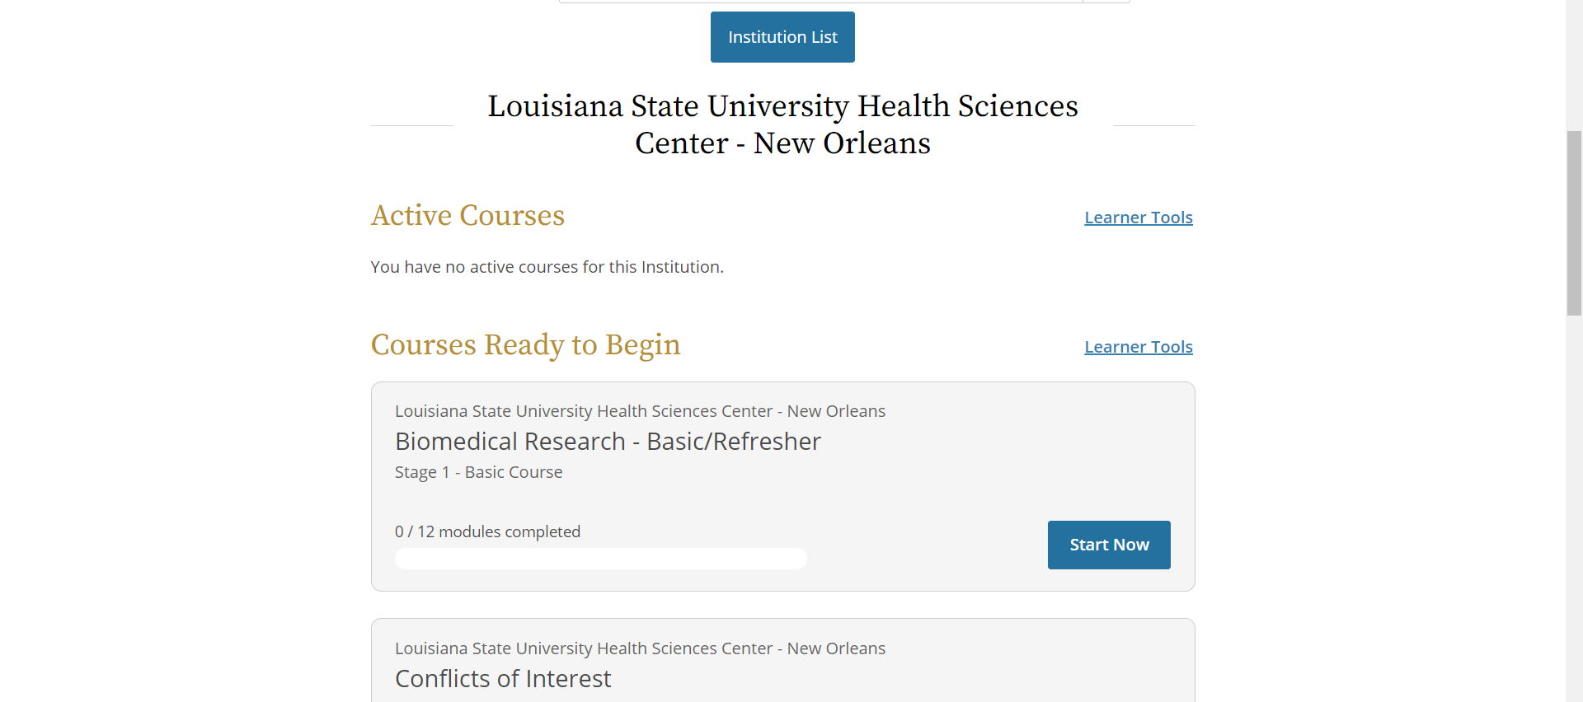
- Follow instructions to complete the course and document completion.

