Updating the PROTOCOL Form - Supporting Documents Table
This guidance is for users submitting an amendment to a non-legacy (initially submitted and approved in KR), approved study that requires attachment of new or revised documents.
Please note that such documents can no longer be uploaded in the AMENDMENT form. They must be attached in the Supporting Documents Table of the PROTOCOL Form. Instructions are provided below.

GENERAL GUIDANCE
- Select the approved and active protocol of interest from the list of all your protocols.
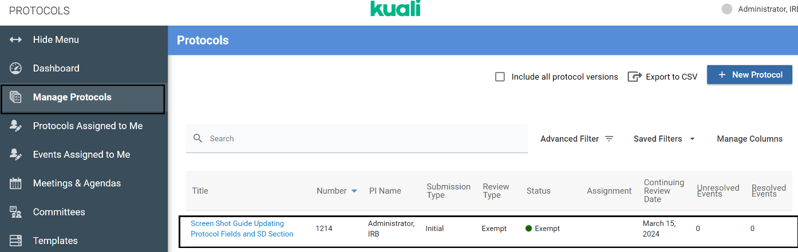
Protocols eligible for post-approval submissions have a status of “Approved,” “Exempt,” or “External Reliance” AND have a green dot

- Choose “Amend” as the post-approval form you’d like to initiate:
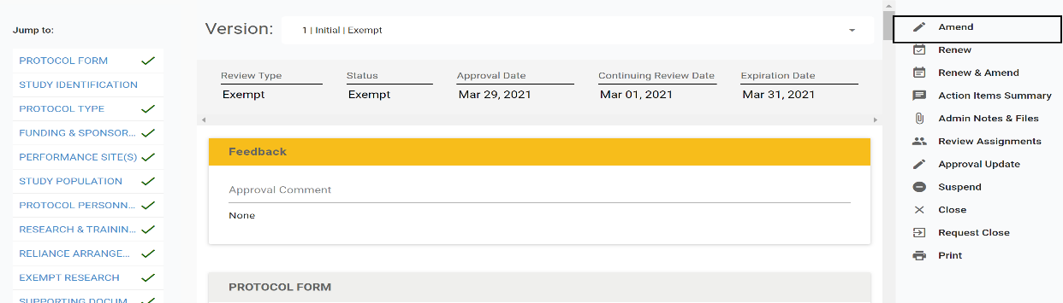
Note: Based on your response to questions in the AMENDMENT form, specific guidance on what to update and where to upload documents will appear.
To access the detailed Amendment Quick Guide, click here.

SUPPORTING DOCUMENTS TABLE UPDATES
- You may be instructed to update the Supporting Documents Section of the PROTOCOL form, for example:

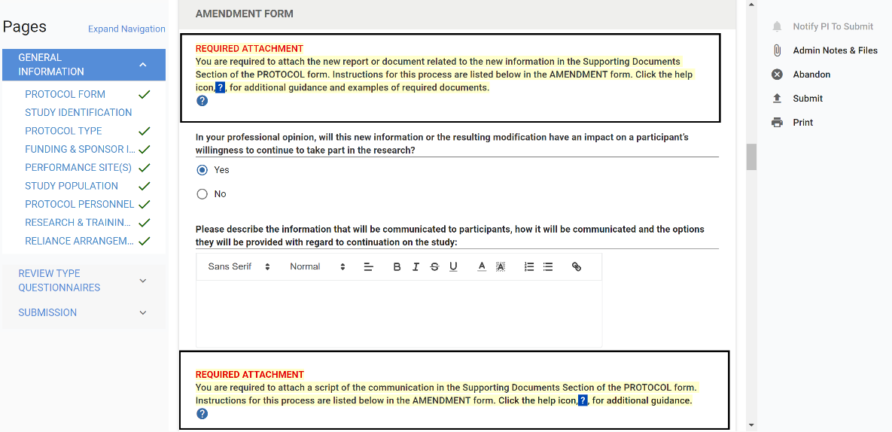
- Be sure to read the specific instructions provided in the post-approval form for updating the Supporting Documents Section of the PROTOCOL. Follow these exact directions when updating the Supporting Documents Table, as each post-approval form has different instructions.
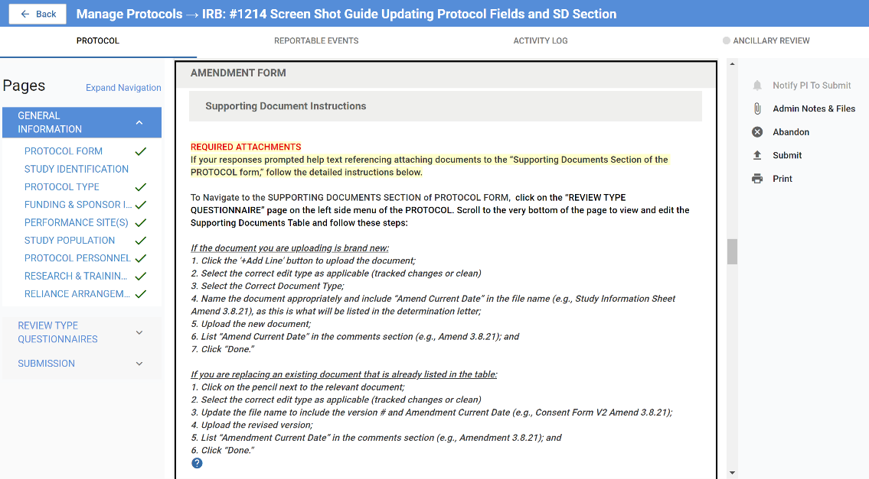
- To access the Supporting Documents Section of the PROTOCOL form, click Review Type Questionnaires on the left sidebar menu. Next, scroll down until you have exited the post-approval form, which will be labeled as “END OF _____ FORM”. You will then be in the currently approved PROTOCOL form.
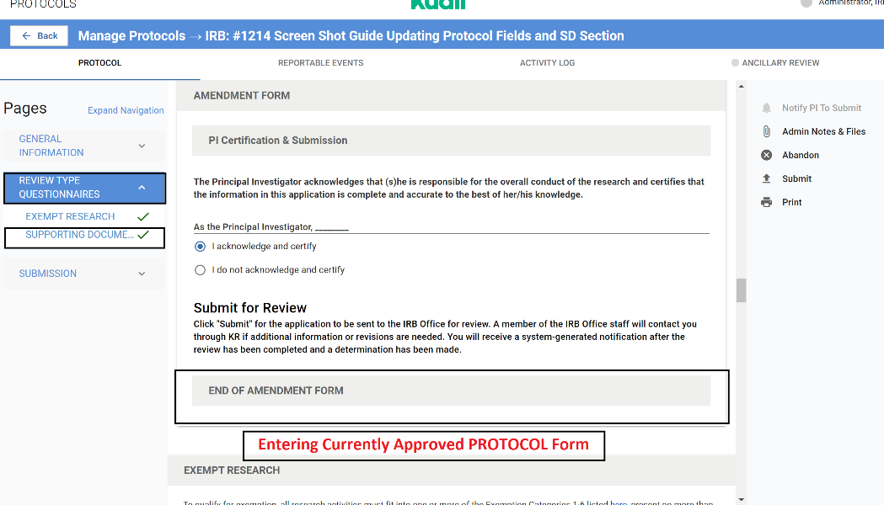
- Scroll to the very bottom of the page to view and edit the Supporting Documents Table as directed in the specific post-approval form instructions.
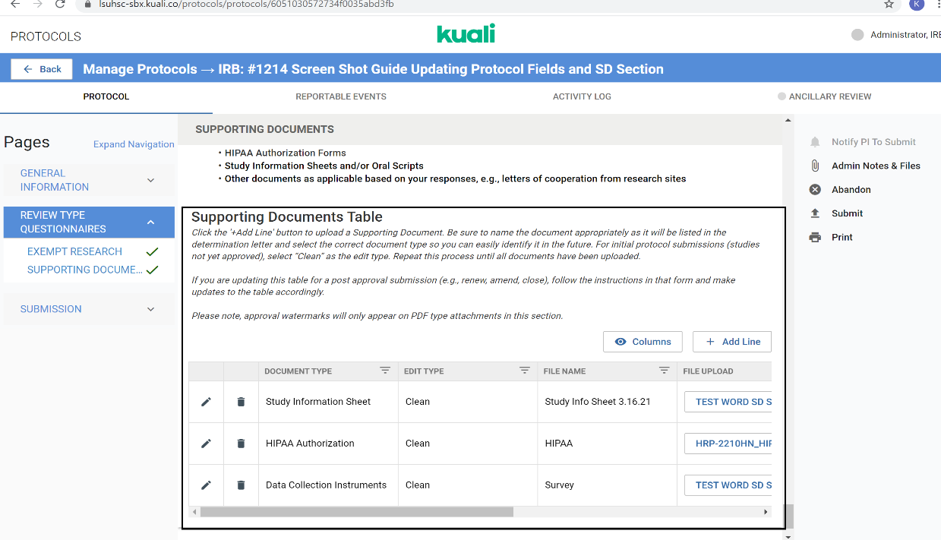
You can also get to the Supporting Documents Section by scrolling to the end of Page 1, pressing “Next” and then scrolling to the end of Page 2 of the original PROTOCOL form.

ADDING BRAND NEW DOCUMENTS
- If you are uploading a brand new document that is not replacing an existing document in the table, follow the steps below:
  - Click the '+Add Line' to add a new document associated with the post-approval submission:
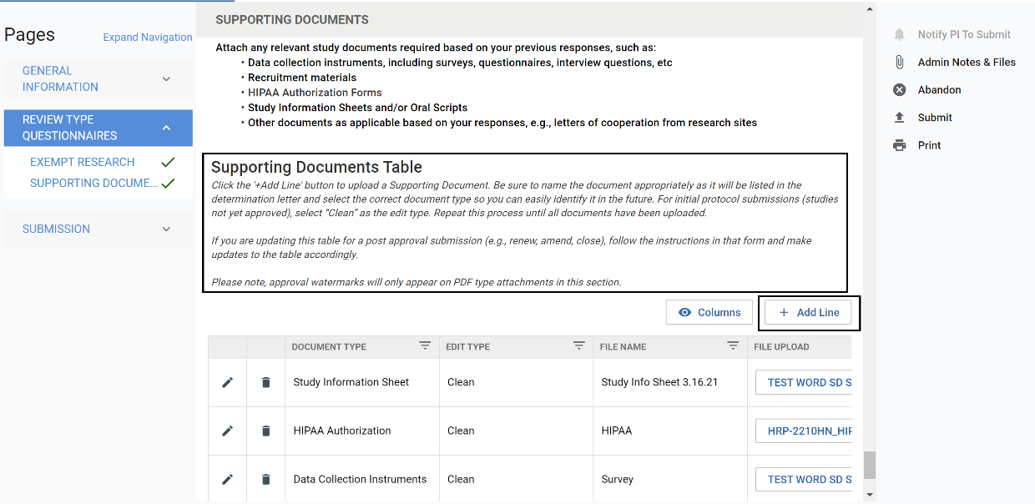
  - Select the document type from the dropdown list. If “Other,” provide description.
  - Select the correct Edit Type as applicable (Tracked changes or Clean).
Tracked changes edit types are only applicable when submitting an Amendment that includes a revised study document - both Tracked changes and Clean edit types are required in this instance.

  - Provide the File Name of the document in this specific format:
    - “Document Name, Amend and Current Date”
      - e.g., Study Information Sheet, Amend 3.17.21
What is listed as the File Name will be listed in the determination letter; therefore be sure to follow the format of Name, Amend and Current Date for proper documentation.

  - Upload the new document.
Note: Approval watermarks will only appear on PDF type attachments.

  - List the Amend and Current Date (e.g., Amend 3.17.21) in the comments section.
  - Click “Done.
Example of adding a new document and file naming format:
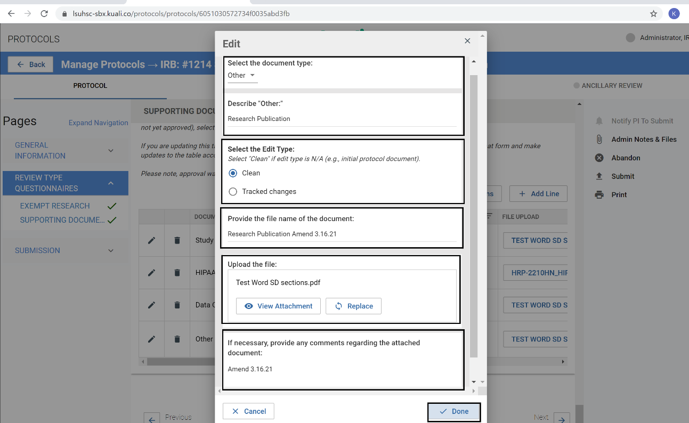
- The new document will then appear in the Supporting Documents Table:
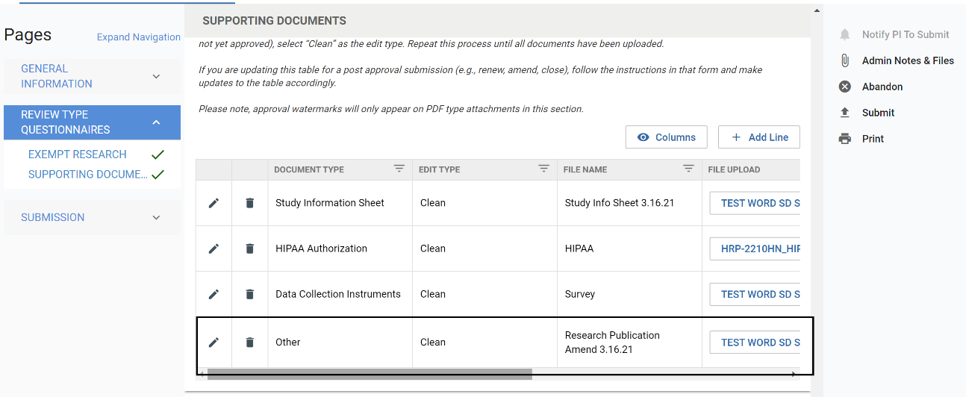
- Repeat this process for as many new documents you wish to upload to the Supporting Documents Table.
If you are only uploading new documents, you may click “Submit” on the right sidebar menu when you have completed updating the table and the AMENDMENT form requirements as applicable.
If you are updating existing documents, follow the instructions on the next page.

UPDATING EXISTING DOCUMENT
- If you are uploading a revised study document that is replacing an existing document in the table, follow the steps below:
  - Click on the pencil next to the study document being replaced:
This is for users submitting an amendment that has an updated study document associated with the submission.
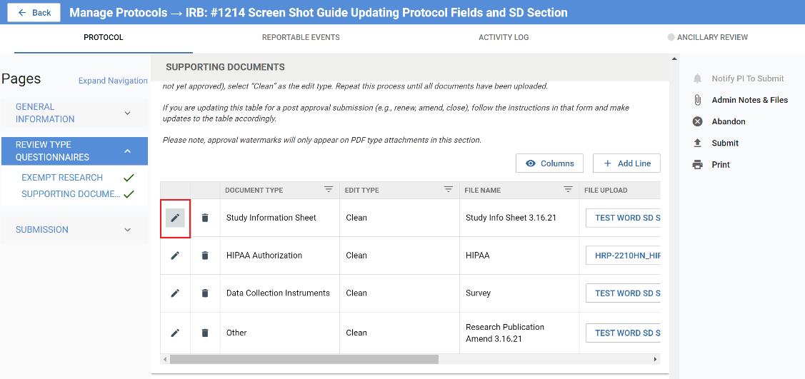
  - Do not change the document type.
  - If the Edit Type is listed, do not change. If it is missing, select “Clean” unless you are replacing a tracked changes version.
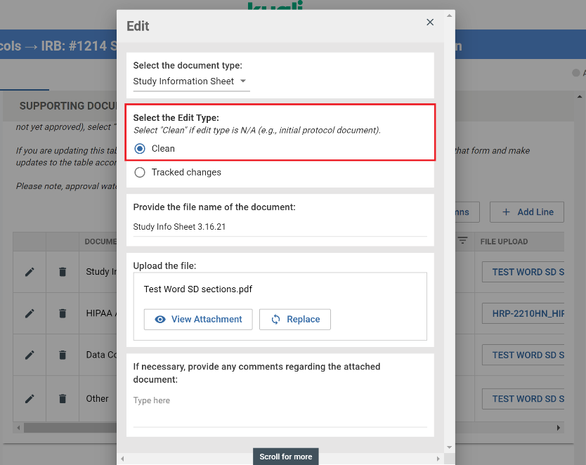

  - Update the File Name of the document to reflect this specific format:
    - “Document Name, Version #, Amend and Current Date”
      - e.g., Study Information Sheet V2 Amend 3.17.21
What is listed as the File Name will be listed in the determination letter; therefore be sure to follow the format of Name, Version #, Amend and Current Date for proper documentation.

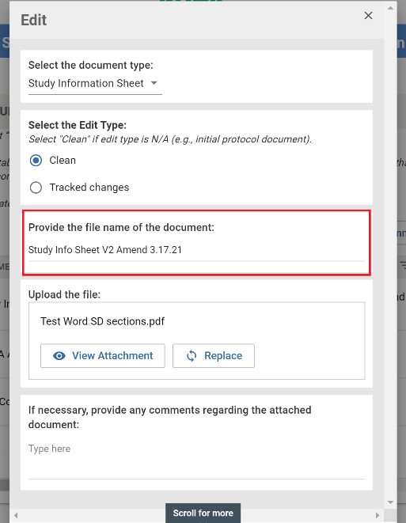
  - Select “Replace” in the Upload the file section:
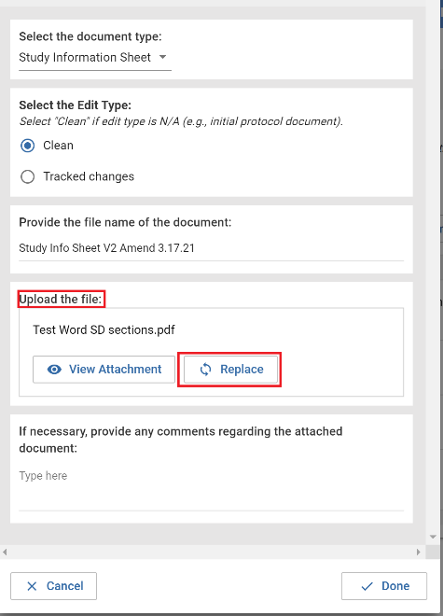

  - Upload the revised version.
  - List the Amend and Current Date (e.g., Amend 3.17.21) in the comments section.

  - Click “Done.”
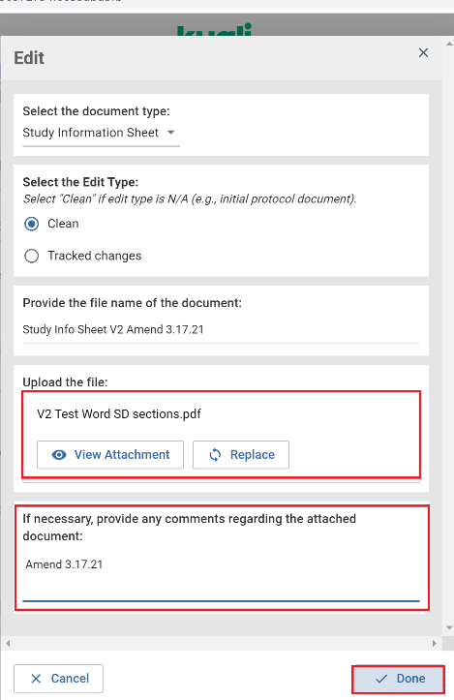
- The updated document will then appear in the Supporting Documents Table:
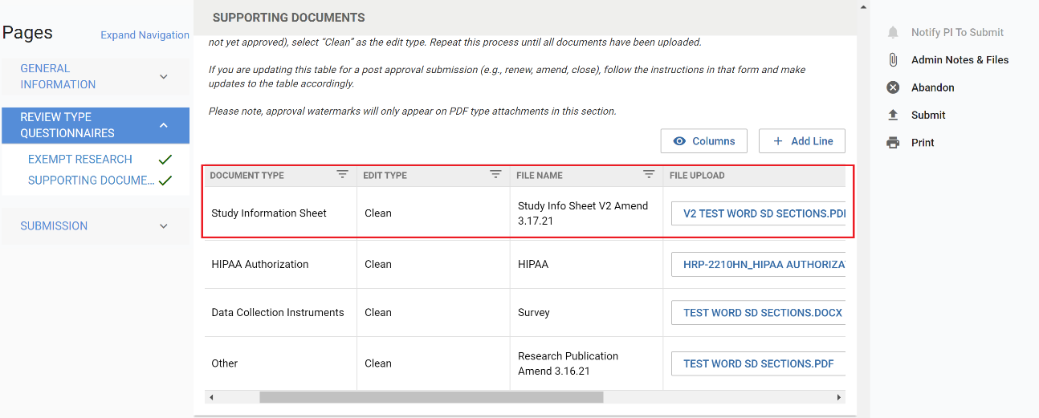
- Repeat this process for as many revised documents you wish to upload to the Supporting Documents Table.
When you have completed the AMENDMENT form, updated any PROTOCOL fields as needed, and finished updating the Supporting Documents Table, click “Submit” on the right sidebar menu.

