
Special Meal E-form Job Aid
To streamline and automate the special meals prior approval form, an electronic version of the previously paper-based form has been developed. This e-form will allow greater ease of use, more visibility into the whereabouts of the form, and electronic workflow approvals.
*****In order to access the special meals eform in PeopleSoft, an employee will need security access assigned to their user profile. Please check with your departmental Business Manager and/or the Accounts Payable Team for more information regarding gaining access.*****
Roles and workflow assigned for Special Meals Forms:
- Form Requestor (A REQUESTOR CANNOT APPROVE HIS/HER OWN FORM)>>>>>>>>>>>>>>>>>>
- Department level approval>>>>>>>>>>>>>>>>>>>>>>>>>>>>>>>>>>>>>>>>>>>>>>>>>>>>>>>>
- Dean’s office approval

How to submit a Special Meals e-form:
Navigation:
- Select>My Financials Home>select GT eforms Homepage

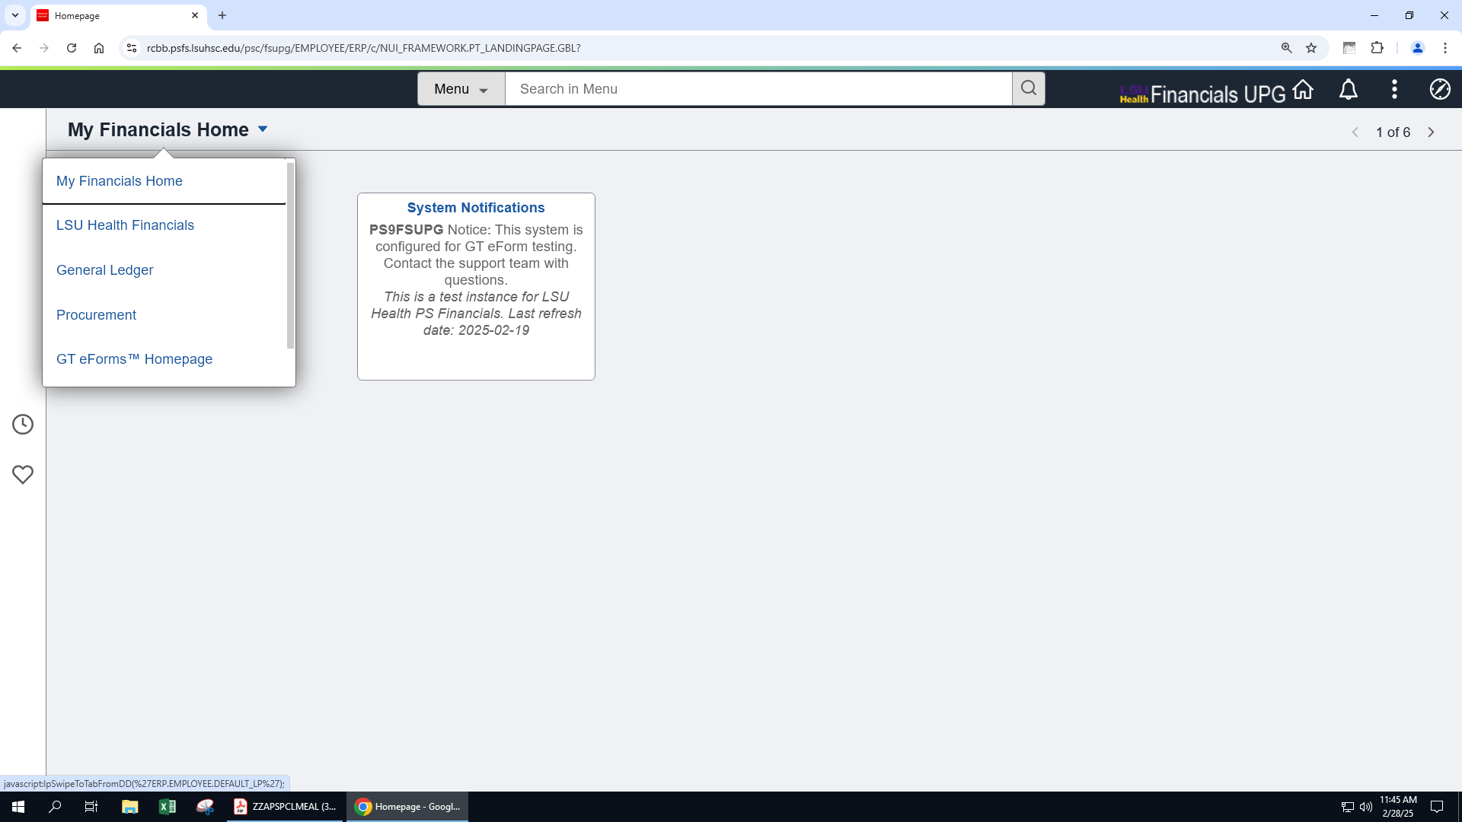

Select>NO AP Special Meal Form

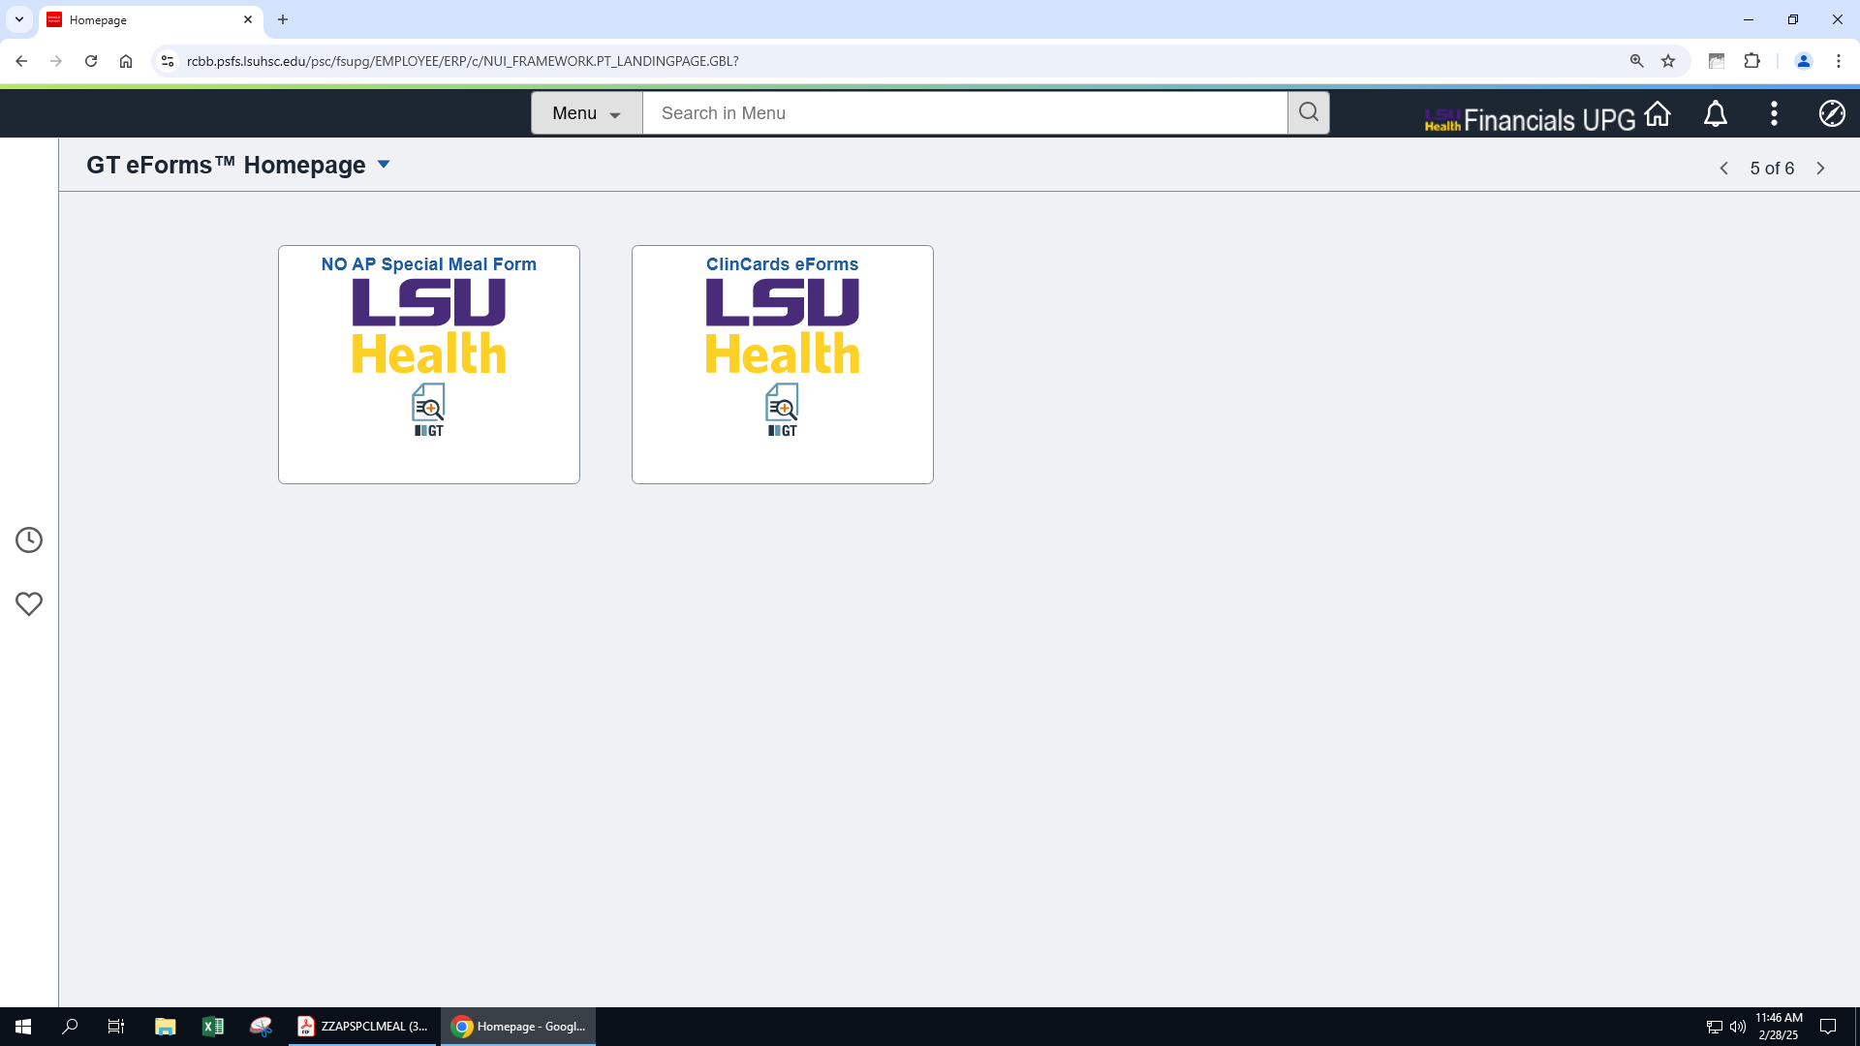

Select>Add a spcl MAE eForm
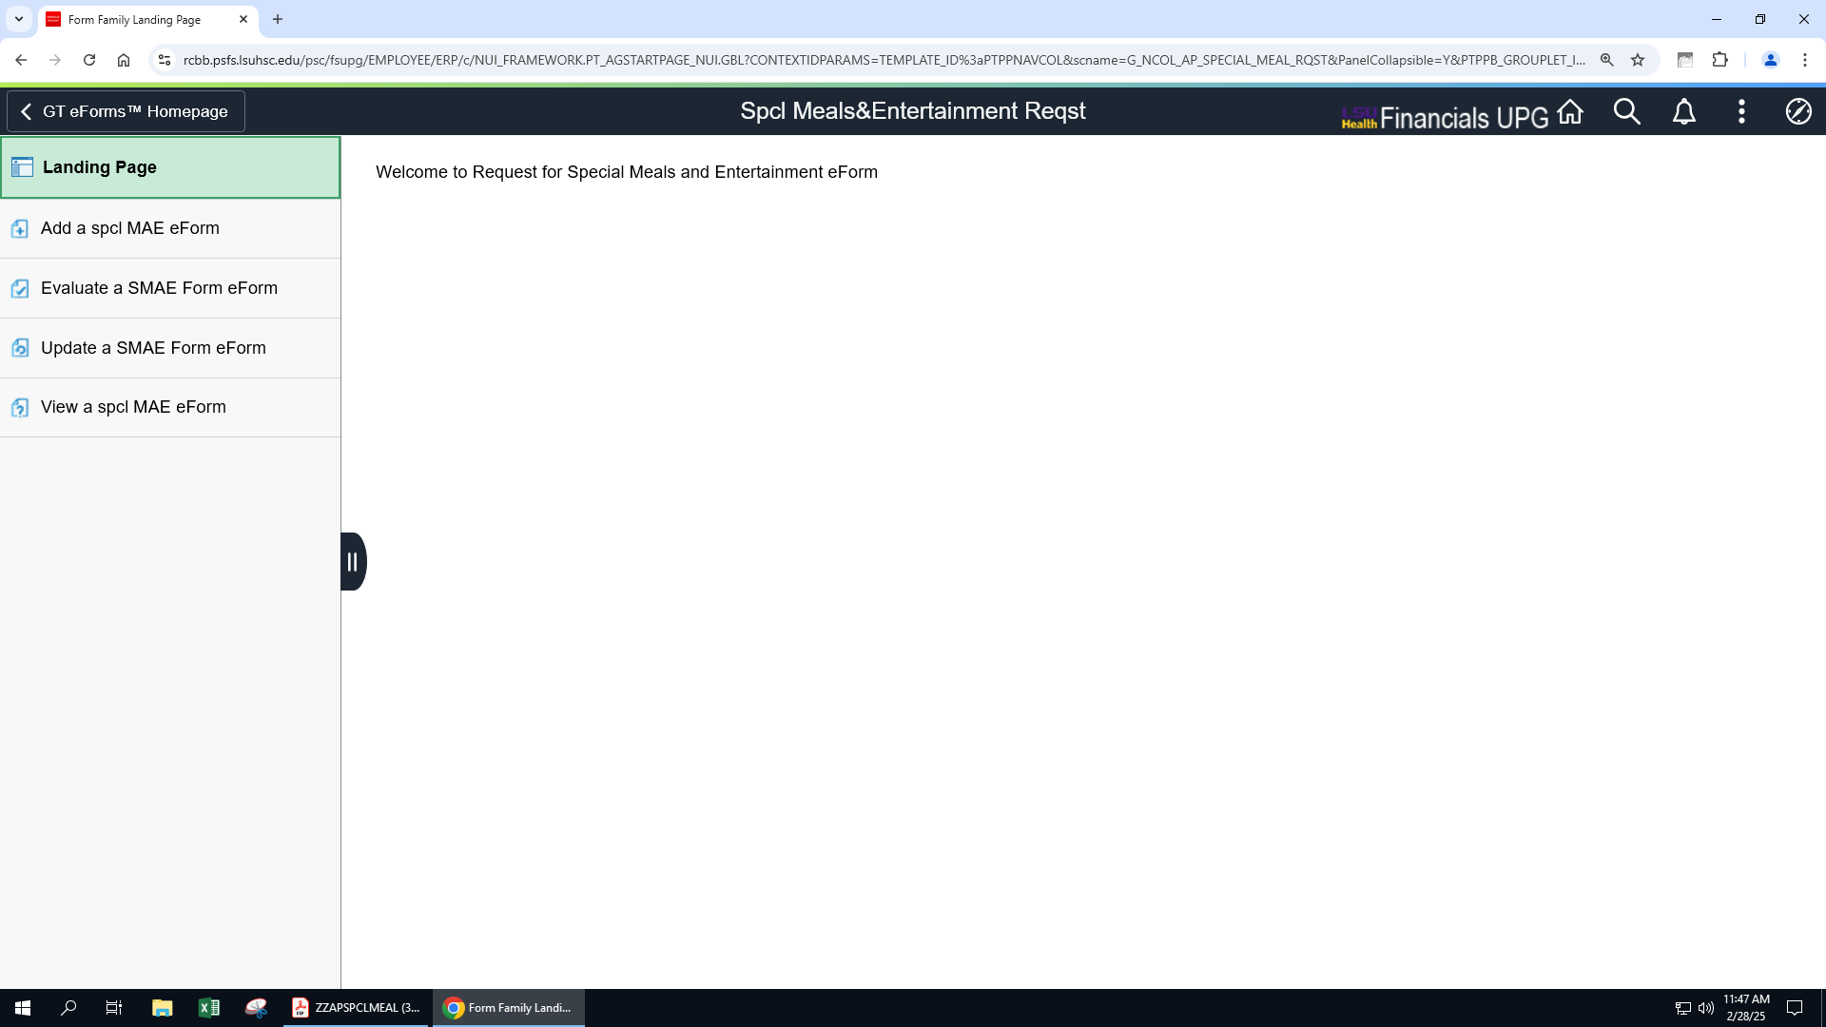

- Please be sure to enter data into all of the required data fields
- Attaching a list of attendees with specific names and affiliation to the University is required
- Click SUBMIT; the eform will then enter the approval workflow designated by your School/Administrative section

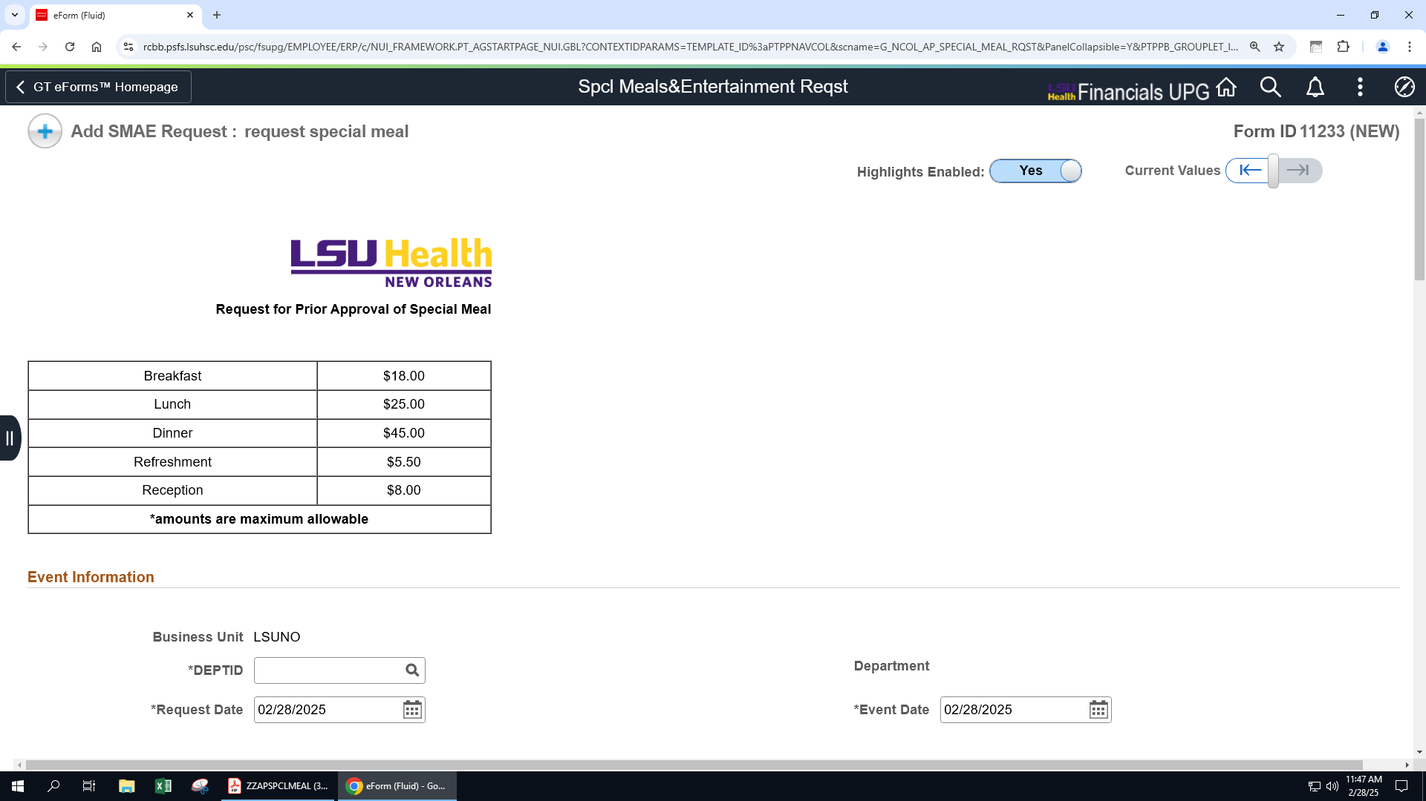

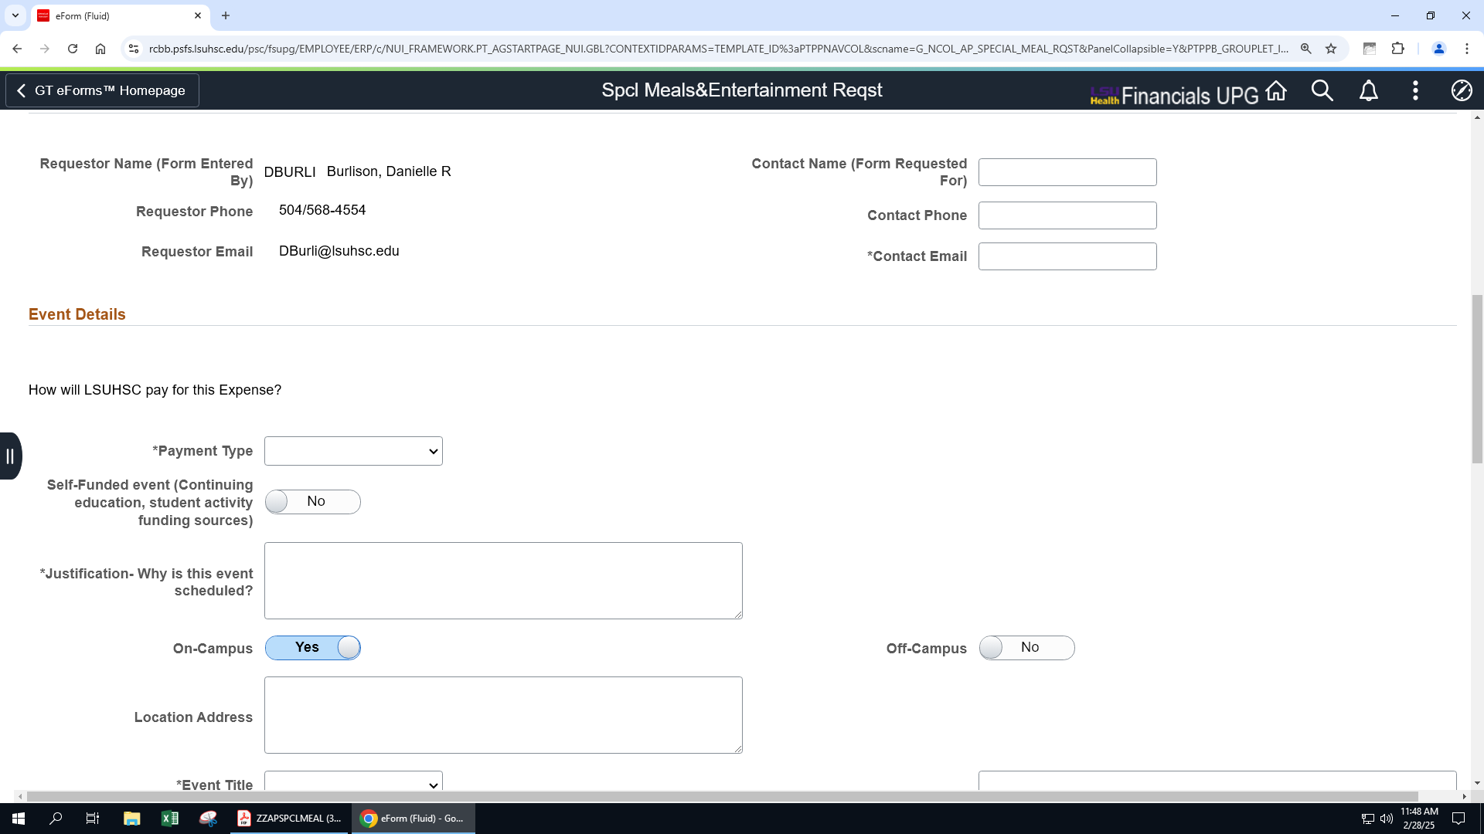
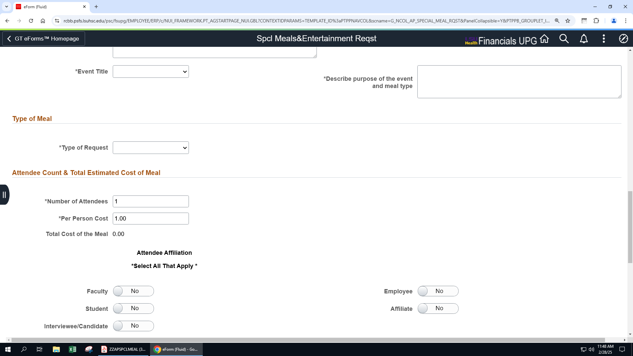
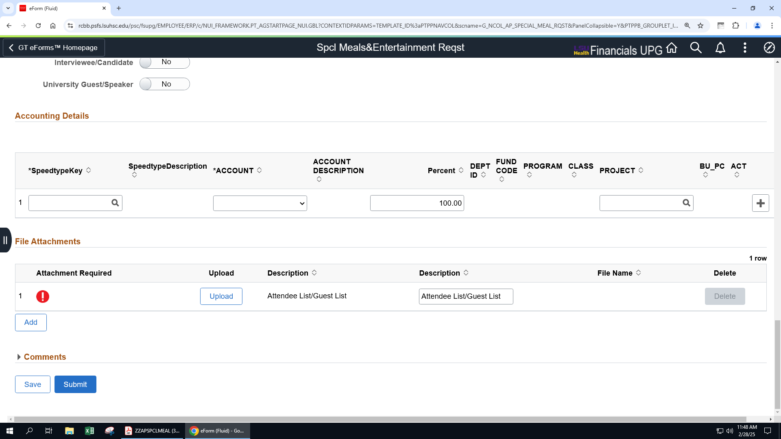

Once submitted, the eform will enter the electronic workflow approval process.
To determine where your form has been routed for approval:
Select>View Approval Route
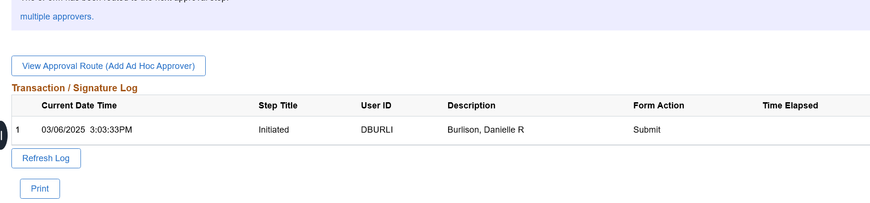

Click hyperlinks to see specific approvers for your department/school
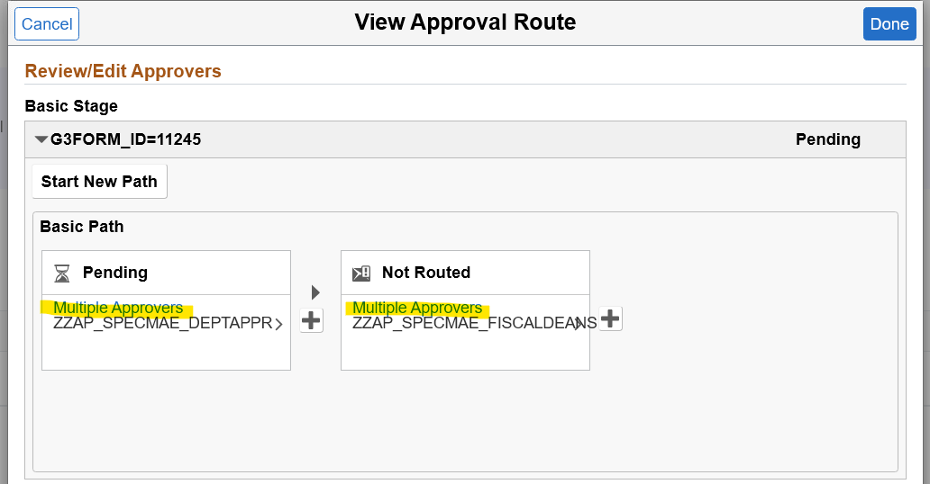

Once approved, the eform requestor will receive an email confirmation of the approved form.
Select the hyperlink to retrieve the form.
Sample email:
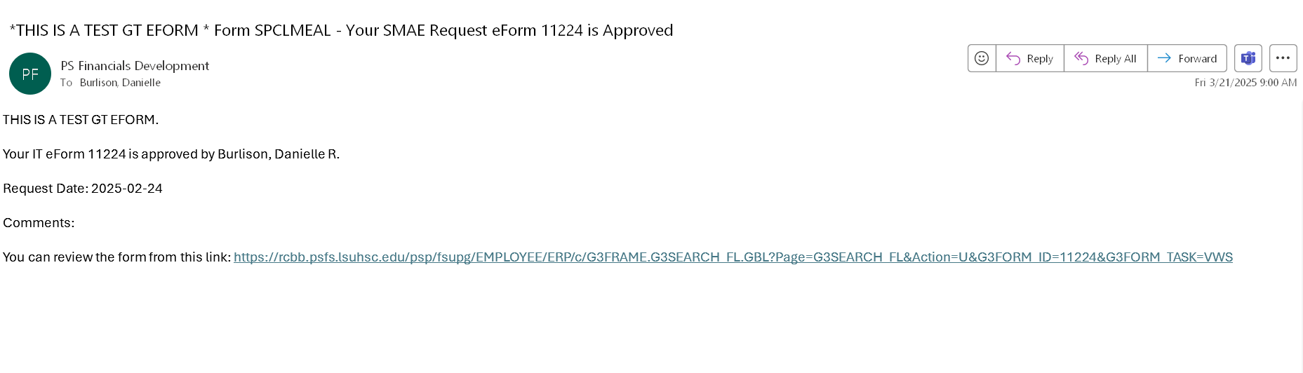

Select> Print:
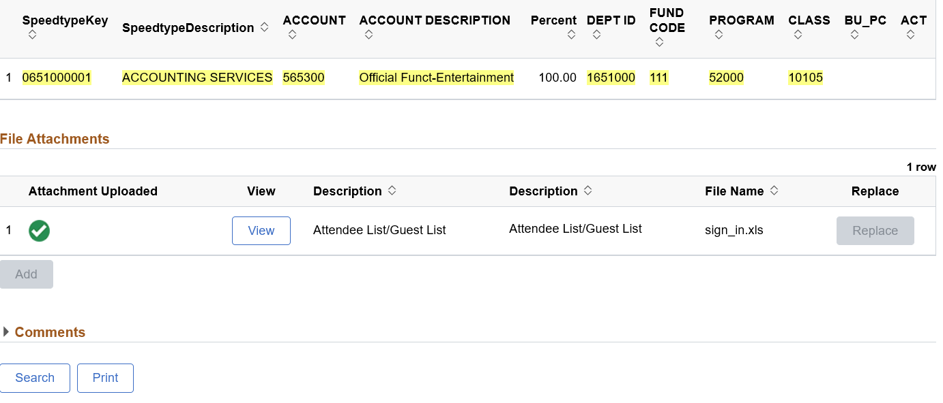
Select Report Name ZZAPSPECLMEAL from the drop-down menu
Select>Print

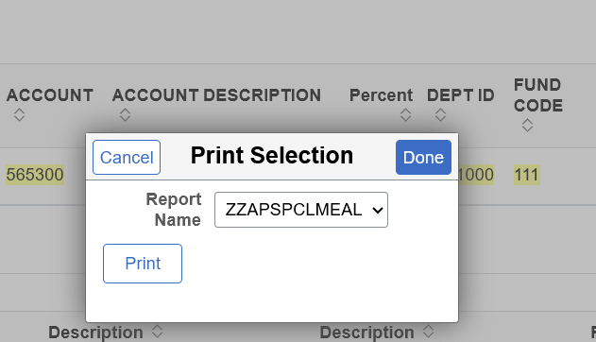

Example of fully approved form.
This form, along with the list of attendees, must be printed and included with LaCarte or Direct Pay documentation.
