How to add an arranger to your travel profile in Christopherson Business Travel’s online booking tool- Airportal
**the traveler must add the arranger to their own profile.
** the arranger must have an established profile in Airportal.
Use the following link to create your travel profile:
CREATE A TRAVEL PROFILE: https://legacy.cbtravel.com/business/profile/stateofla/
*if your profile is already established, proceed to the next step below.

Once your profile is created, use this link to access it and add your travel arranger:
CHRISTOPHERSON BUSINESS TRAVEL LOGIN (AIRPORTAL): https://app.cbtat.com

Click on the icon in the upper right-hand corner and select “SETTINGS” from the dropdown menu. You will be redirected to CBT’s SAP-Concur site.

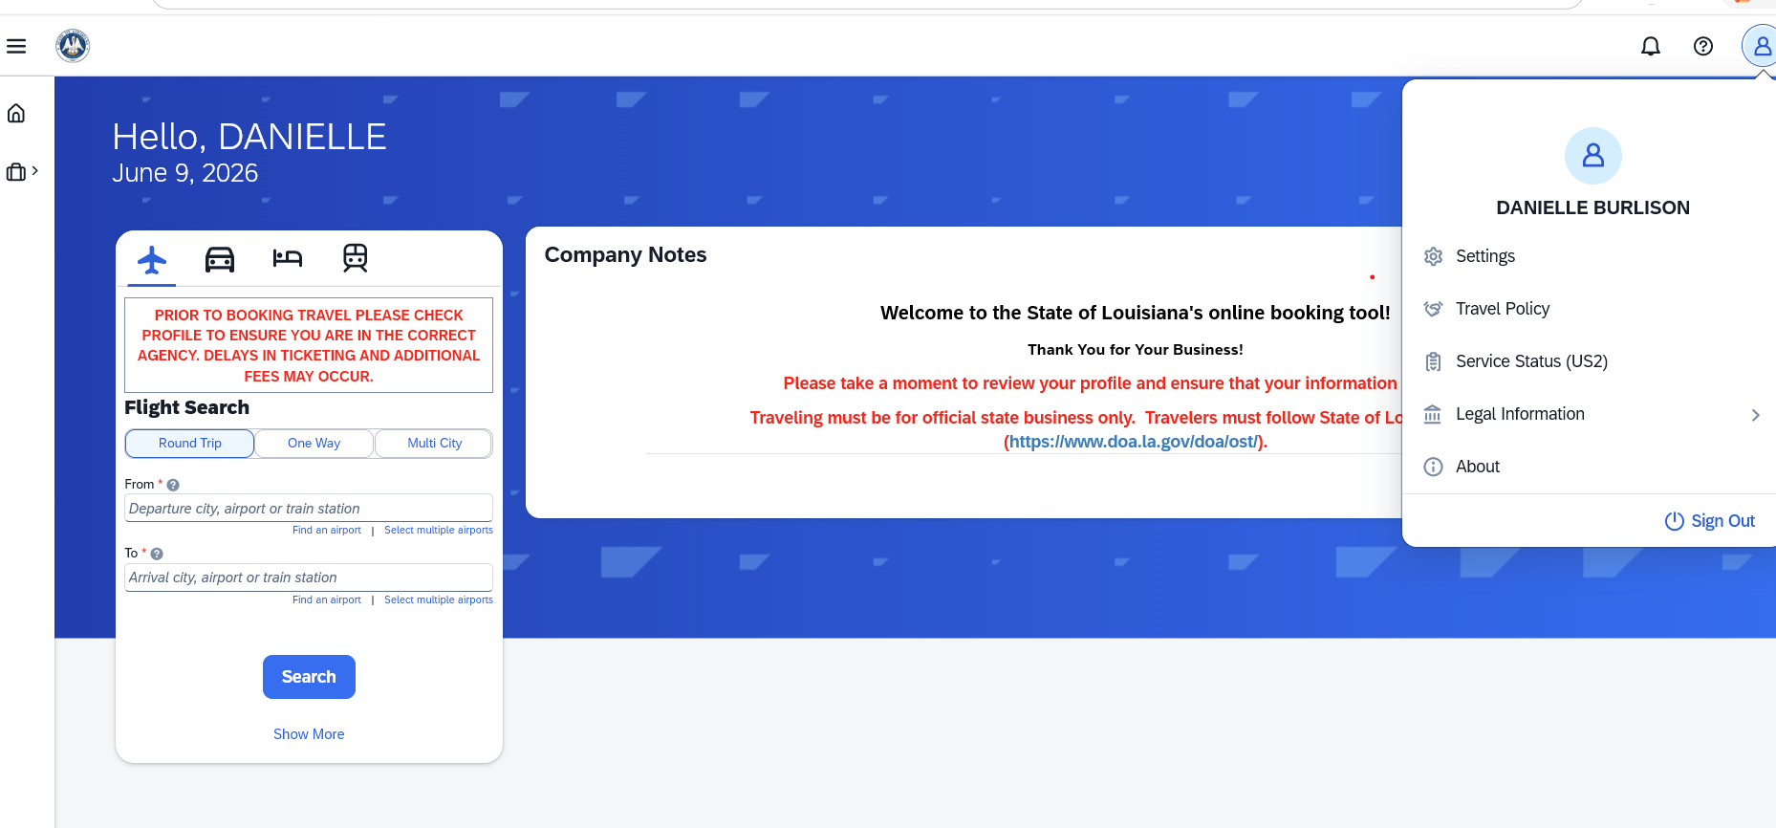

Select “SETUP TRAVEL ASSISTANTS”
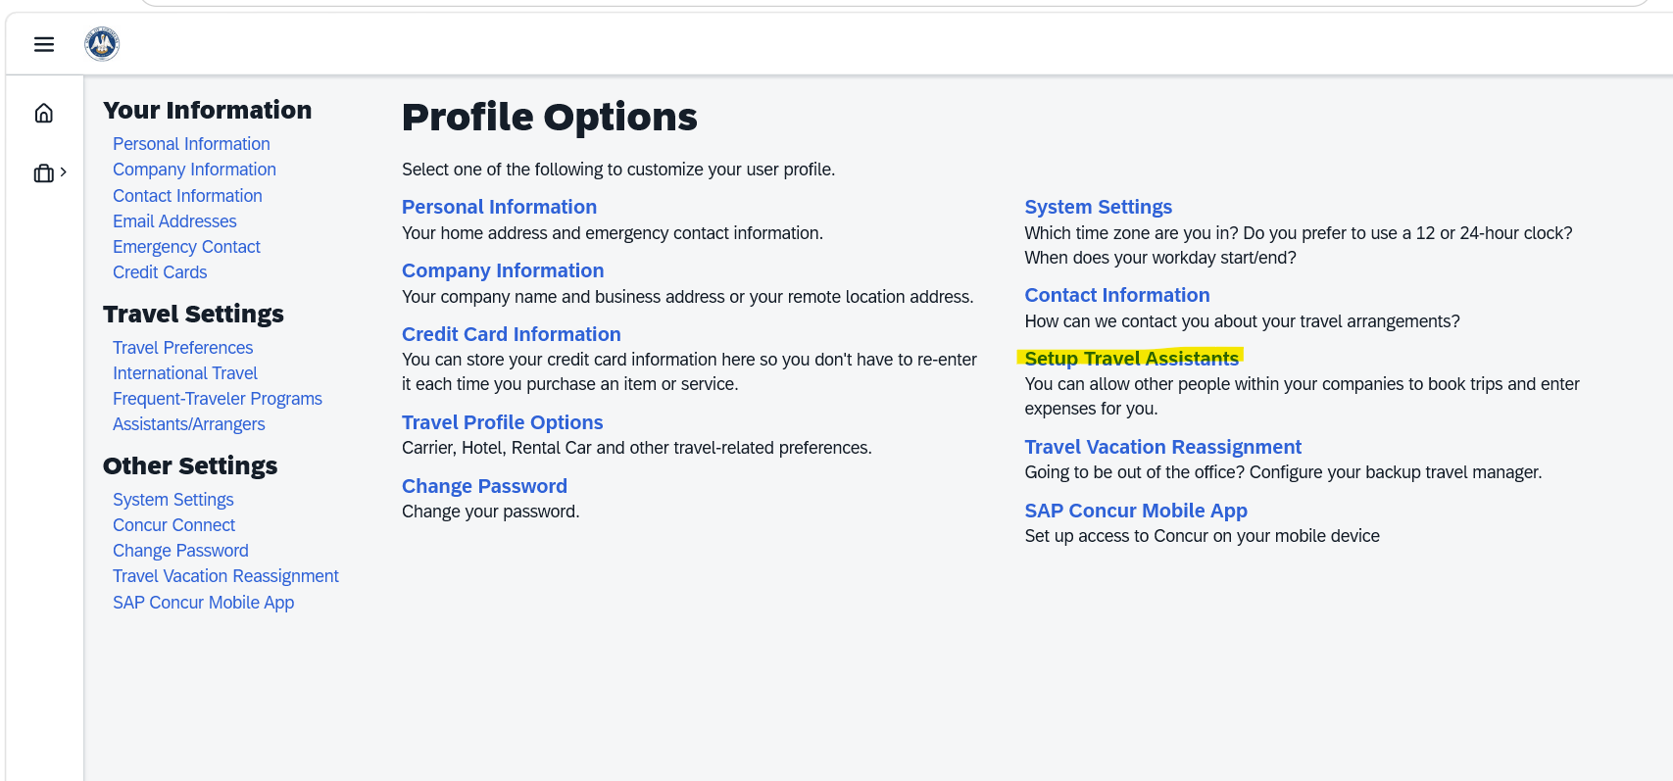

Select “ASSISTANTS” in the “jump to” data field and press “choose”

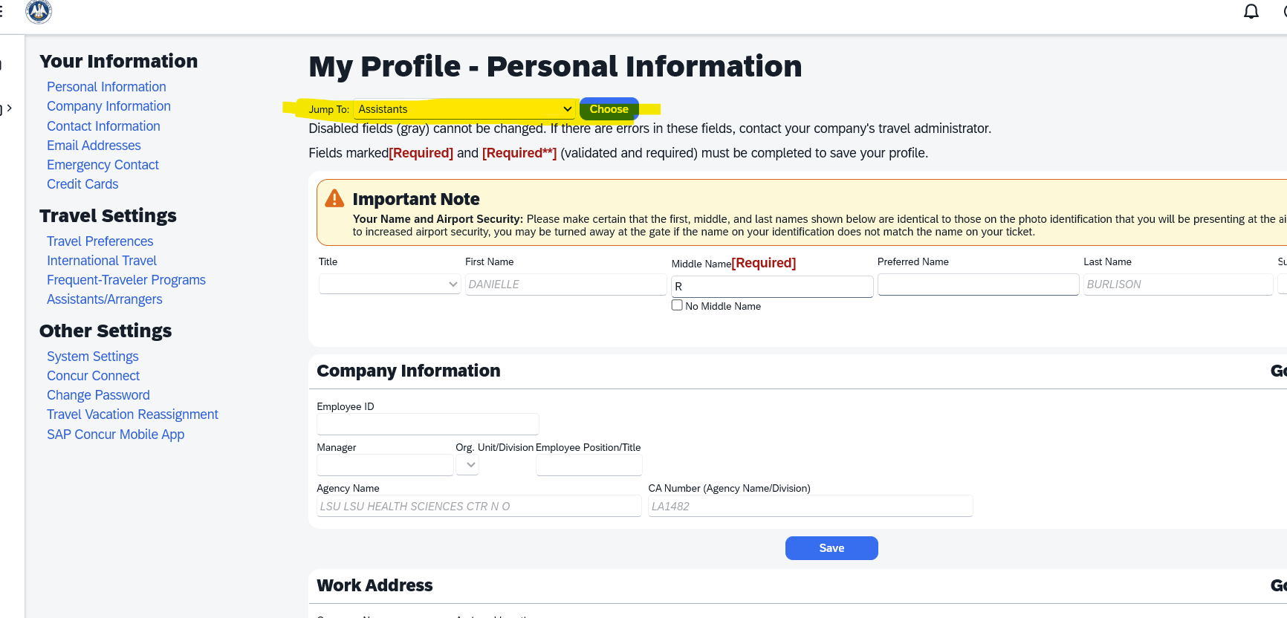

Select “ADD AN ASSISTANT” and search for travel arranger.
Click SAVE

