How to add an arranger to your travel profile in Christopherson Business Travel’s online booking tool- Airportal
**the traveler must add the arranger to their own profile.
** the arranger must have an established profile in Airportal.

Use the following link to create your travel profile:
CREATE A TRAVEL PROFILE: https://legacy.cbtravel.com/business/profile/stateofla/
*if your profile is already established, proceed to the next step below.

Once your profile is created, use this link to access it and add your travel arranger:
CHRISTOPHERSON BUSINESS TRAVEL LOGIN (AIRPORTAL): https://app.cbtat.com/

Click on your name in the upper right hand corner and select view travel profile from the dropdown menu. You will be redirected to CBT’s SAP-Concur site.
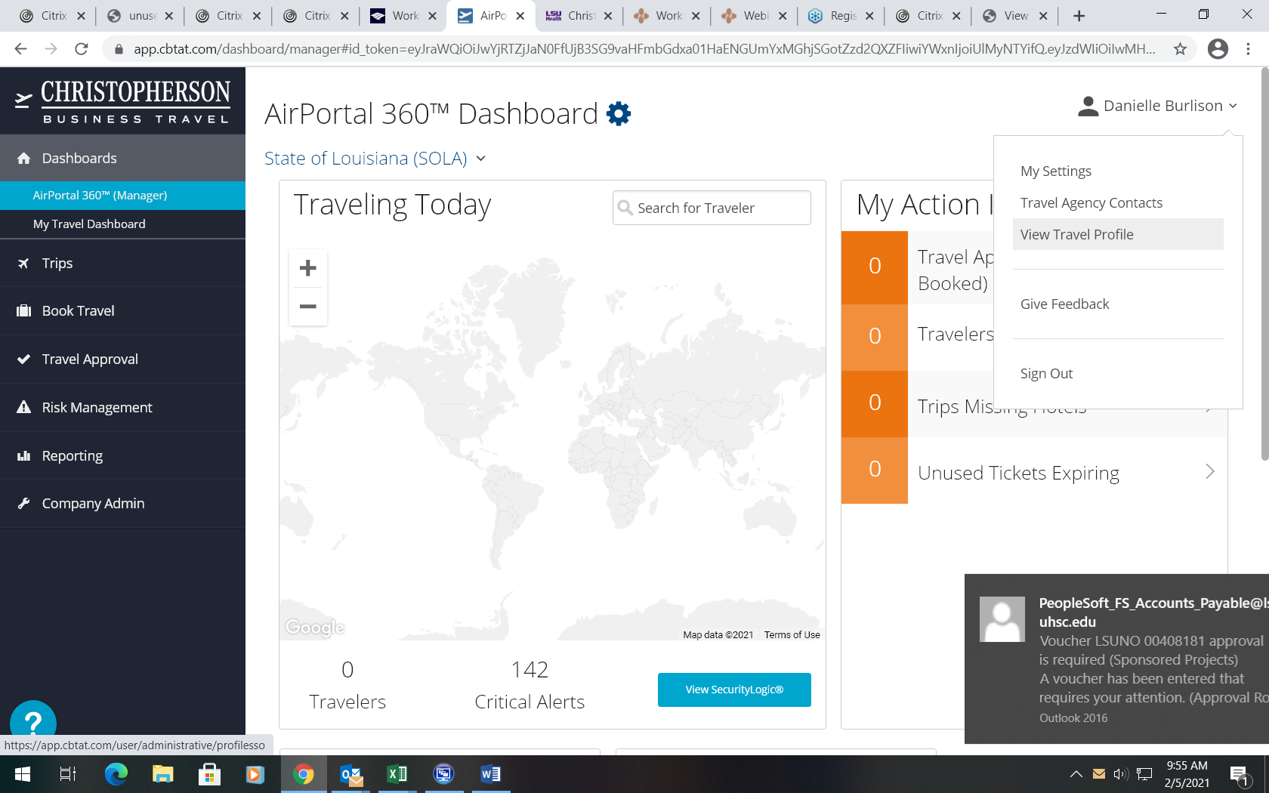

On the left side menu under “Travel Settings”, select view travel Assistants/Arrangers
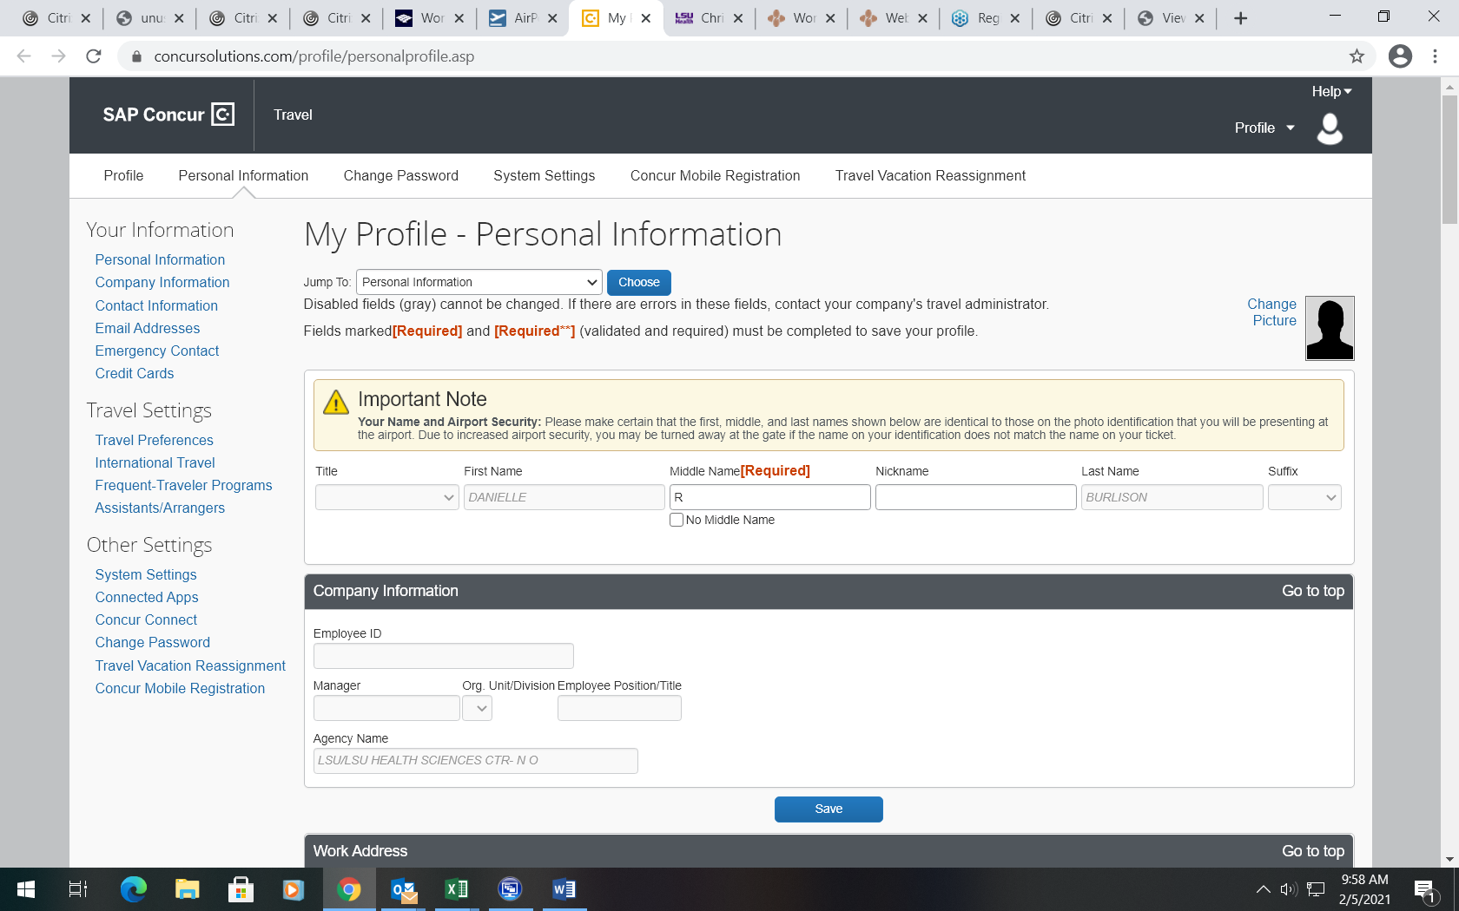

Next, click add an assistant.

Search for arranger’s name in search box. Reminder- they must have a profile setup.
Click Save.
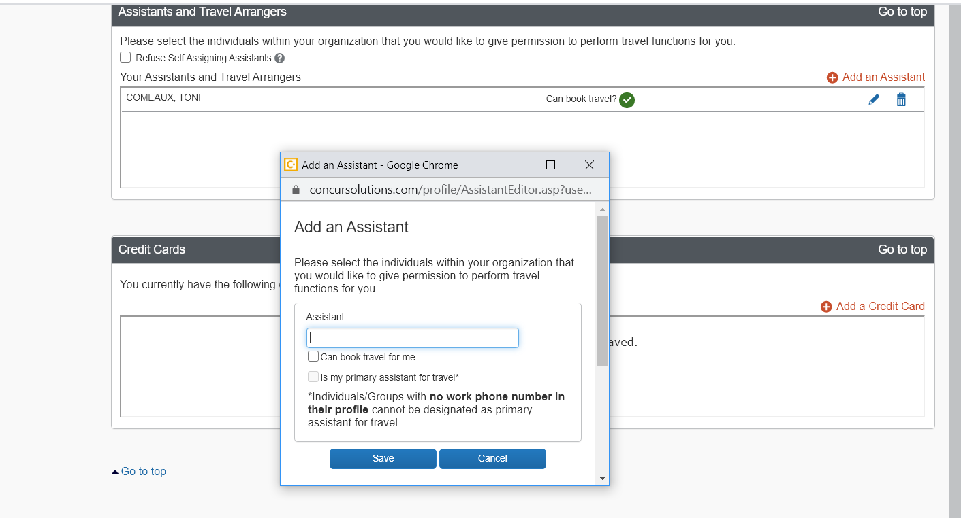
If your arranger’s name does not appear in the search box, please clear your cache and cookies by clicking the keys [Ctrl], [Shift] and [del] on your Keyboard.

