How can I look up an invoice or payments?
Go to PeopleSoft Financials Production>Main Menu>Accounts Payable>Review Accounts Payable Info>Vouchers>Voucher
Select the New Orleans Business Unit (BU) you’re looking for in the “From Business Unit” data field
LSUNO – BU for AP related PO vouchers/payments
LSUNE- BU for Travel and Direct Pay vouchers/payments
LSUNA- BU for Auxiliaries related vouchers/payments
****make sure the business unit is populated in both the from and to data fields
****make sure the “Supplier SetID” data field is blank
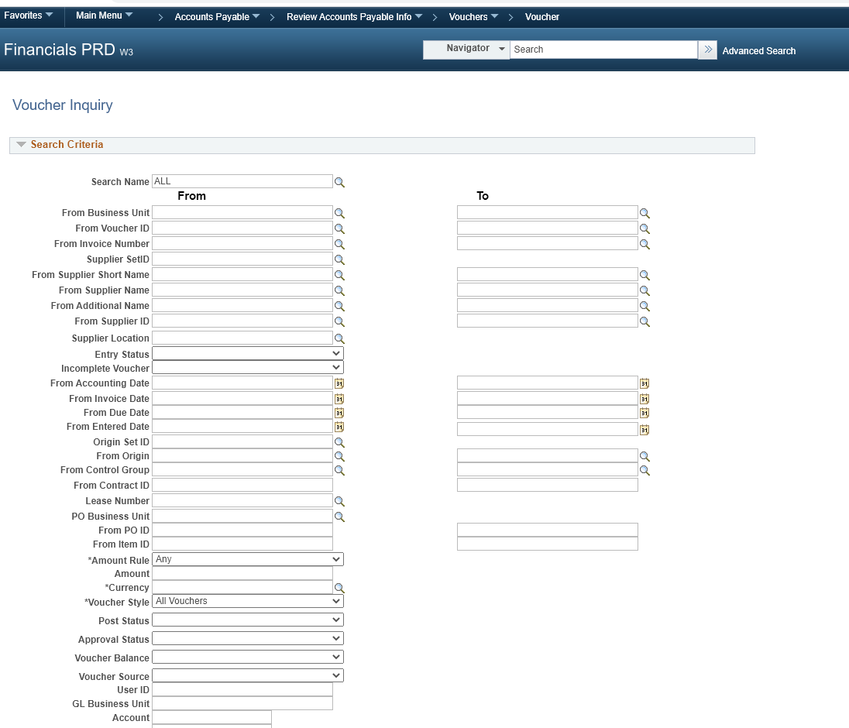

Enter the invoice number in the “From invoice Number” data field and click Search
****reminder- make sure the correct business unit is populated in the from/to business unit data field and the Supplier setid data field is blank.
Direct Pay Invoice numbers start with DPxxxxxxx
Travel Invoice numbers start with TVxxxxxxx
PO related invoices- invoice number provided by the vendor
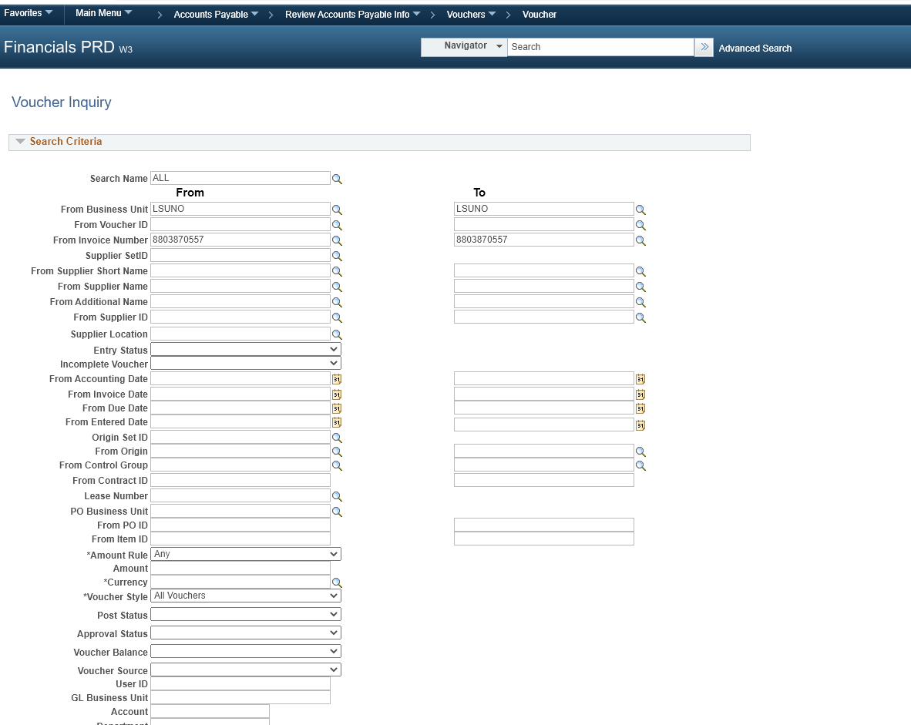

Click Search.
Click on the tabs to reveal more information regarding the payment or
Click the Actions hyperlink and choose from the dropdown menu to:
- View attachments- scanned invoices
- Review accounting entries
- Matching
- Payment information (payment reference number; for copies of checks, please contact General Accounting. For copies of EFT settlements, please contact AP)
- Voucher details
- Review document status

Voucher details page

