How do I find payments made against a PO?
Go to PeopleSoft Financials Production>Main Menu>Accounts Payable>Review Accounts Payable Info>Vouchers>Voucher
Select the New Orleans Business Unit (BU) you’re looking for in the “From Business Unit” data field
LSUNO – BU for AP related PO vouchers/payments
Enter the PO number in the “From PO ID” data field
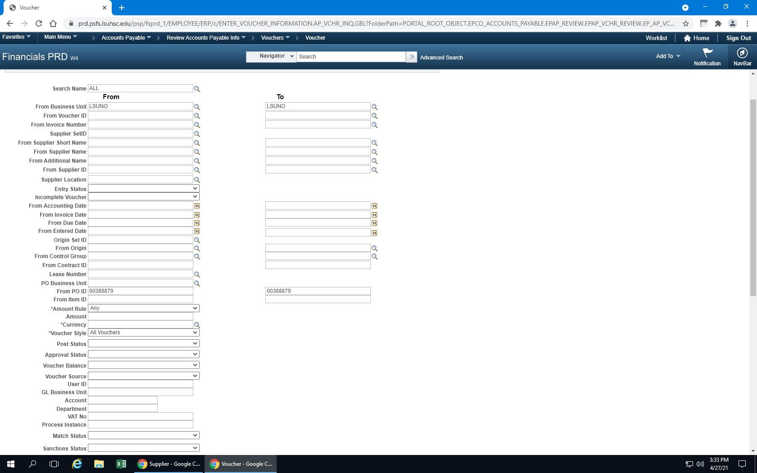

Click Search
Click on the tabs to reveal more information regarding the payment or
Click the Actions hyperlink and choose from the dropdown menu to:
- View attachments- scanned invoices
- Review accounting entries
- Matching
- Payment information (payment reference number; for copies of checks, please contact General Accounting. For copies of EFT settlements, please contact AP)
- Voucher details
- Review document status

