Transaction Log Navigation in WORKS
This guide provides navigational instructions on how to print out your transaction log.
Click on Reports
Click on Template Library
Under Shared (header section), select “By Signing I attest all items received by LSUHSC” (description- LSUHSC Transaction Log)
Click Run/Modify
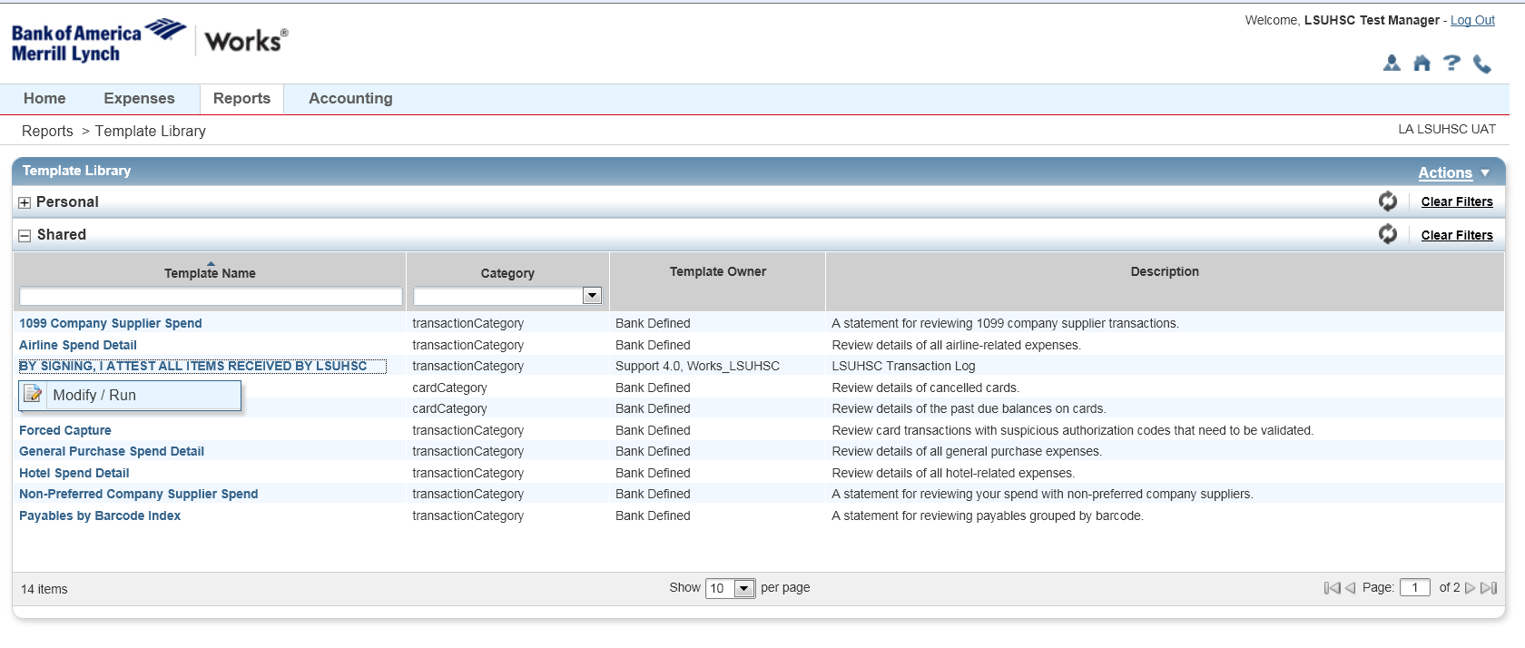
The report is already built for you. If you are a Business Manager or other approver with access to all cardholders within your department, enter the last name of the cardholder’s log you’d like to print. Regular cardholders only have access to their own log and can skip this step.
Review post dates to make sure your printing off the correct log.
Click submit report

