LSU Health Sciences Center in New Orleans
Retroactive Changes in Source of Funds Training
July 1st, 2008

What is a Retroactive Change in Source of Funds?

- It is a redistribution of the classification of previously paid salary costs

- It is generally necessary when the actual effort expended by a faculty member is different from the planned effort

- It does not allow for the same salary costs to be charged to two different places at the same time

- The process creates a journal entry but it is not a journal entry in and of itself

How is a retro processed?

- Salary data is extracted for a date range for an employee
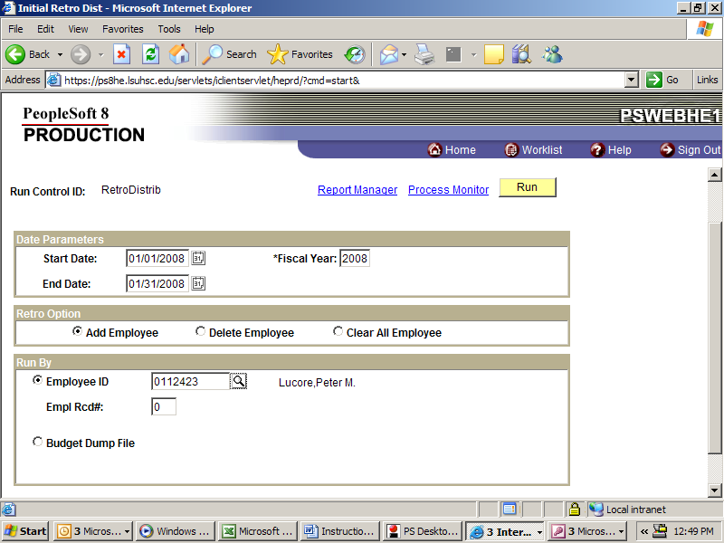

- Records from the current distribution are selected for redistribution and the new distribution is input into the new distribution section. The total old amount and the total new distribution must equal each other.

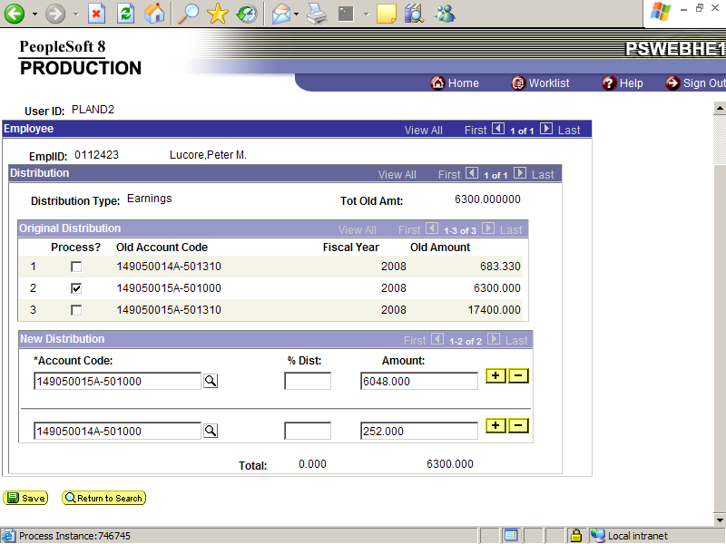

- Once a retroactive change in source of funds is finalized in the HR system, it is interfaced to the General Ledger. As part of the interface process, a journal entry is created.

Instructions for Retroactive Changes in Source of Funds

- Check box 10 on the Personnel Status Change Form (PER-3)

- Enter the Beginning and Ending Dates of the applicable pay periods in the Effective and Funds End Date fields under section 12.

- Enter the applicable Chartfields for the Present Amount(s) and the Proposed Amount(s). Only the Chartfields for the Present Amount(s) and the Proposed Amount(s) that are being changed are required. The listing of additional Chartfields is optional.

- The Present Amount column should represent the exact amount that was charged to the applicable Chartfields for the period indicated in Section 12. There is a query in the PeopleSoft HR Reports database named LSU_EMP_SAL_DIST_BY_PERIOD that will provide users with the current distribution for an employee for a given fiscal year by Check Date.

- The Project/Grant Column should include the Speedtype for Fund 111 chartstrings to ensure timely processing.

- The Proposed Amount column must clearly indicate the distribution amount that is expected and it must equal the total of the Present Amount column.

- Separate PER-3s must be prepared for each account. A PER-3 for account # 501000 (Salary-Monthly-Regular Pay) cannot be included on a PER-3 for account # 501310 (Salary-Mon-Extra Com-Prof Care).

- Once complete and approved, all PER-3s for retroactive changes in source of funds must be routed to Susan Arnold.

Questions Provided in Advance

- Are retroactive and prospective changes in source of funds permitted on the same form for base pay?

No.

- Why not?

The first reason is accuracy in processing. The number one cause of retroactive changes in source of funds being processed in a manner inconsistent with the intent of the preparer is the present amount in the HR system being different than the amount intended to be redistributed. This clarification also improves the processing time of retroactive changes in source of funds and reduces the number resubmissions.

The second reason is a proper audit trail. The Legislative Auditors require the University to have documentation that supports a transaction in a manner such that an experienced auditor could review the documentation and draw the same conclusions as the preparer, the approver and the processor.

- The policy states that it is for retroactive changes, are annualized amounts to be continued for changes that are intended to be strictly prospective?

Human Resources only uses the percent of effort from the PER-3s for base salaries so annualized amounts would be acceptable.

- What happens to forms that are submitted near a payroll and don’t get to Accounting Services in time, thus making them retrospective and prospective. Will they be returned or processed?

Emails seeking clarification will be sent to the initiator of any retroactive change in source of funds that does not agree to the present amounts in the PeopleSoft HR system.

- Is the rate of pay computation in section 12 used to process a retroactive change in source of funds?

No. These instructions are designed to work within the existing multipurpose form as much as possible and do not address computations that are not relevant to the retro process.
Common Retroactive Change in Source of Funds Issues

- Inconsistencies between Projects and chartfields listed in the Present Amount column and the payroll system

- Invalid Project numbers (transpositions, extra and missing characters)

- Inaccurate dates (end dates before the effective date, effective dates earlier than project start dates)

Common PER-3 issues encountered by Payroll

- Multiple pay groups included on a single PER-3

- Inconsistencies between the pay group and the effective and end dates on the PER-3 – Very common when residents become faculty members

- Attachments to PER-3s that do not equal the PER-3 totals

- Mathematic accuracy of attachments

Common PER-3 issues encountered by Human Resources

- Inaccurate or incomplete employee and position information

- Percentage distribution does not equal 100%

- Present amount and present distribution are not consistent with the HR system.

