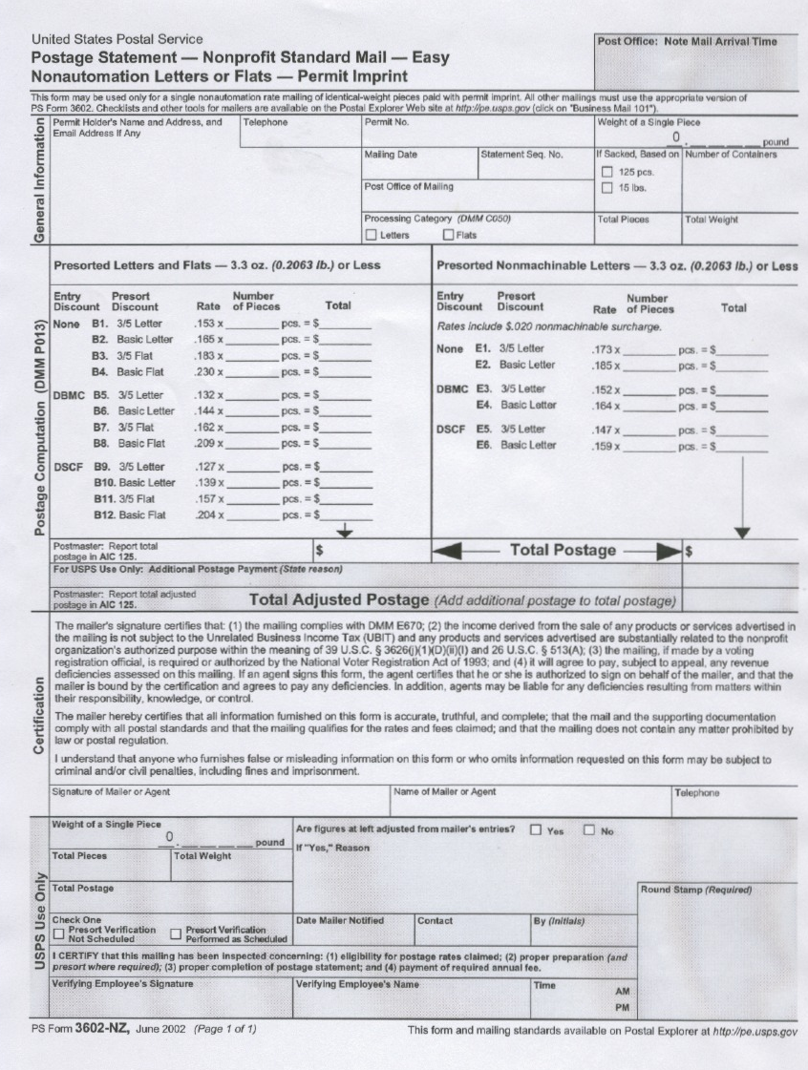
1
2

3
4
5
6
7
8

9

10
111
- ENTER: LSU Health science center, 433 Bolivar Street, New Orleans, La.
- Enter Your Department Number.
- Enter Non-Profit Permit Number 2175.
- Enter Date Mailed.
- Enter Total Number of mail trays by size of tray. (E.G. 4 - 1 ft. trays, 6 - 2ft. trays).
- When you have more than 150 (3) three digit Zip Codes, use this rate to calculate your postage cost.
Enter number of pieces Under the Pieces Column. Enter Total Postage in Total column. (To calculate postage multiply pieces by the rate indicated on the form and enter the amount in the total column).
- When you have less than 150 items of 3 digit Zip Codes (E.G.704-705-395 etc.), use this rate to calculate your postage cost. Enter number of pieces Under the Pieces Column. Enter Total Postage in Total column. (To calculate postage multiply pieces by the rate indicated on the form and enter the amount in the total column).
- When you have 150 or more items for Zip Codes 700 or 701 each, use this rate to calculate your postage cost. Enter number of pieces Under the Pieces Column. Enter Total Postage in Total column. (To calculate postage multiply pieces by the rate indicated on the form and enter the amount in the total column).
- When you have less than 150 items for Zip Codes 700 or 701 each, use this rate to calculate your postage cost. Enter number of pieces Under the Pieces Column. Enter Total Postage in Total column. (To calculate postage multiply pieces by the rate indicated on the form and enter the amount in the total column).
- Signature of Approved Departmental Signature.
11. Departmental Contact’s Telephone Number.

