LSUHSC nVision Reports Catalog

Business Unit: HPLMC
Report Description: Revenue & Expenditures - Dept
2-tier Layout: Sch of Rev and Exp with Prompt.xnv
Web Layout: W Sch of Rev and Exp with Prompt.xnv
Report Request: RVEXDEPT
Web Report Request: WRVEXDPT
Dashboard Page/Button: HPL_FIN/Dept w/Prompt
Report As of Date: Default from Business Unit or Specify last day of month

The report produces a Statement of Activities by department for HPLMC. The report columns begin with the Fiscal Year Budget column. This column specifies the query HCSD_DEPT_BUDGET_PROMPT, the timespan YTD, and Posted Total Amount with the sign reversed. The query is written on the ORG_BD ledger from the LEDGER_KK table. The criteria require that the account be less than 700000 and prompts on the department id. The next column, Fiscal Year Actual, utilizes the criteria of HCSD_DEPT_PROMPT query, Posted Total Amount, and the YTD timespan nploded. This query, from the LEDGER table, requires the ACTUALS ledger and prompts on department id. The next labeled column is called Encumbrances and specifies the query HCSD_DEPT_PROMPT_ENC, the Posted Total Amount, and YTD timespan. The query is written on the LEDGER_KK table and specifies that the ledger is DETAIL_ENC. The query also prompts on department id. The rows of the report display Revenues and Expenditures. Within each grouping are rows defined for the sub-groupings of accounts. These rows nplode to the detail accounts that belong to that account group as defined in the ACCTROLLUP tree. The final row of the report is an Income (Loss) row. At run-time, the prompt will appear three times. The web based report utilizes the queries called WHCSD_DEPT_BUDGET_PROMPT, WHCSD_DEPT_PROMPT, and WHCSD_DEPT_PROMPT_ENC. These queries incorporate the use of the ZZNVISIONPROMPT table that replaces the prompt criteria from the original queries. This enables web based prompting.
Report Example:
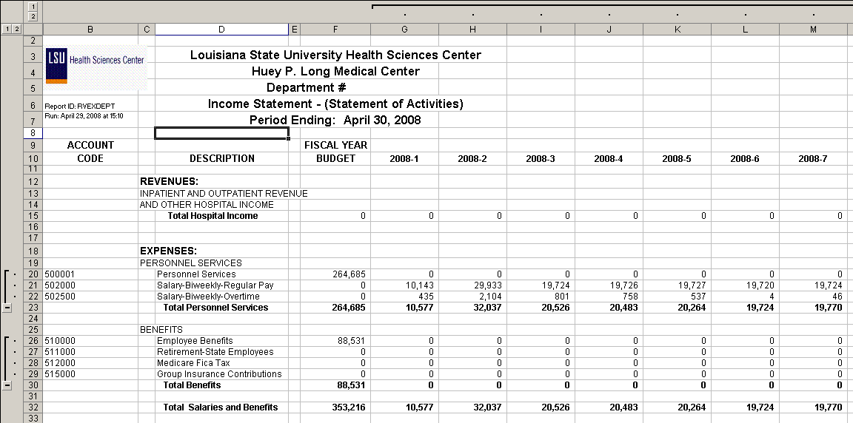

Query Fields HCSD_DEPT_BUDGET_PROMPT
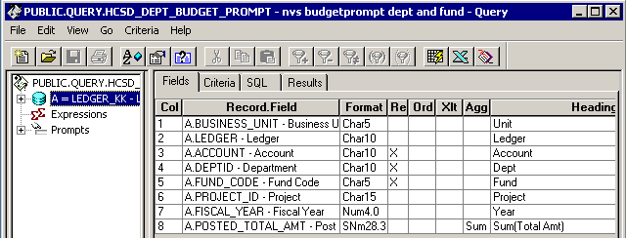
Query Criteria
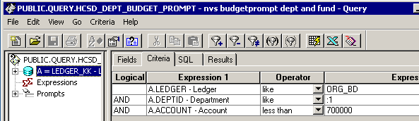
Query Fields HCSD_DEPT_PROMPT
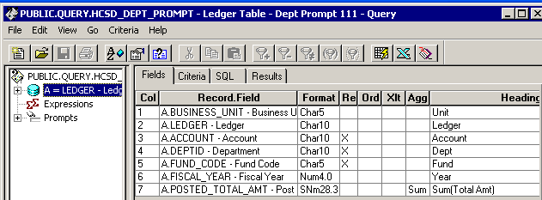
Query Criteria
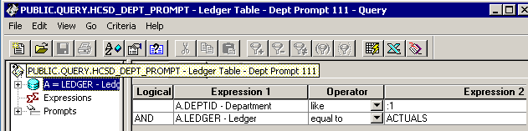

Query Fields HCSD_DEPT_PROMPT_ENC
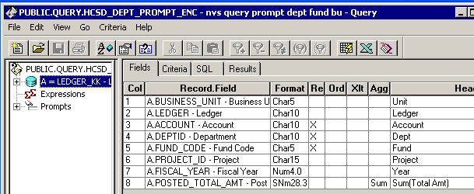
Query Criteria
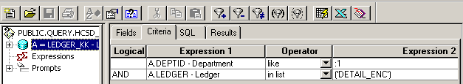

Web Based Query Criteria WHCSD_DEPT_BUDGET_PROMPT
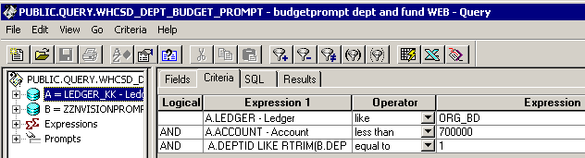

Web Based Query Criteria WHCSD_DEPT_PROMPT
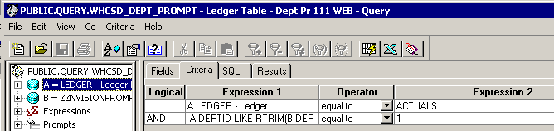

Web Based Query Criteria WHCSD_DEPT_PROMPT_ENC
