LSUHSC nVision Reports Catalog

Business Unit: LJCMC
Report Description: Department Comparison
Layout: DeptList by BU 111 Comparison_new.xnv
Report Request: DEPTCOMP
Dashboard Page/Button: N/A
nVision Scope: N/A
Report As of Date: AS of Date from Business Unit table

This report provides total expenditures report by department for the LJCMC Business Unit. This report allows the analyst to compare the values based on departments in the LJCMC node of the DEPTS_HCSD tree to values in departments based on the ALL_DEPARTMENTS node in the DEPTROLLUP tree through a scope on the report request. The entire spreadsheet specifies the ACTUALS ledger and year to date timespan. The first report column will display the label information for the department number. The second column provides the department name. The third report column includes the Posted Total Amount value, year to date from the DEPT_COMP_NVS query. The query details the requested business unit, fund 111, and expenditure accounts. The fourth report column specifies the UNRESTRICTED fund from the FUNDROLLUP tree and the EXPENDITURES account node from the ACCTROLLUP tree. The final report column calculates any difference between the values reported from the two previous columns. The row of the report is defined to nplode to the department detail based on the node called ALL_DEPARTMENTS in the DEPTROLLUP tree. If there is a difference in the results, the report layout provides instructions for next steps.
Report Example:
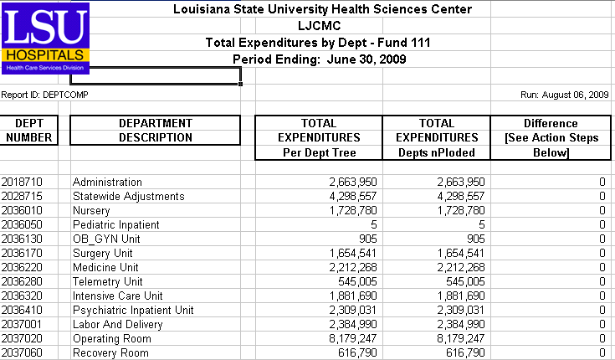

Query: DEPTCOMP_FOR_NVS
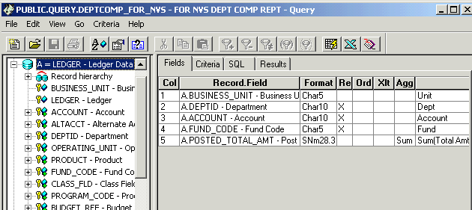

Criteria
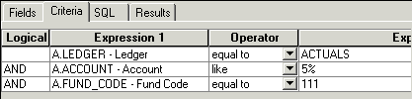

Rev8/2009

