LSUHSC nVision Reports Catalog

Business Unit: LJCMC
Report Description: Dept Actuals and Accruals by Dept 115
2-tier Layout: Dept Actuals & Accruals – By Dept – Fund 115.xnv
Web Layout: W Actuals & Accruals – By Dept – Fund 115.xnv
Report Request: DPTAA115
Web Report Request: WDPAA115
Dashboard Page/Button: LJC_ACC\ Fund 115/815
nVision Scope: N/A
Report As of Date: Default from Business Unit

This report provides revenue and expenditures both Actuals and Accruals by Department. The report contains 4 columns for data. The Budget column is based on the query HCSD_DEPT_BUDGET_PROMPT_115. The query is written on the LEDGER_KK table and uses the Business Unit, Account, Fund, Department, Class, Program and Project id chartfields and Posted Total Amount as fields that could potentially be used in the report. The query specifies the ORG_BD ledger, fund code 115, and Account less than 700000. The query prompts on the department id. The next column, YTD Actual is written on the HCSD_DEPT_PROMPT_115 query. The query also is written on the LEDGER_KK table and utilizes the same fields. The criteria specify the Ledger of ACTUALS, fund code 115 and prompts on the department id. The report displays the Posted Total Amount in the column. The Year to Date Accrual column utilizes the query HCSD_DEPT_PROMPT_815 query and displays the Posted Total Amount. The query is written on the LEDGER table and specifies criteria of fund 115, Ledger of HCSD_ACCRU and prompts on the department id. The next column displays a Fiscal Year total that is calculated by adding the Actual column value to the accrual column value. The final column is called Balance and is calculated by subtracting the year to date total column values from the budget column values. The rows of this layout are divided into two main categories, Revenues and Expenses. Within each section, there are defined rows for each type of revenue or expense. The revenues section contains a row for Patient Revenue and Other Hospital income. This row is nploded on the Account node REVENUES from the ACCTROLLUP tree. Within the Expenses section, there are defined rows for Personnel Expenses, Benefits, Travel, Operating Services, Supplies, Professional Services, Other Charges, Capital Outlay, Major Repairs and Debt Services. Each of these rows is nploded to the account detail. At the bottom of the report is a calculated Income or Loss.

For the web based nVision report, the queries utilized are called WHCSD_DEPT_BUDGET_PROMPT_115, WHCSD_DEPT_PROMPT_115, and WHCSD_DEPT_PROMPT_815. Each includes the additional table of ZZNVISIONPROMPT that is joined to the original tables to enable the web prompting. The prompt criteria in each query are replaced by expressions for web prompting.
Report Example:
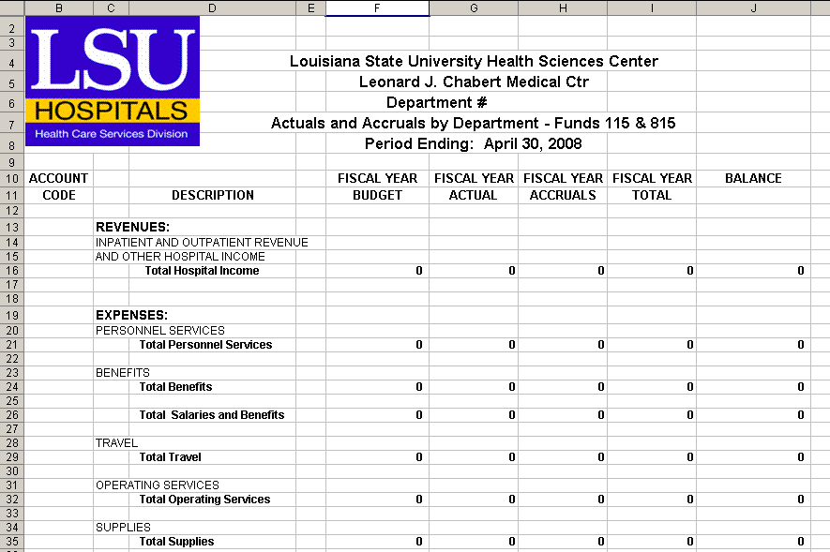

Query Fields HCSD_DEPT_BUDGET_PROMPT_115:
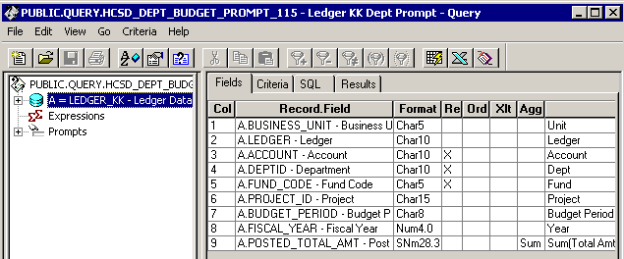

Criteria:
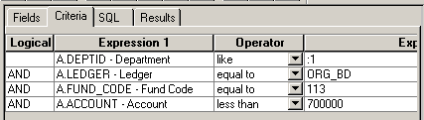
Query Fields HCSD_DEPT_PROMPT_115:
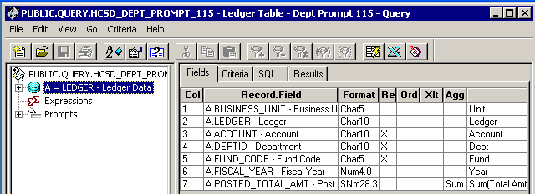
Criteria:
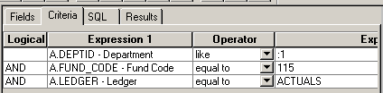

Query Fields HCSD_DEPT_PROMPT_815:
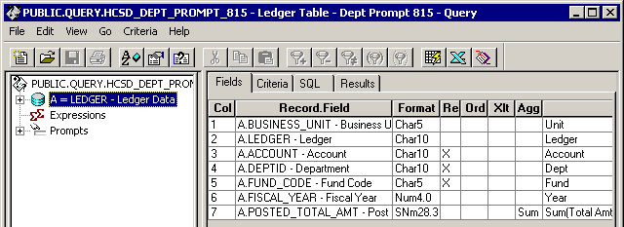
Criteria:
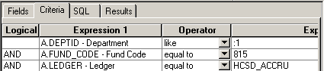

Modified Query Criteria WHCSD_DEPT_BUDGET_PROMPT_115:
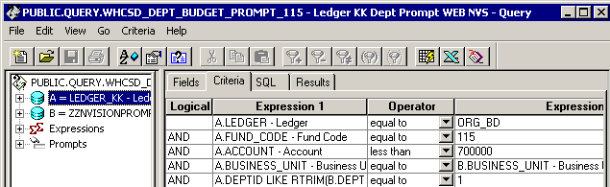

Modified Query Criteria WHCSD_DEPT_PROMPT_115:
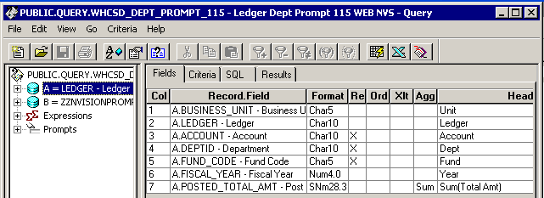

Modified Query Criteria WHCSD_DEPT_PROMPT_815:
