LSUHSC nVision Reports Catalog

Business Unit: LJCMC
Report Description: Inventory Valuation Report
2-tier Layout: INV Value.xnv
Web Layout: INV Value.xnv
Report Request: INVVALUE
Web Report Request: WINVALUE
Dashboard Page/Button: LJC_FIN/Valuation
Report As of Date: Default from Business Unit or Specify last day of month

The report produces an Inventory Valuation by item id by inventory business unit. The information in the report is based on the query INV_VALUE_REPORT. The columns are labeled for the item specifics: Item id, Description, Item Group, Area, Level 1, Level 2, Level 3, Level 4, Standard Unit of Measure, Unit of Measure, Conversion Rate, Quantity, Base Quantity, Average Cost, Total Cost, and Item Status. The rows of the report are each item id that belongs to the prompted business unit and setid.

The web based report uses the query called WINV_VALUE_REPORT. This query joins in the ZZNVISIONPROMPT table and replaces the individual prompt criteria with expressions to enable prompting on the web.

Report Example:
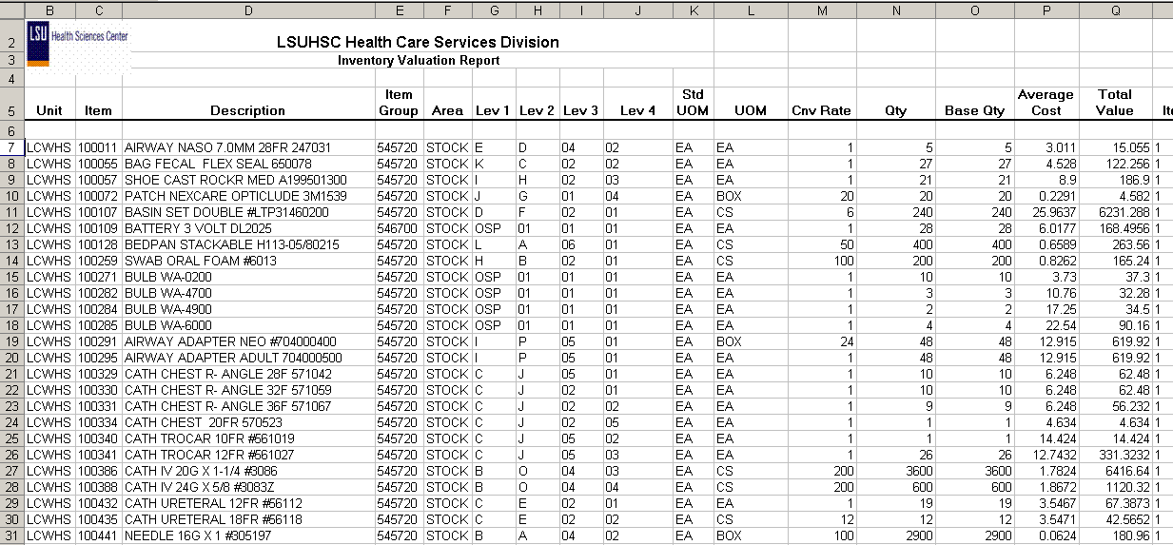
Query Fields
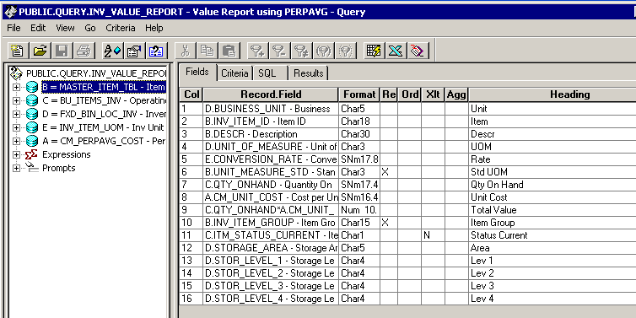
Query Criteria
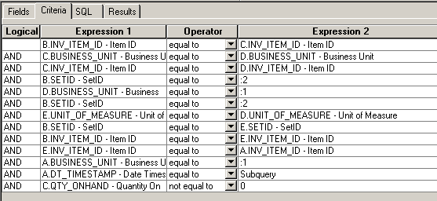

Modified Criteria WINV_VALUE_REPORT
