LSUHSC - PeopleSoft nVision v8.8
nVision Documentation Addendum – Common Problems, Kill Process and Workaround Navigation
This addendum document shall accompany all handouts to PeopleSoft nVision dashboard users post upgrade from v7.5 to v8.8.
The LSU dashboard using PeopleSoft nVision is experiencing intermittent problems on several reports. These reports are not processing correctly when using the dashboard pushbutton but do run successfully when processing from the menu. Whenever the problem occurs, users should kill the process through the new Kill nVision and Excel process. Then, the user should utilize the nVision Reports Request menu access to run the reports instead whenever a problem is experienced. The problems may occur on any report but the following are the most common reports that experience problems.

Most Common nVision Dashboard Reports that are experiencing Intermittent Problems
Dashboard Page | Pushbutton | Layout | Report Request
EKL_FIN | Project Inc Stmt - ROA Specific | Project Year to Date by Month5 | PROJ_ROA
HQ_FIN | Project Inc Stmt - ROA Specific | Project Year to Date by Month5 | PROJ_ROA
UMC_FIN | Project Inc Stmt - ROA Specific | Project Year to Date by Month5 | PROJ_ROA
WOM_FIN | Project Inc Stmt - ROA Specific | Project Year to Date by Month5 | PROJ_ROA
LSUNO | FY Jrnl | AM091 | AMO91
 | AP Detail | AP Detail | APDET
 | Previous FY | AJ Previous Fiscal | AJ_PREV
LSUNO MGMT | Allied Health - By Dept | FGS ALLIED BY DEPT | ALLIED2
 | Dental by Dept | FGS DENTAL BY DEPT | DENTAL2
 | Med Sch by Dept | FGS MED BY DEPT | MED2
LSU Year End 1 | Analysis-C2A Version One | LSUNO - Analysis C-2A Version One w PH | FYEFS11
 | Analysis-C2A Version Two | LSUNO - Analysis C-2A Version Two w PH | FYEFS_10
 | Analysis C2B Version One | LSUNO - C-2B Version One w PH | FYEFS_7
LSUSH | Fiscal Year Report - All Years with Actual Ledger | LSUSH - All Fiscal Years | ALLFISC
 | FY Jrnl | AM091 LSUSH | SHR_JRNL
 | AP Detail | LSUHSC-S AP Detail | APDETAIL
 | Inv Detail Transactions | LSUSH - Inventory Transactions by Dept | INVDEPT
Annual II | Medicare-Medicaid Cost Report | LSUSH - Medicare - Medicaid Cost Report FY….. | MEDCST

Example of Noted Problem
“Microsoft Excel is waiting for another application to complete an OLE action”
This message occurs on a few of the reports and is related to processing timing on some of the reports containing prompts. You may continue to try to process the report upon receipt of this message by pressing ok each time the message appears. In some instances, the reports will complete their processing and produce results. If this does not happen and the session becomes hung, the user must run the new “Kill nVision and Excel Process” to close the session. Once the user runs the process then the user must launch nVision once more and run the report from the menu.
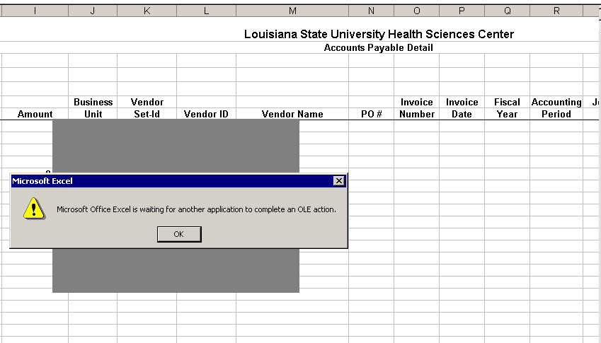
Kill all Excel and nVision Process
The user is able to kill the nVision process through the Start menu within PSDesktop. By utilizing this process, the user will kill the hung up nVision session and any open Excel files. Upon receipt of the “Microsoft Excel is waiting for another application to complete and OLE action”, the user should select:
Start> All Programs>Kill all Excel and nVision
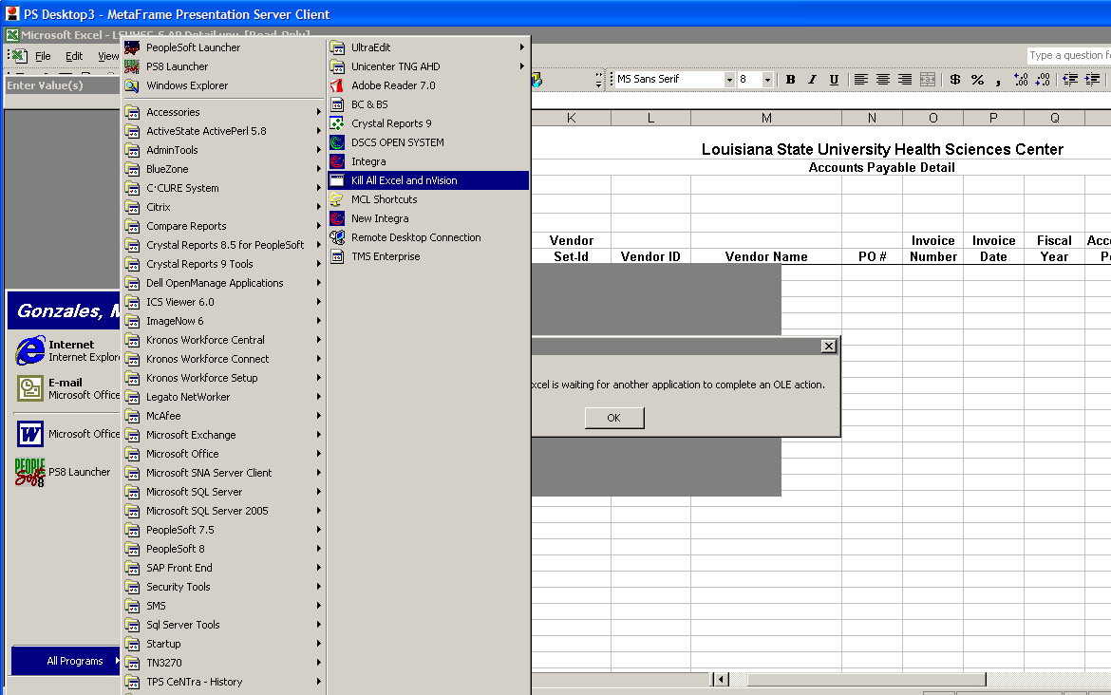
A small black box appears briefly while the process runs. Then, upon completion of the kill process, the nVision and Excel programs are closed and the user is returned to the PSDesktop screen.
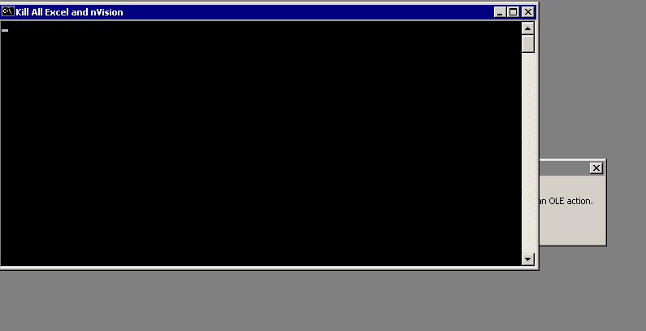
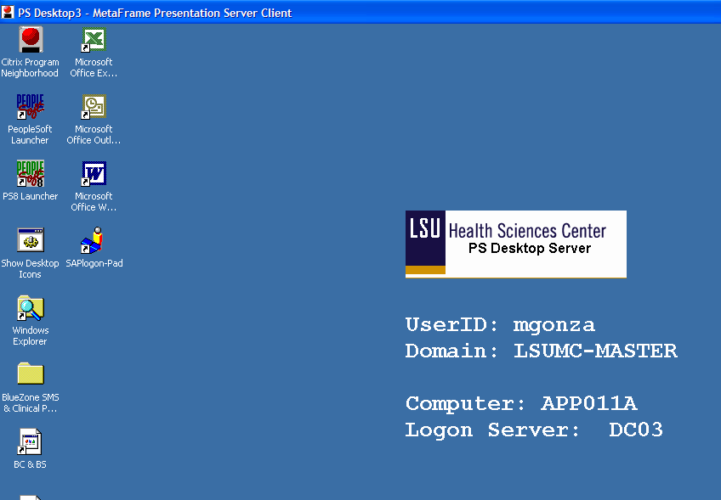

Workaround - Accessing nVision, and running a report from the Menu Navigation steps using the AP Detail Report as the example
The following pages display the steps to log on to PeopleSoft nVision and the navigation steps that users may utilize to run the reports from the menu within nVision.

Logon to PSDesktop via Citrix
- Note: PeopleSoft 8.8 must be accessed from Citrix (as did PeopleSoft 7.5).

Logon to PeopleSoft nVision Reporting via the PS8 Launcher.
- Double-click the PS8 Launcher icon on the PSDesktop.
- For PeopleSoft System, Select Financials
- For Database, Select PS8 Financials Report (PS8FSRPT)
- For Application, Select PS/nVision
- Click Start.

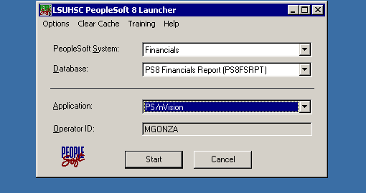
Single Signon authenticates the userid and password and then Excel opens and the NVSUSER (Dashboard) menu appears.

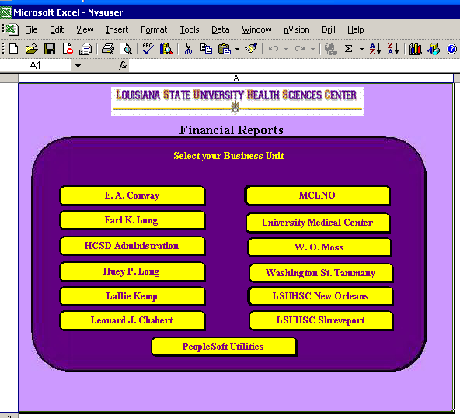
To open and run a report request:
From the menu, select nVision, Report Request
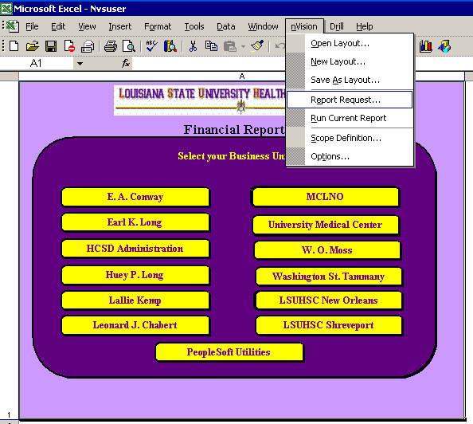
The example will use the EACMC Balance Sheet Detail report.
At the Report Request Dialog box, press the Open button.
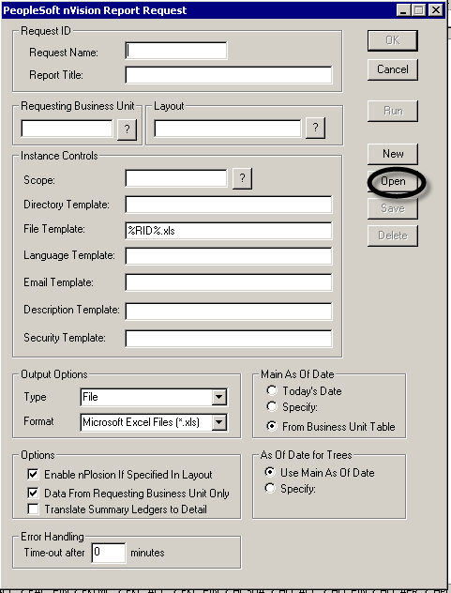
At the next dialog box, press the Get List button:
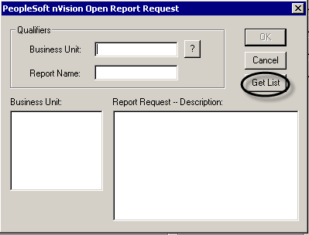

The Report Request box is populated. Select the Business Unit. Scroll through the list of report requests for the business unit and select the desired Report Request. Press OK.
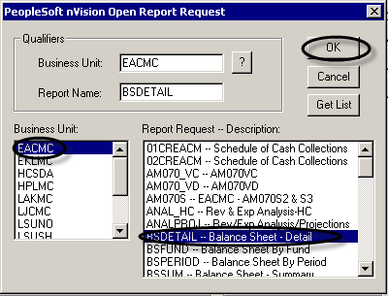
The Report Request and its associated layout are now populated on the main Report Request box. Press Run.
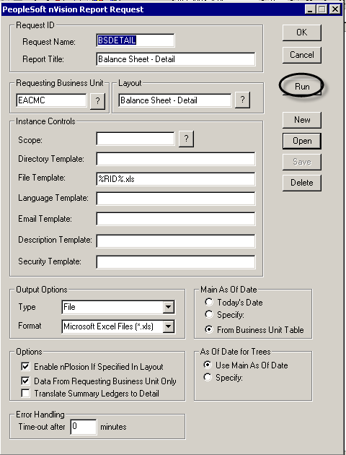

The report processes and the results are displayed.
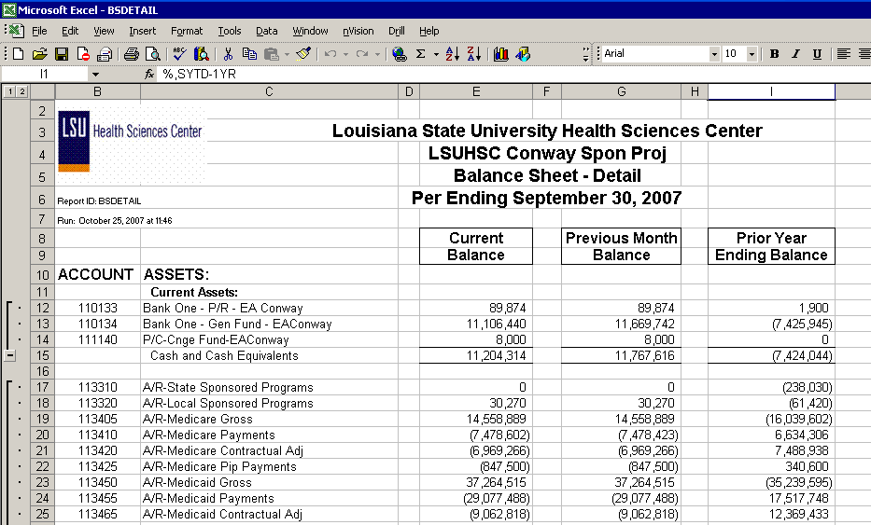
For users with full access to nVision who may need to open/modify a layout:
From the dashboard, select nVision, Open Layout
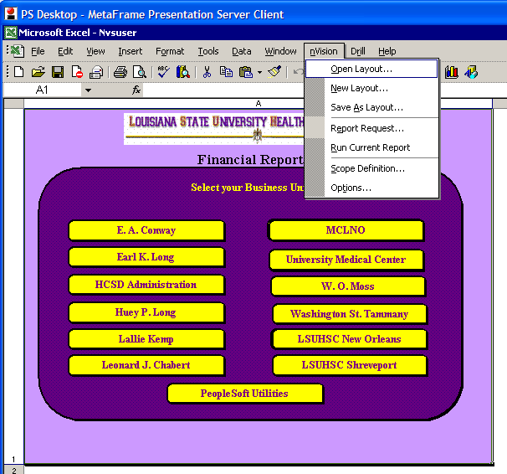
This example will use the LSUHSC-S AP Detail.xnv
In the file name box, type LSU and press the drop-down arrow.
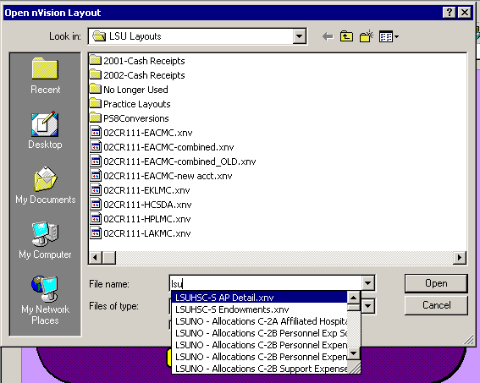
Click on the LSUHSC-S AP Detail.xnv, press Open
The layout displays.
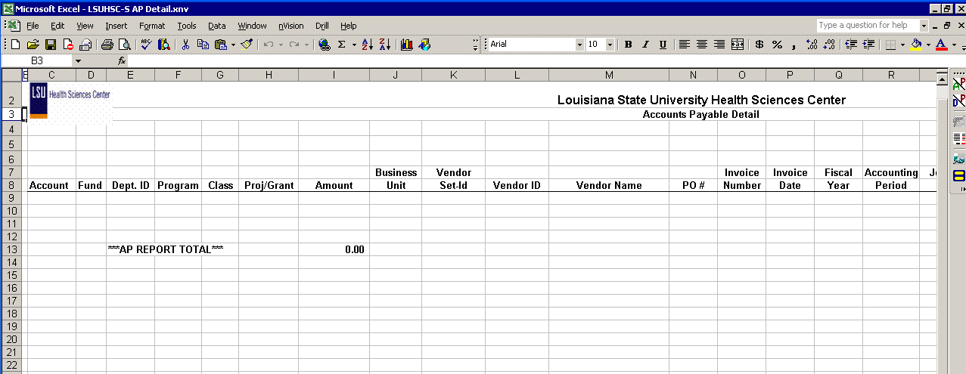

From the menu, select nVision, Report Request
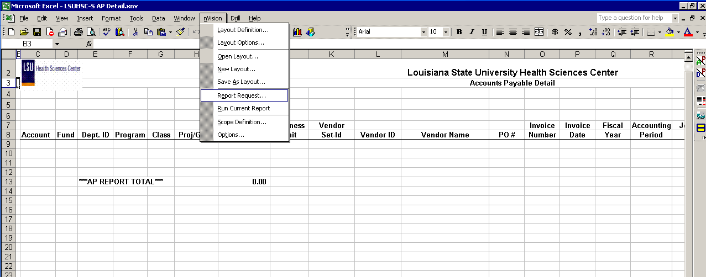

The Report Request box displays
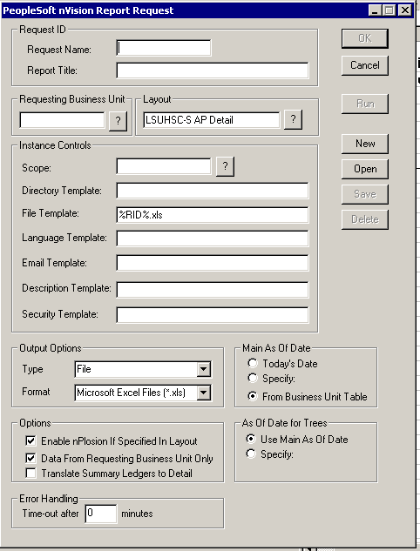
On the Request box, press the Open button

On the selection box, press the Get List button
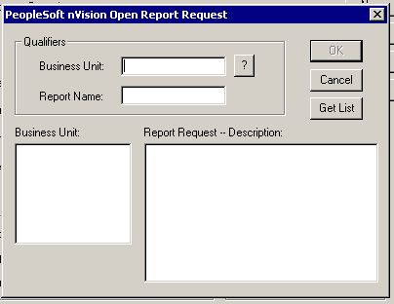

The Open Report Request box populates with a list of Business Units on the left and Report Requests on the right of the box.
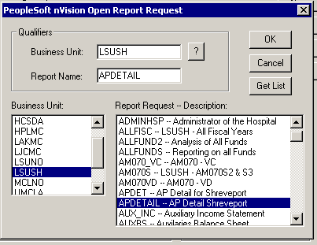
Click once on LSUSH in the Business Unit box and once on the Report Request APDETAIL. Next, press OK.
The Report Request appears.
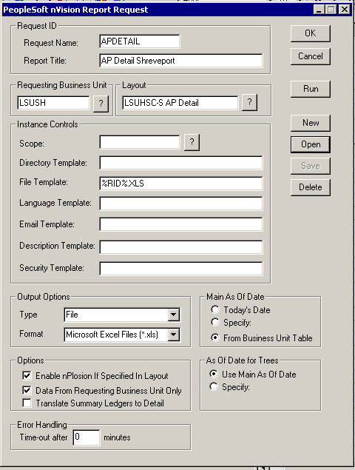
Press the Run button. The report will then process.

This report includes a prompt. The prompt box appears. The user must then enter the prompt criteria and press ok.
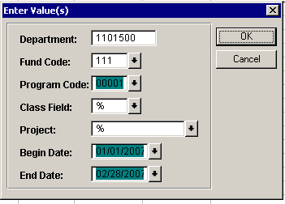
The report processes and displays the results.
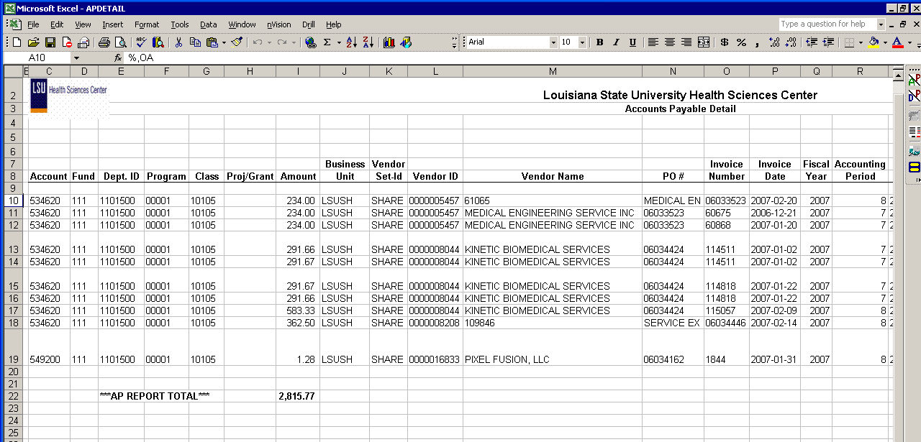

The report processes and is displayed on your screen.
Example of a second Noted Problem and Work-around
“Processing Box Covers Prompt Box”
This problem sometimes occurs on the FY_JRNL and the AP_DETAIL reports. Upon pressing the pushbutton, the layout is called and the prompt box and the processing box appear. The problem is that the processing box covers the prompt box, not allowing entry of the prompt data. If this occurs, the work-around is to click and drag the prompt box from behind the processing box, enter the prompt criteria and press ok. The report should then process normally.
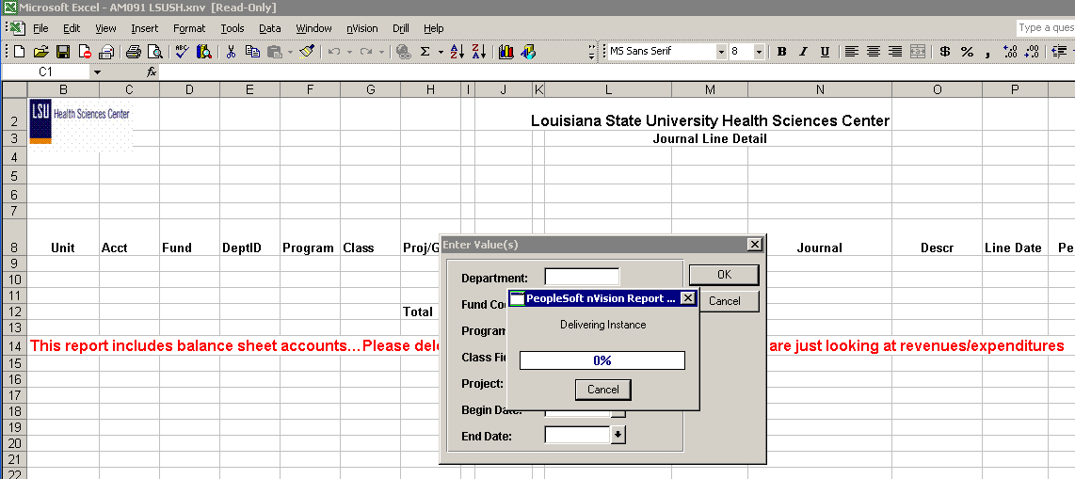
Click and drag the Prompt box from behind the processing box. Enter the values and press ok.
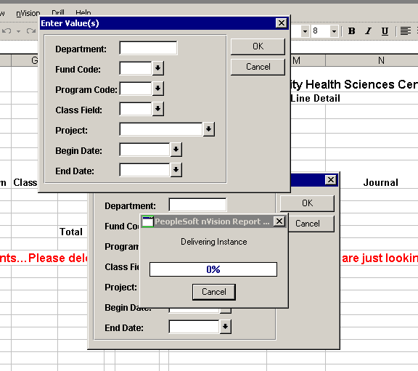

The report will then process and produce the results.
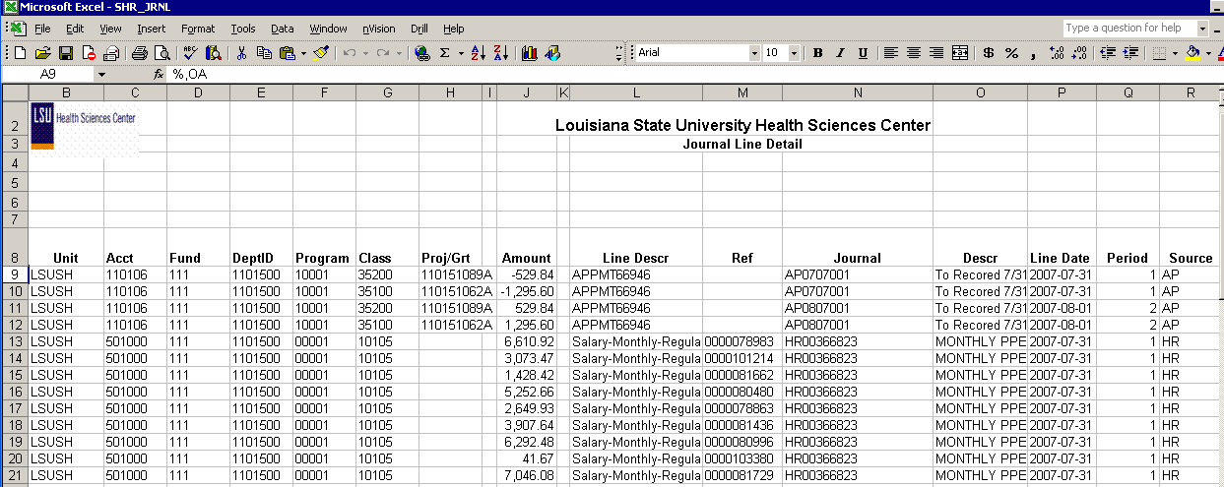

This type of problem rarely occurs but it is easily managed. Alternately, the reports could also be run from the report request menu. When run from the menu, this problem has not been noted.

