LSUHSC nVision Reports Catalog

Business Unit: LSUNO
Report Description: Academic Trial Balance by Fund
Layout: Academic Trial Balance by Fund.xnv
Report Request: ATBFUND
Dashboard Page and Button: N/A
nVision Scope: N/A
Report As of Date: Default from Business Unit

The report produces a trial balance that displays the current period (BAL timespan), inception to date (ITD), beginning balance (BEGBAL3) and year to date (YTD) ACTUALS ledger values. The beginning balance is a calculated value by subtracting the year to date actual amount from the beginning balance. The totals per column are nploded by fund code. The rows of the report are nploded by account (ACCTROLLUP tree)and defined by the breakdown of balance sheet account groups( Assets, Liabilities, Beginning Fund Balance, Current Fund Balance and Net Difference). There are no prompts on this report.

Report Sample:

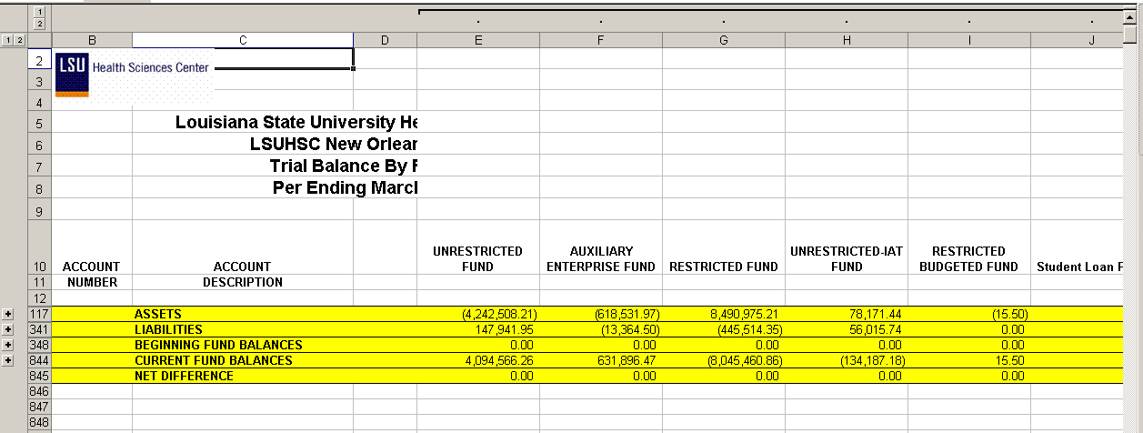

Note: This example displays the Current Period values by fund nploded (columns) but all of the Account Groupings (rows) are collapsed. To display the details, press the + by the row or the 2 button in the left margin.

