LSUHSC nVision Reports Catalog

Business Unit: LSUNO
Report Description: Expenditure/Budget Comparison
Layout: Sch of Rev, Exp, Budget.xnv
Report Request: RVEXBUD
Dashboard Page/Button: N/A
nVision Scope: N/A
Report As of Date: Default from Business Unit

The report produces a fiscal year schedule of revenue and expense activity nploded by account. The columns display budget, current month actual, year to date actual, project to date actual, encumbered and pre-encumbered amounts. The available balance column is a value calculated by subtracting actuals, encumbered, and pre-encumbered amounts from the budget. A calculated percent used column completes the report. The data for each column is derived from several queries that are included in hidden columns of the report. All of the queries are built using the LEDGER_KK table and pull in the same fields. The fields are: Business Unit, Posted Total Amount (summed), Ledger, Fund Code, Account, Department, Program Code, Class Field, Budget Period, Project Id, Affiliate, Currency Code, Statistics Code, Fiscal Year, Accounting Period, Posted Base Amount, Date Time Stamp, Base Currency and Process Instance. The only field used in the nVision report from the query is Posted Total. The criteria specified for each of the queries is used to differentiate the queries by specifying the Ledger names that the data is allowed/disallowed to be pulled from. The queries and the pertinent details of each are: AM090_ACTUALS_ALL – data from Actuals Ledger, AM090_ACTUALS_EN – data from encumbrance ledgers that include _EN as part of the name, and AM090_ACTUALS_PR – data from pre-encumbrance ledgers that include _PR as part of the name. Each of the hidden columns in the report include a timespan to identify the current period, year to date and inception to date values. The displayed columns of the report include formulas that reference the hidden columns. The rows of the report are grouped into the major breakdowns of Revenues and Expenses. Within each of these categories, there are account groupings defined. These groupings are nodes from the ACCTROLLUP tree. Each of these account groupings nplodes when the report is produced to display the detailed information. At the bottom of the report is a calculated Surplus/Deficit Row.
Report Example:
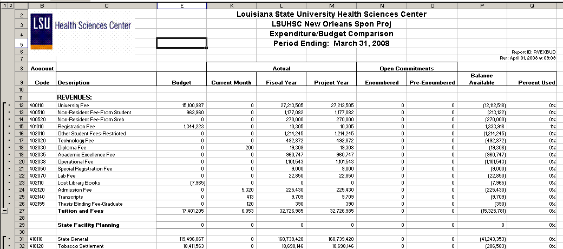
Query Fields – AM090_BUDGET
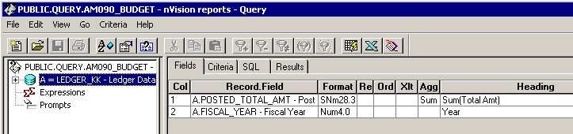

Query Criteria
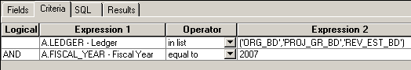

Query Fields – AM090_ACTUALS_ALL
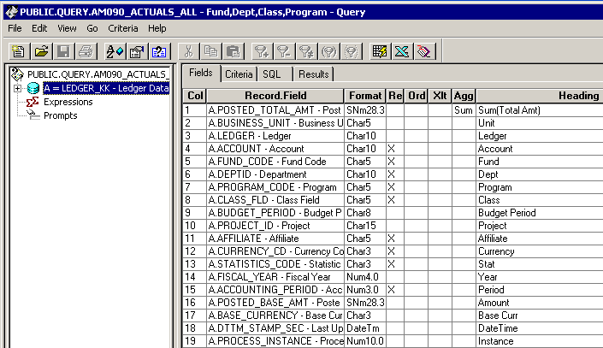

Query Criteria
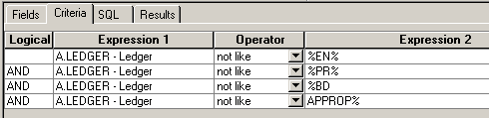

Query Fields- AM090_ACTUALS_ALL_EN
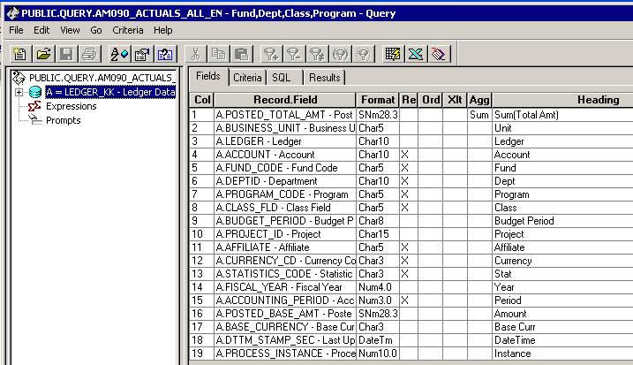

Query Criteria
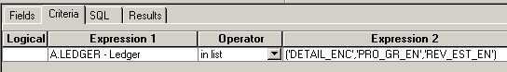

Query Fields – AM090_ACTUALS_ALL_PR
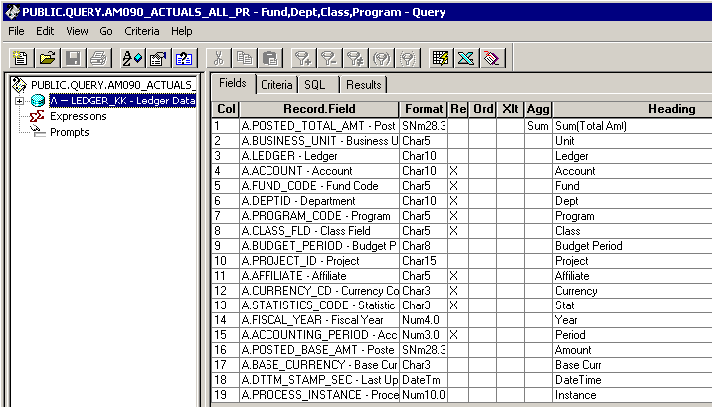

Query Criteria
