LSUHSC nVision Reports Catalog

Business Unit: LSUNO
Report Description: FY Activity Dental State Funds
Layout: AJ Fiscal Report Books.xnv
Report Request: DENT_SGF
Dashboard Page/Button: N/A
nVision Scope: DENT_SGF
Report As of Date: Default from Business Unit

The report produces a fiscal year activity of revenues and expenses nploded by account. The columns display budget, year to date actuals, encumbered and pre-encumbered amounts. The available balance is calculated by subtracting actuals, encumbered amount and pre-encumbered amount from the budget value. The data for each column is derived from queries. The query for the budget data is called AJ_BUDGET_RPT_BKS that pulls data from the LEDGER_KK table. The year to date actuals column in the report is nploded and the data is derived from the AJ_JRNL_RPT_BKS query that is written on the JRNL_HEADER and JRNL_LINE tables. The Encumbered amount and Pre-encumbered amount columns display the data as derived from the ZZGL_TRANS_DTL table in the AJ_LEDGERS_RPT_BKS query. This report contains no prompts. This report specifies that the accounts begin with 4 or 5. The query also excludes period 999 from any values. The rows of the report layout are designated as specific groupings of accounts. Each grouping will be nploded when the report is produced. The scope used in the Report request is called DENT_SGF. This scope limits the data to that for the departments that are included in the DENTISTRY node on the department tree and the unrestricted fund codes.

Report Example:
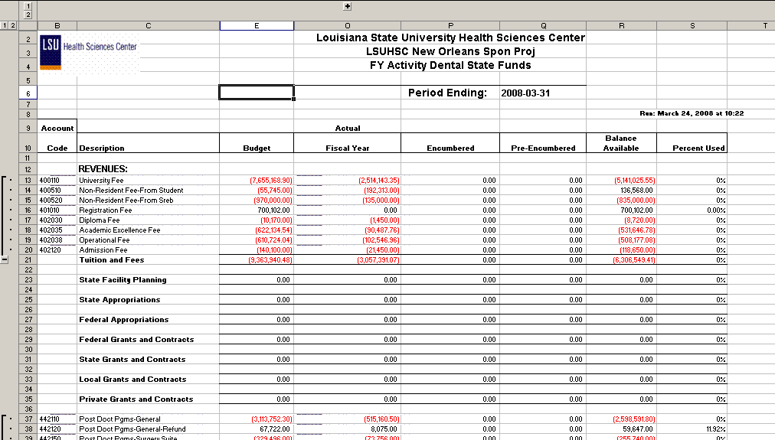
Query Fields – AJ_BUDGET_RPT_BKS
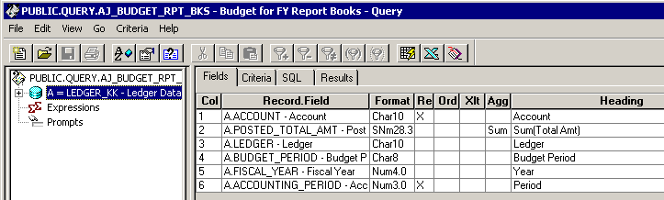

Query Criteria
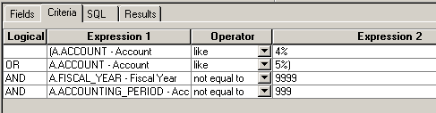

Query Fields – AJ_JRNL_RPT_BKS
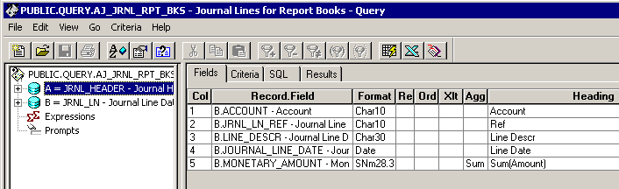
Query Criteria
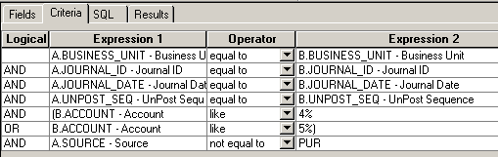

Query Fields – AJ_LEDGER_RPT_BKS
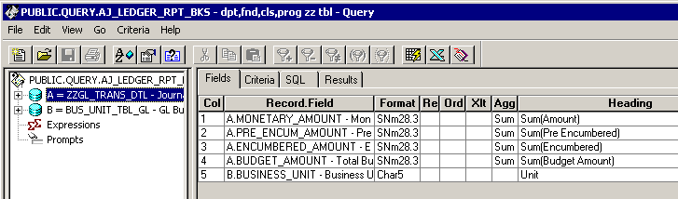

Query Criteria
