LSUHSC nVision Reports Catalog

Business Unit: LSUNO
Report Description: Fiscal Year Activity
2-tier Layout: AJ Fiscal.xnv
Web Layout: W AJ Fiscal.xnv
Report Request: AJ_FISC
Web Report Request: WAJ_FISC
Dashboard Page/Button: LSUNO/ Fiscal Yr
nVision Scope: N/A
Report As of Date: Default from Business Unit

The report produces a fiscal year activity of revenues and expenses nploded by account. The columns display budget, year to date actuals, encumbered and pre-encumbered amounts. The available balance is calculated by subtracting the actuals data from the budget. The data for each column is derived from the LSUNO_FISCAL_YEAR query that pulls information from the ZZGL_TRANS_SUM1 table. The query for the web version of the report is called WLSUNO_FISCAL_YEAR that pulls data from the ZZGL_TRANS_SUM1 and ZZNVISIONPROMPT tables. The year to date actuals column in the report is nploded. This report prompts on Deptid, Fund code, Program code, Class field, and Project id. There is also a prompt that the accounting period cannot be greater than the entered value. The query specifically pulls data for the LSUNO, LSUNE, and LSUNA business units. This query also specifies that the accounts begin with 4 or 5. The query also excludes period 999 from any values. The web based query includes criteria expressions for those fields prompted in the client version as seen below in the screen shots. The rows of the report layout are designated as specific groupings of accounts. Each grouping will be nploded when the report is produced.

Report Example:
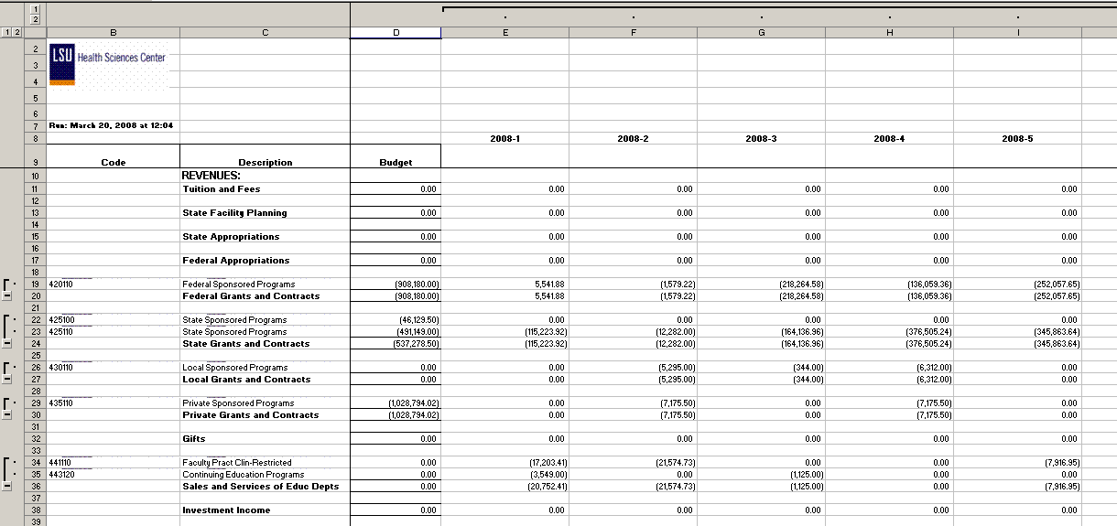
This report example displays department 1052000 values.
Query Fields for 2-tier LSUN O_FISCAL_YEAR query:

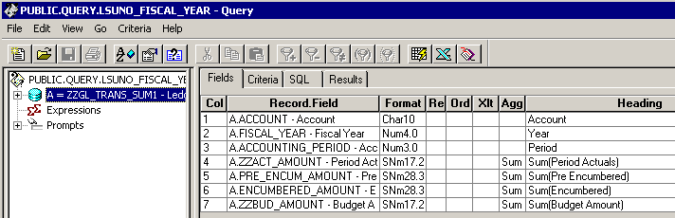

Query Criteria 2-tier version:

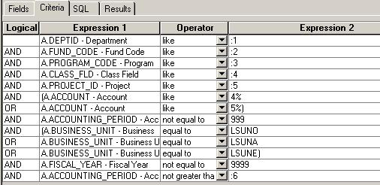

Query Fields for web nVision query WLSUNO_FISCAL_YEAR:

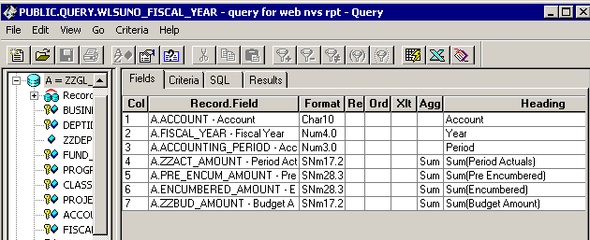

Query Criteria for web nVision version:

