LSUHSC nVision Reports Catalog

Business Unit: LSUNO
Report Description: Foundation Invoice
2-tier Layout: AJ Foundation Invoice.xnv
Web nVision Layout: WAJ Foundation Invoice.xnv
2-tier Report Request: FOUND
Web nVision Request: W_FOUND
Dashboard Page and Button: N/A
nVision Scope: N/A
Report As of Date: Default from Business Unit

The report produces a listing of Project/Grant Ids and the short and long description of each. The report is based off of the query called FOUNDATION. For the web based nVision product, the query is called WFOUNDATION. The query lists the project id, its short and long descriptions, the accounting period, the account, account description, fiscal year, and posted total amount. Note that the report only displays the project id and description fields from the query. The tables used in the query are PROJECT, PROJECT_DESCR, LEDGER_KK, and GL_ACCOUNT_TBL. The query specifies criteria that the description of the projected must be “like” LSUMCF% or LSUMC Foundation. The criteria also limit the accounts to those beginning with a 4 or 5. There are prompts for Fiscal Year and Accounting Period on this report. For the web nVision query, an additional table, the ZZNVISIONPROMPT is joined in to the query. The criteria prompts are modified to be expressions allowing for Fiscal Year and Accounting Period.

Report Sample:
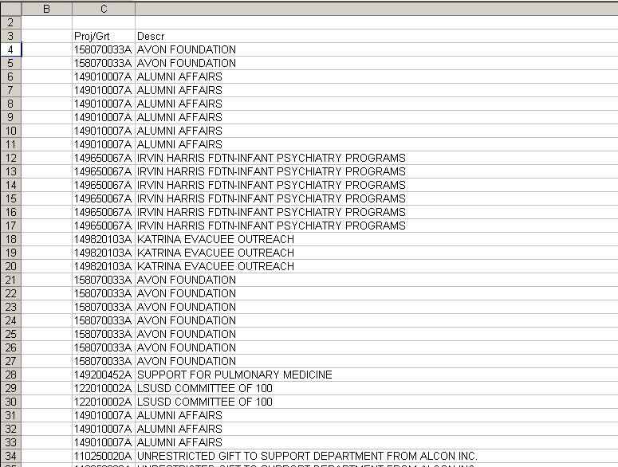

FOUNDATION Query Fields
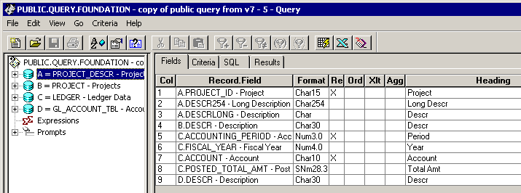

Query Criteria
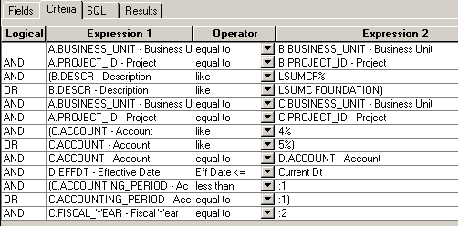

WFOUNDATION Query Fields:

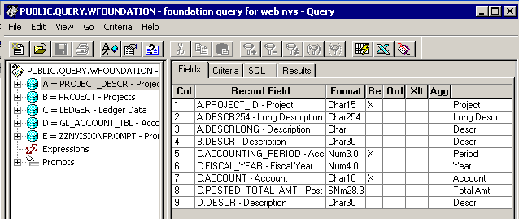

WFOUNDATION Query Criteria:
