LSUHSC nVision Reports Catalog

Business Unit: LSUNO
Report Description: Journal Summary
2-tier Layout: AM091.xnv
Web Layout: W AM091.xnv
2-tier Report Request: AM091
Web Report Request: W_AMO91
Dashboard Page/Button: LSUNO/FY JRNL
nVision Scope: N/A
Report As of Date: Default from Business Unit

This is the Journal Line Detail Report and provides all pertinent data for the journal lines. The 2-tier report uses the AJ_JRNL_DETAIL query that pulls data for the LSUNO, LSUNA, and LSUNE business units. The query is written against the JRNL_HEADER and JRNL_LN tables. The query lists business unit, account, fund code, department id, class, project id, journal id, and journal description, journal line description, line date, line reference, source, and amount, fiscal year, accounting period, budget period, ledger, journal header status, and posted date. The query used in the report prompts on deptid, fund code, program code, class field, project id, and fiscal year and accounting period. The web based nVision uses the query WAJ_JRNL_DETAIL. The ZZNVISIONPROMT table is joined to the JRNL_HEADER and JRNL_LN tables. The prompt criteria in this query are modified to be an expression that is enabled on the web.

Report Example:
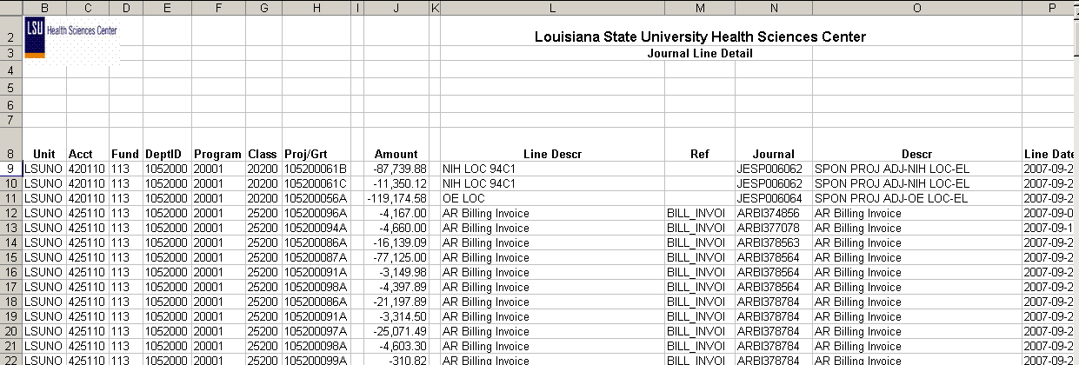

2-tier Query Fields
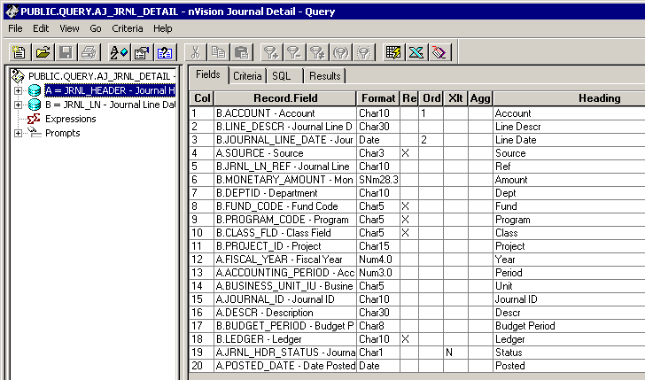

Query Criteria
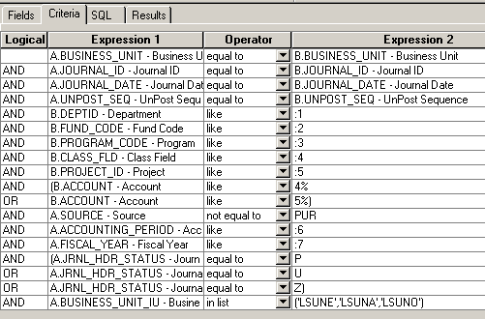
Web based query WAJ_JRNL_DETAIL fields
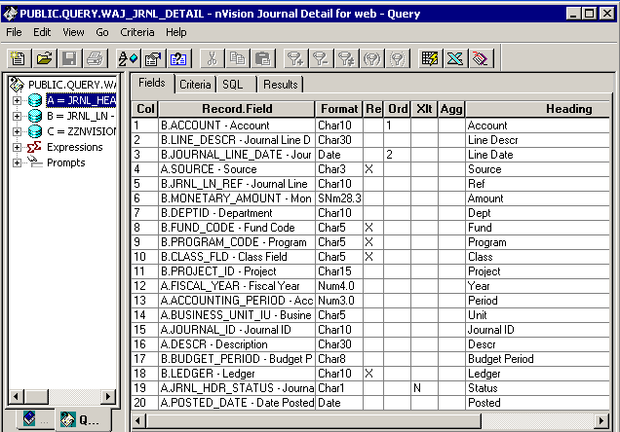

Query Criteria
