LSUHSC nVision Reports Catalog

Business Unit: LSUNO
Report Description: Operating Funds by Function
2-tier Layout: AJ NO OP.xnv
Web Layout: WAJ NO OP.xnv
Report Request: NO_OP
Web Report Request: W_NO_OP
Dashboard Page/Button: LSUNO/ Op by Function
nVision Scope: N/A
Report As of Date: Default from Business Unit

The report produces a fiscal year activity of revenues and expenses nploded by account. The columns display budget, year to date actuals, encumbered and pre-encumbered amounts. The available balance is calculated by subtracting actuals from the budget. The data for the budget column is derived from the AJ_NO_BUD_OP query that pulls information from the LEDGER_KK table. The year to date actuals column in the report is nploded. The query used for this column is called AJ_NO_JRNL_OP. It pulls data from the JRNL_HEADER and JRNL_LN tables. The query for the Encumbered amounts is called AJ_NO_BUD_OP_EN deriving data from the LEDGER_KK table. The Pre-Encumbered amount column utilizes the AJ_NO_BUD_OP_PR query that also pulls data from the LEDGER_KK table. The queries display the Account, Amount, Ledger, Fiscal Year, Budget Period, Accounting Period, Business Unit, Fund Code and Prgram Code. This report prompts on Program Code and Accounting Period. The query specifically pulls data for the LSUNO, LSUNE, and LSUNA business units and for funds 111, 114, and 115. The criteria indicate that the Program Code cannot be 00000. This query also specifies that the accounts begin with 4 or 5. The query also excludes period 999 from any values. The queries prompt on Program Code and Accounting Period. Each of the queries used specifies the ledger that the data is posted to. For the web based nVision report, the queries included in the report are named: WAJ_NO_BUD_OP, WAJ_NO_JRNL_OP, WAJ_NO_BUD_OP_EN, and WAJ_NO_BUD_OP_PR. These queries include modified criteria to prompt in the web for the Program Code and the Accounting Period by joining the ZZNVISIONPROMPT table to each query and creating expressions. The rows of the report layout are designated as specific groupings of accounts. Each grouping will be nploded when the report is produced.

Report Example:
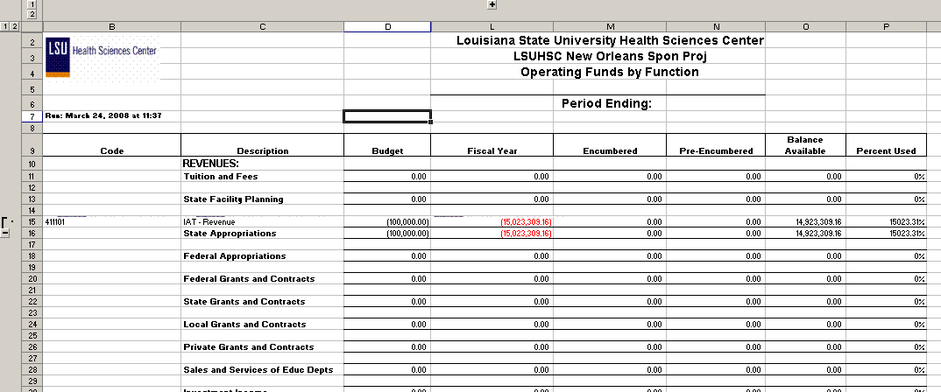

Query Fields – AJ_NO_JRNL_OP
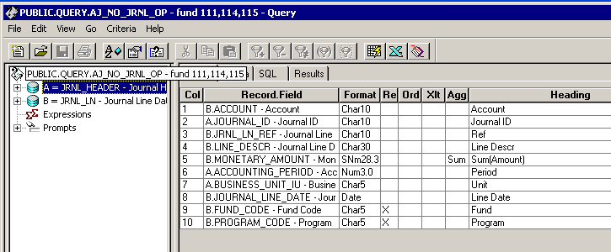
Query Criteria
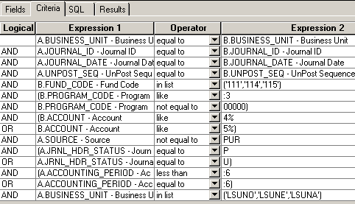

Query Fields – AJ_NO_BUDGET_OP
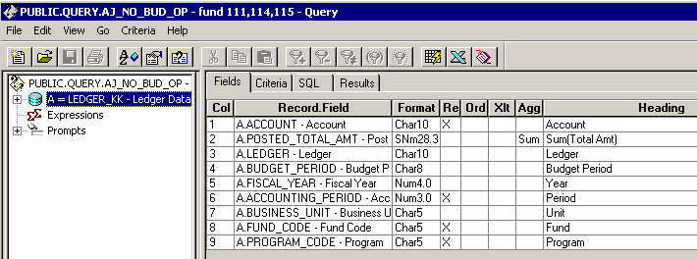

Query Criteria
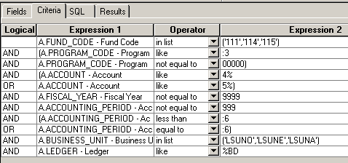

Query Fields – AJ_NO_BUDGET_OP_EN
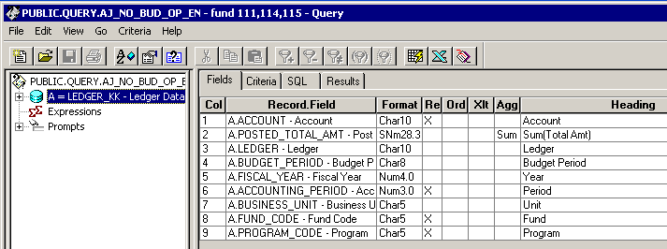

Query Criteria
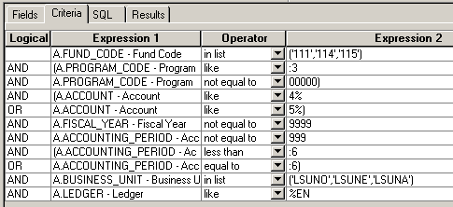

Query Fields – AJ_NO_BUDGET_OP_PR
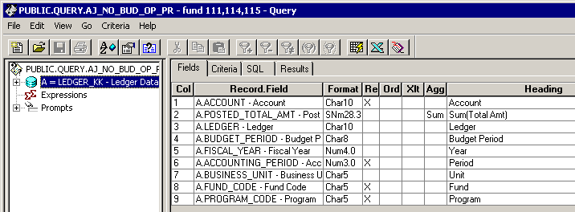

Query Criteria
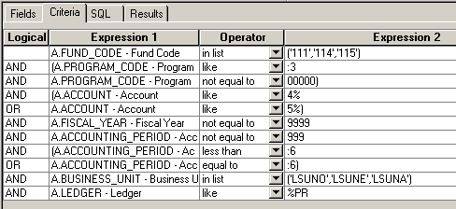

For all four of the web based queries, the fields are identical to those displayed in the fields tabs of the above displayed queries. The criteria tab for each of the queries includes modifications. The following screen shots display on the criteria tabs of the four web based queries.

WAJ_NO_BUD_OP Criteria:
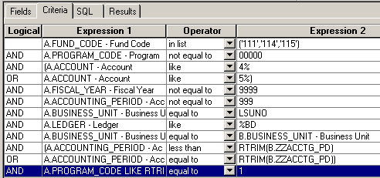

WAJ_NO_BUD_OP_EN Criteria:
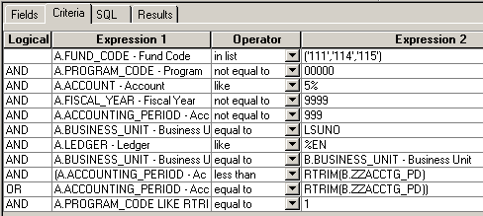

WAJ_NO_BUD_OP_PR Criteria:
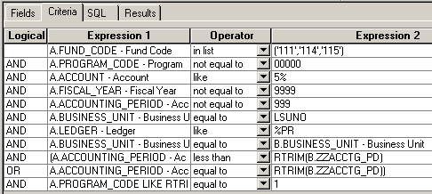
WAJ_NO_JRNL_OP Criteria:
