LSUHSC nVision Reports Catalog

Business Unit: LSUNO
Report Description: Previous Fiscal Year Activity ZZ
2-tier Layout: AJ Previous Fiscal_ZZ.xnv
Web Layout: W AJ Previous Fiscal_ZZ.xnv
2-tier Report Request: AJ_PREVZ
Web Report Request: WAJ_PREZ
Dashboard Page/Button: N/A
nVision Scope: N/A
Report As of Date: Default from Business Unit

The report produces a fiscal year activity of revenues and expenses nploded by account. The columns display budget, year to date actuals, encumbered and pre-encumbered amounts. The available balance is calculated by subtracting actuals from the budget. The data for the budget, encumbered and pre-encumbered amount columns is AJ_BUDGET_NEW. The query pulls the Account, Amount, Ledger, Fiscal Year, Budget Period, Accounting Period from the ZZGL_TRANS_DTL table. The actuals column in the report is nploded. The query used for this column is called AJ_JRNL. It pulls data from the JRNL_HEADER and JRNL_LN tables. This query displays the fields above plus the journal id, line, line reference, description, journal line date, header status, and source. The queries specifically pull data for the LSUNO, LSUNE, and LSUNA business units. These queries also specify that the accounts begin with 4 or 5. The queries also exclude period 999 from any values. Each of the queries used specifies the ledger where the data is posted. This report prompts on Department, Fund Code, Program Code, Class Field, Project Id, and Accounting Period. For the web based nVision report, the queries used are WAJ_BUDGET_NEW and WAJ_JRNL. Each query includes an additional table, ZZNVISIONPROMPT. The criteria in the query modifies the prompts to enable the report to run on the web. The rows of the report layout are designated as specific groupings of accounts. Each grouping will be nploded when the report is produced. The report uses the ALLYEAR-1 timespan.

Report Example:
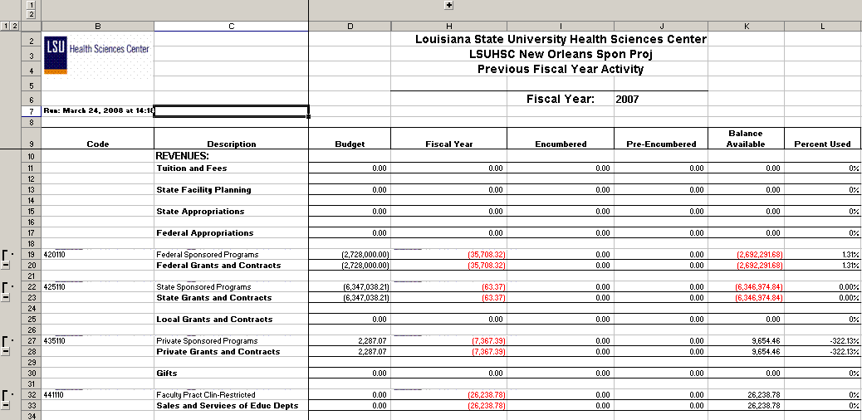
Query Fields – AJ_JRNL
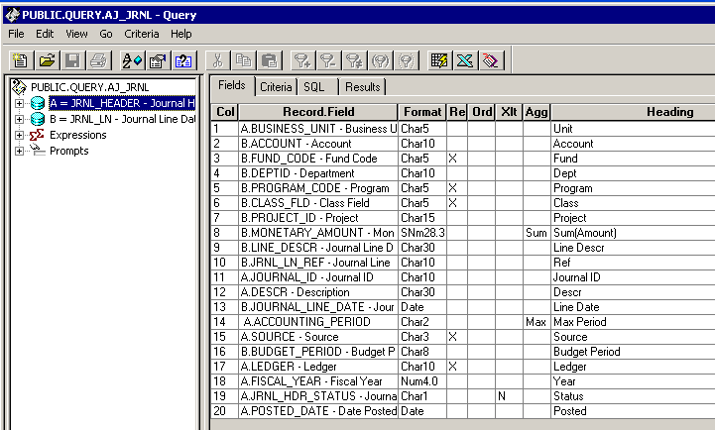

Query Criteria
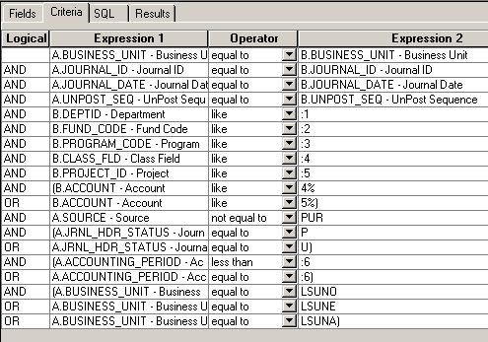

Query Fields – AJ_BUDGET_NEW
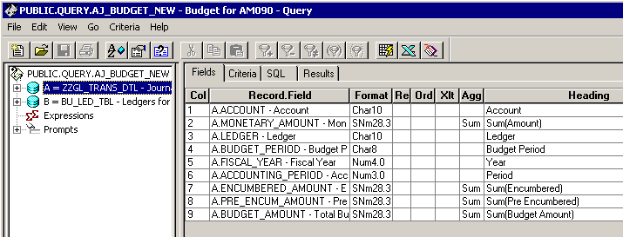

Query Criteria
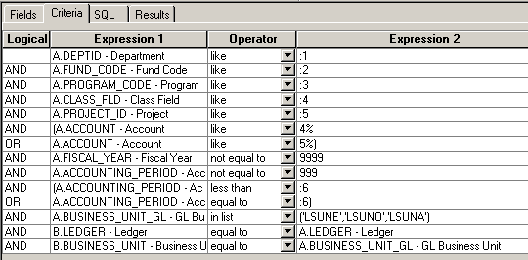

The query fields in the web based queries are identical to those used in the 2-tier version. The criteria is modified to include expressions to allow for the web prompts.

WAJ_BUDGET_NEW Criteria:
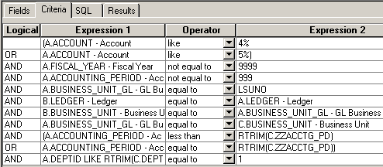
WAJ_JRNL Criteria:
