LSUHSC nVision Reports Catalog

Business Unit: LSUNO
Report Description: Previous Fiscal Year Activity
2-tier Layout: AJ Previous Fiscal.xnv
Web Layout: W AJ Previous Fiscal.xnv
Report Request: AJ_PREV
WEB Report Request: WAJ_PREV
Dashboard Page/Button: LSUNO/ Previous FY
nVision Scope: N/A
Report As of Date: Default from Business Unit

The report produces a fiscal year activity of revenues and expenses nploded by account. The columns display budget, year to date actuals, encumbered and pre-encumbered amounts. The available balance is calculated by subtracting actuals from the budget. The data for the budget column is derived from the query AJ_BUDGET. The queries for the Encumbered amounts and Pre-encumbered amounts columns are called AJ_BUDGET_EN and AJ_BUDGET_PR respectively. All of these queries pull the Account, Amount, Ledger, Fiscal Year, Budget Period, and Accounting Period from the LEDGER_KK table. The actuals column in the report is nploded. The query used for this column is called AJ_JRNL. It pulls data from the JRNL_HEADER and JRNL_LN tables. This query displays the fields above plus the journal id, line, line reference, description, journal line date, header status, and source. The queries specifically pull data for the LSUNO, LSUNE, and LSUNA business units. These queries also specify that the accounts begin with 4 or 5. The queries also exclude period 999 from any values. Each of the queries used specifies the ledger where the data is posted. This report prompts on Department, Fund Code, Program Code, Class Field, Project Id, and Accounting Period. The web based nVision report uses the modified queries WAJ_BUDGET, WAJ_BUDGET_EN, WAJ_BUDGET_PR, and WAJ_JRNL. These queries include an additional table, ZZNVISIONPROMPT. The prompt fields are modified to enable the prompts on the web and are included in a special expression. The screen shots below depict the differences from the 2-tier version to the web version. The rows of the report layout are designated as specific groupings of accounts. Each grouping will be nploded when the report is produced. The report uses the ALLYEAR-1 timespan.

Report Example:
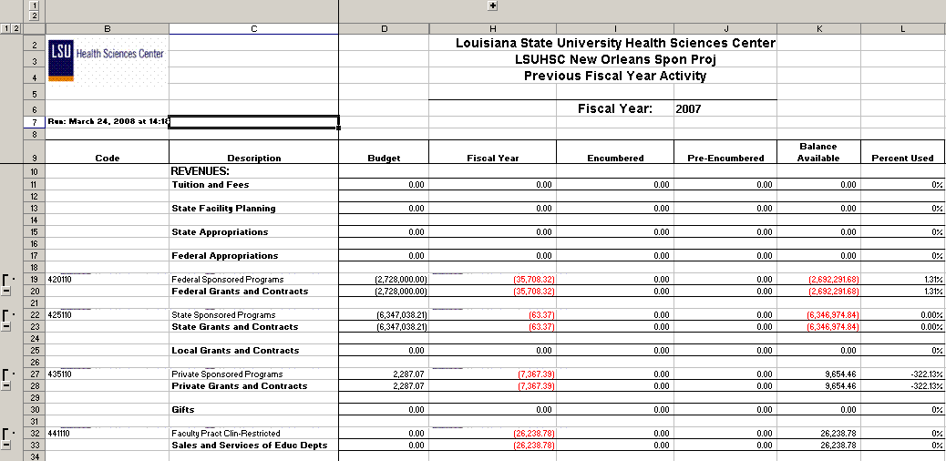

2-tier Query Fields – AJ_JRNL
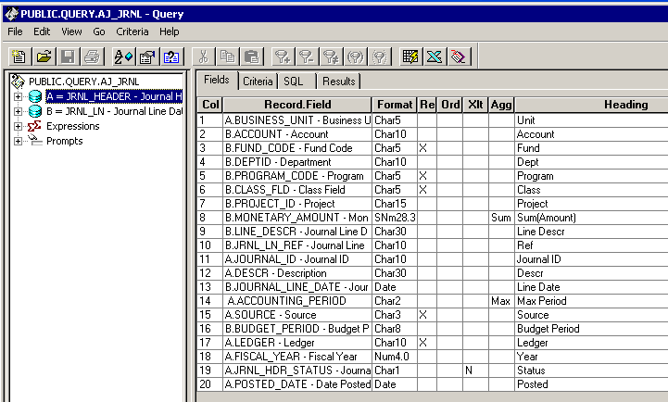

Query Criteria
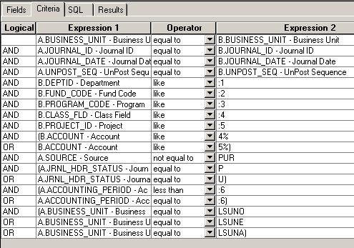

2-tier Query Fields – AJ_BUDGET
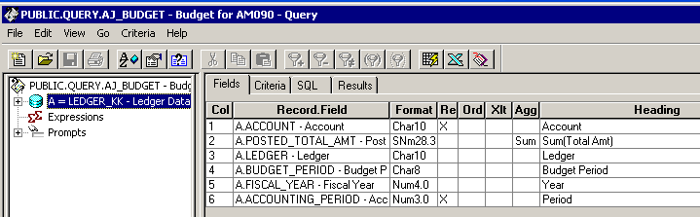

Query Criteria
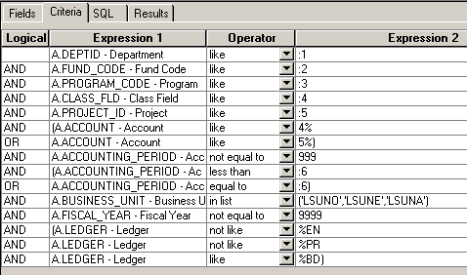

2-tier Query Fields – AJ_BUDGET_EN
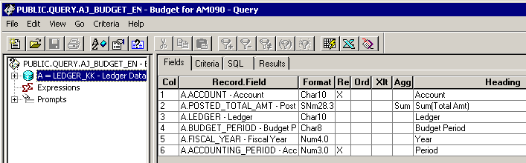

Query Criteria
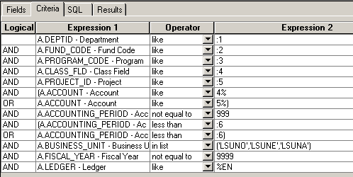

2-tier Query Fields – AJ_BUDGET_PR
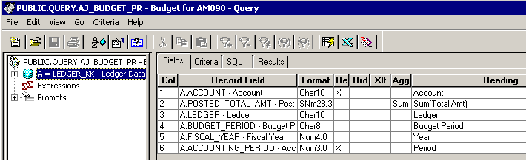

Query Criteria
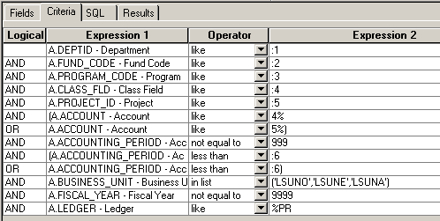

Web Based Queries include the same fields as the 2-tier versions. The criteria for each query is changed.

WAJ_JRNL Criteria:
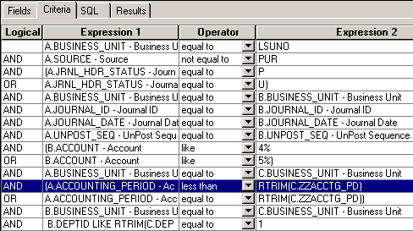

WAJ_BUDGET:
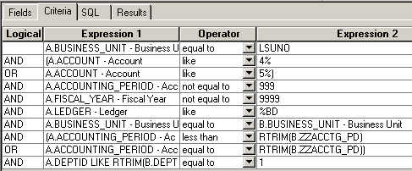
WAJ_BUDGET_EN:
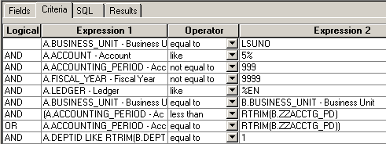

WAJ_BUDGET_PR:
