LSUHSC nVision Reports Catalog

Business Unit: LSUNO
Report Description: Project to Date Activity NO
2-tier Layout: AJ Project to Date.xnv
Web Layout: W AJ Project to Date.xnv
2-tier Report Request: AJ_PROJ
Web Report Request: WAJ_PROJ
Dashboard Page/Button: LSUNO/PROJECT
nVision Scope: N/A
Report As of Date: Default from Business Unit

This report provides revenues and expenditures by account category for a prompted project id. The report includes a project to date column and a fiscal year to date column. The Project to date column nplodes data based on the ITD timespan. The column displays information based on the query LSU_AJ_ITD. This query is written against the LEDGER table and pulls in the following fields: Account, Department, Fund, Product, Class, Project, Posted Total Amount, Fiscal Year and Accounting Period. The criteria specify the LSUNO, LSUNA, or LSUNE Business Units. The query prompts on project id. The Year to date column references the same query. Each of the rows is a specified account group from the ACCTROLLUP tree. Examples include Tuition and Fees, Investment Income, Travel Expenses and Indirect Costs. Each of these is nploded at run time. The web version of the report uses the query WLSU_AJ_ITD query that includes the ZZNVISIONPROMPT table. The criteria in the query is modified to include an expression for the prompt on project id.

Report Example:
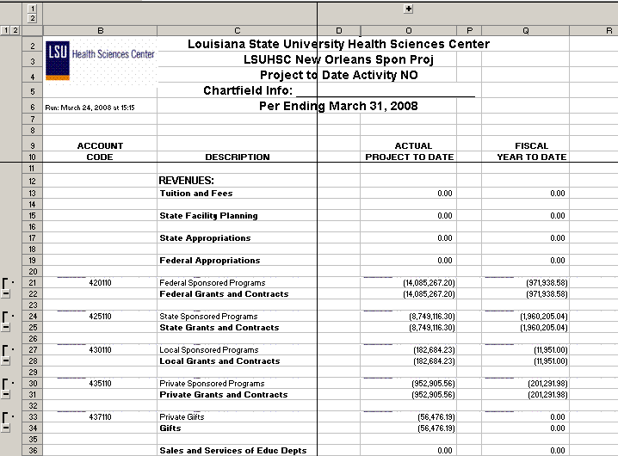
.
Query Fields
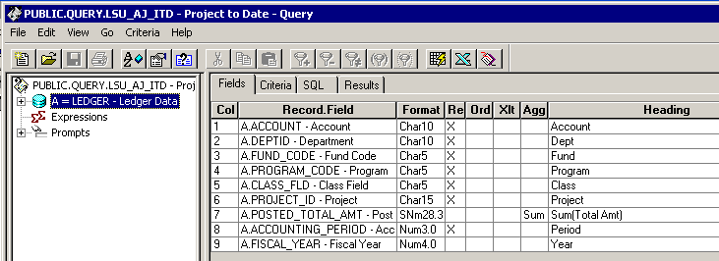

Query Criteria
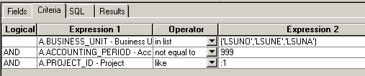

WLSU_AJ_ITD Fields:

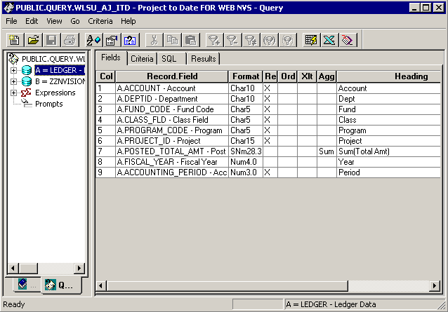

WLSU_AJ_ITD Criteria:
