LSUHSC nVision Reports Catalog

Business Unit: LSUSH
Report Description: AM070 – VC and VD Combined
Layout: LSUSH –AM070 – VC & VD COMBO.xnv
Report Request: AM070COM
Dashboard Page/Button: LSUSH_YEAR_END/AM070 VC & VD
nVision Scope: N/A
Report As of Date: Specify last day of the year e.g. 06/30/20xx

This report provides a summary report of revenues and expenditures by category. The columns of the report begin with the descriptive information for the category. To the right is a calculated Budget column. This calculated column references data from one or more of the four hidden columns to the right. The first of these hidden columns selects the LSUSH_BUDGET_APPROP (KK_BUDGET_LN table) query, monetary amount reversed as the criteria. The query specifies budget data for funds 111 and 114 from the ORG_BD, PROJ_GR_BD or APPROP_BD ledgers for budget period FY_2007. The second column selects the LSUSH_BUDGET_115 query as the source of the data. The query is written against the KK_BUD_LN table and specifies fund 115 from the ORG_BD, PROJ_GR_BD, or APPROP_BD ledgers for budget period FY_2007. The field Monetary Amount is selected and is reverse signed for the report. The third hidden column utilizes the LSUSH_BUDGET_REV_EST_115 (KK_BUD_LN table) with monetary amount reversed selected. This query references the REV_EST_BD ledger, fund 115 and budget period FY_2007. The fourth hidden column specifies the query LSUSH_BUDGET_REV_EST (KK_BUD_LN table) and displays the monetary amount reversed. The query selects data from the REV_EST_BD ledger, funds 111 or 114 for budget period FY_2007. The next displayed column is headed ACTUAL and references a hidden column to the right. This hidden column has the criteria of ACTUALS ledger selected Posted Total Amount as the amount and YTD as the timespan. The last column is the Variance column. This is calculated by subtracting the Budget column values from the Actual column values. The rows of the report are divided into two groups, Revenues and Expenditures. The Revenues section includes four subsections. Each of these sections includes one or more rows that specify an account or several accounts and Fund Code 115. The four sections are State Generated, Self Generated, Interagency Transfers, and Non-appropriated funds. The Budget column for the Revenues section specifies that the data is the sum of the value of the cells in the two hidden budget columns (queries LSUSH_BUDGET_REV_EST and LSUSH_BUDGET_REV_EST_115). After these rows, there is a calculated Total Revenue row. In the section called Expenditures, the fund code for each row is specified as the detail values of 111, 114, and 115. The accounts for each of the rows is the node EXPENSES from the AM070 tree. The program is the selected field that differentiates each of the rows. The Programs are selected from the STMT_REV_EX tree. Examples of the Programs selected for the rows include INSTRUCTION, STUDENT_SERV, and O_AND_M. At the bottom of each group is a total and the last row of the report is the Total Unexpended Appropriation – Current Year.
Report Example:
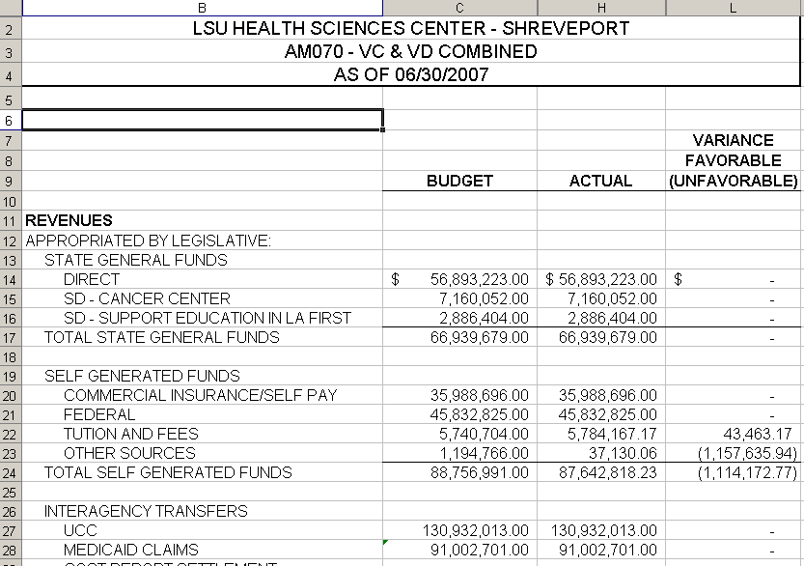

Query Fields – LSUSH_BUDGET_APPROP
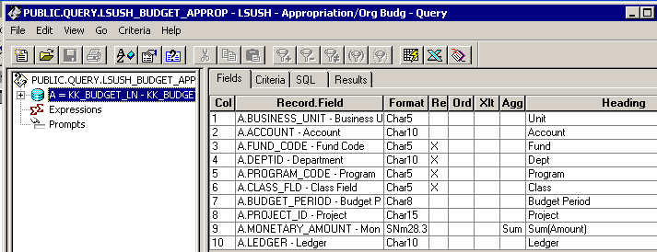

Query Criteria
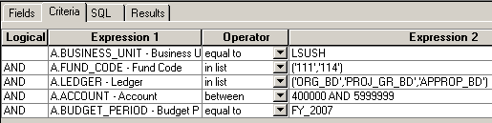

Query Fields – LSUSH_BUDGET_REV_EST
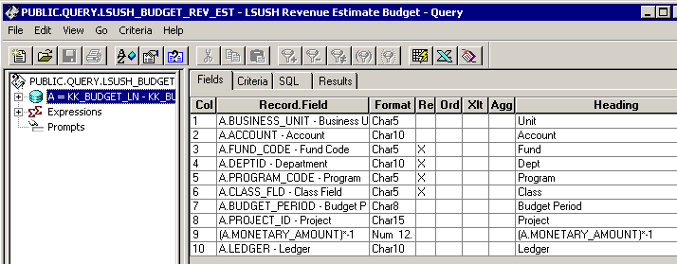

Query Criteria
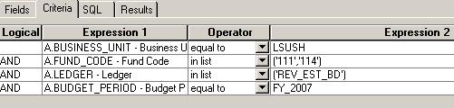
Query Fields – LSUSH_BUDGET_115
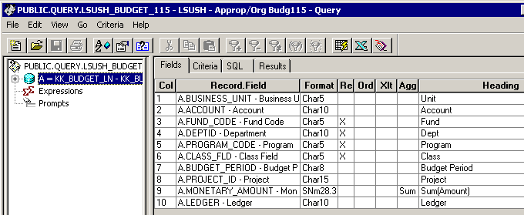

Query Criteria
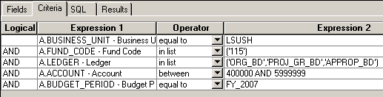

Query Fields – LSUSH_BUDGET_REV_EST_115
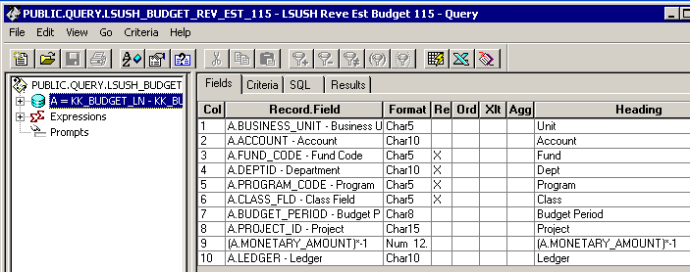
Query Criteria
