LSUHSC nVision Reports Catalog

Business Unit: LSUSH
Report Description: AP Detail Shreveport
2-tier Layout: LSUHSC-S AP Detail.xnv
Web Layout: W LSUHSC-S AP Detail.xnv
Report Request: APDETAIL
Web Report Request: WAPDETAL
Dashboard Page/Button: LSUSH/AP Detail
nVision Scope: N/A
Report As of Date: Default from Business Unit

This report provides Accounts Payable details for accounts greater than account 230000. The report uses the SHV_AP_ACTIVITY query as the basis and prompts on department id, fund code, program code, class field, project id, accounting period and fiscal year. The query is written against the VOUCHER, VCHR_ACCTG_LN, VENDOR, PYMNT_ADVICE, PAYMENT_TBL, and PYMNY_VCHR_XREF tables. The fields included in the query are: Business Unit, Vendor Id, Invoice Id, Invoice Date, Voucher Id, , Account, Department, amount, vendor name, accounting date, journal line description, purchase order id, journal id, journal date, vendor setid, accounting period, fund code, program code, class field, project id, monetary amount, payment id reference, payment date and general ledger distribution status. The query criteria are built to specifically pull data for LSUSH, and LSUSE. Additionally, the query specifies that the accounts included in the report exclude 110101, 110106, 110103, 110102, 221101, and 221005. The web based report relies on the query WSHV_AP_ACTIVITY that includes the new ZZNVISIONPROMPT table. The prompt criteria have been replaced with expressions to enable web based prompting.

Report Example:
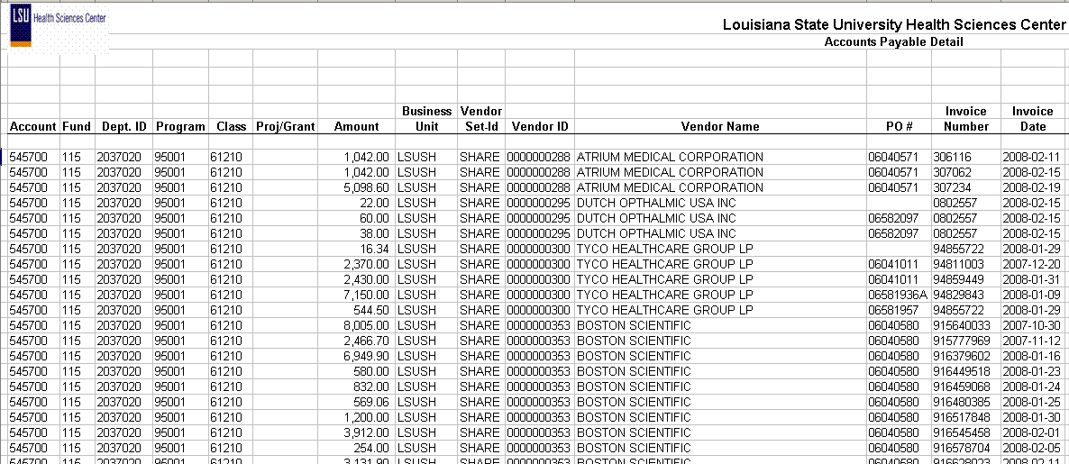.

Query Fields
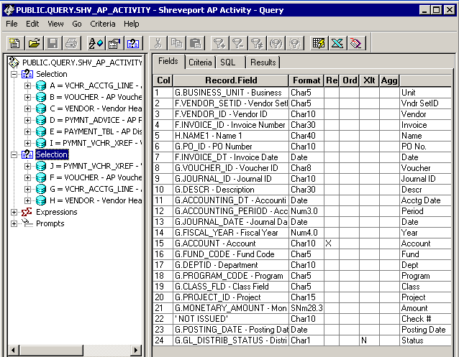

Query Criteria
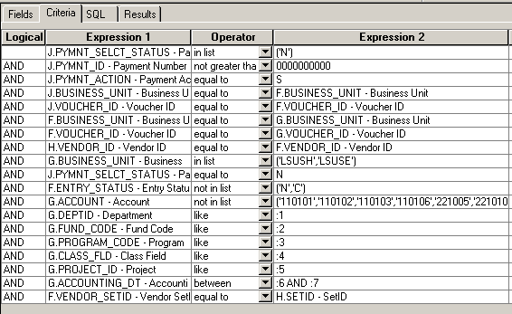
Modified Query Criteria WSHV_AP_ACTIVITY Selection 1
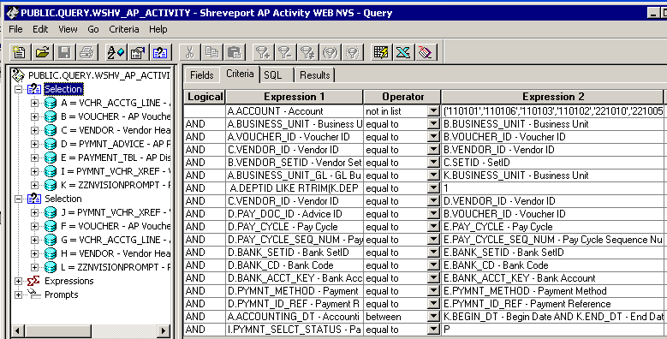

Modified Query Criteria for Selection 2

