LSUHSC nVision Reports Catalog

Business Unit: LSUSH
Report Description: AP Detail
2-tier Layout: AP Detail SHRV.xnv
Web Layout: W AP Detail SHRV.xnv
Report Request: SHR_AP
Web Report Request: W_SHR_AP
Dashboard Page/Button: N/A
nVision Scope: N/A
Report As of Date: Default from Business Unit

This report provides Accounts Payable details for accounts greater than account 230000. The report uses the AJ_SHR_AP_VOUCHER query as the basis and prompts on department id, fund code, program code, class field, project id, accounting period and fiscal year. The query is written against the VOUCHER, VCHR_ACCTG_LN, and VENDOR tables. The fields included in the query are: Voucher id, Account, Department, amount, vendor name, accounting date, voucher line description, purchase order id, journal id, journal date, vendor setid, accounting period, fund code, program code, class field, project id, fiscal year and posting date. The query is built to specifically pull data for LSUSH, and LSUSE. The web based nVision report uses the query WAJ_SHR_AP_VOUCHER as its basis. This query joins in the ZZNVISIONPROMPT table to the original tables. The prompt criteria in this query is included in expressions that enable prompting on the web.

Report Example:
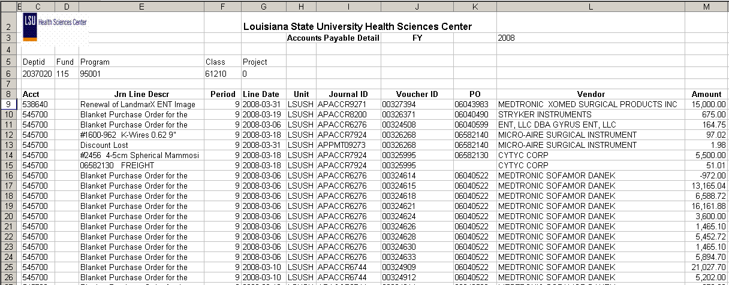.
2-tier Query Fields
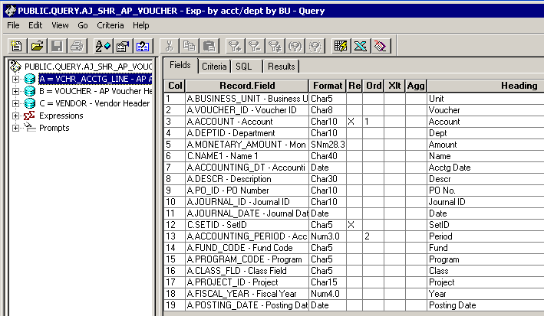

Query Criteria
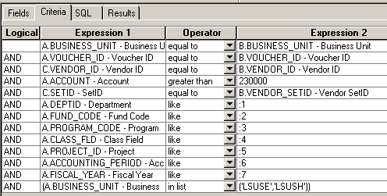

Web Based Query Criteria
