LSUHSC nVision Reports Catalog

Business Unit: LSUSH
Report Description: Administrator of the Hospital
Layout: LSUSH –Administrator of the Hospital Report.xnv
Report Request: ADMINHSP
Dashboard Page/Button: N/A
nVision Scope: N/A
Report As of Date: Default from Business Unit

This report provides a summary of expenditures by Administrator by Department for LSUSH. The columns of the report begin with descriptive information, Fund Code, Department Number, Program, Class, and Account Description. To the right of this descriptive information are columns for the major break downs of expenses. The criteria for these columns utilize the field account from the ACCTROLLUP tree. After each column heading listed, the account nodes included in that column are listed in parentheses. The columns included are: Personnel Services (4PERSONNEL_SERVICES), Related Benefits (4EMPLOYEE_BENEFITS), Travel (4TRAVEL), Operating Services (4OPERATING_SERVICES), Supplies (4SUPPLIES), Professional Services (4PROFESSIONAL_SERV), Equipment (4CAPITAL_OUTLAYS and 4MAJOR_REPAIRS), and Other (4DEBT_SERVICE, 4INDIRECT_COST_RECOV, 4OTHER_CHARGES, and 4RESTR_FUND_PURCH). Each of these columns selects the Actuals ledger for the source of the data and all of the values are year to date. The column to the right of Other is a calculated Total column. Next is the Expended Amount column that pulls in the monetary amount from the query LSUSH_HOSP_ADMIN (JRNL_HEADER and JRNL_LN tables). The query selects the fields Business Unit, Account, Fund, Department, Class, Program, Project id, Budget Period, Monetary Amount, Fiscal Year and Accounting Period. The criteria for this query specifies the LSUSH business unit, the accounts must begin with 5, the ledgers of DETAIL_ENC and DETAIL_PR, and Fiscal Year not greater than 2008. The next column is the Total Committed column that is calculated by adding the Total column to the Expended Amount column. The next column is the Budget column that specifies the ledger ORG_BD, YTDBUDCUR is the timespan, and Posted Total Amount is the value pulled in. The final column is Total Available that is a calculation which subtracts the Total Committed column value from the Budget column value. The rows of the report are grouped by Administrator. Within each Administrator are rows for each of the departments that report to the Administrator. The criteria on each row specify detail values for Department, Fund, Program and Class. The Account specified on the row is listed as the ALL_ACCOUNTS node from the STMT_REV_EXP tree. At the bottom of each group is a total and the last row of the report is a Grand Total row.

Report Example:

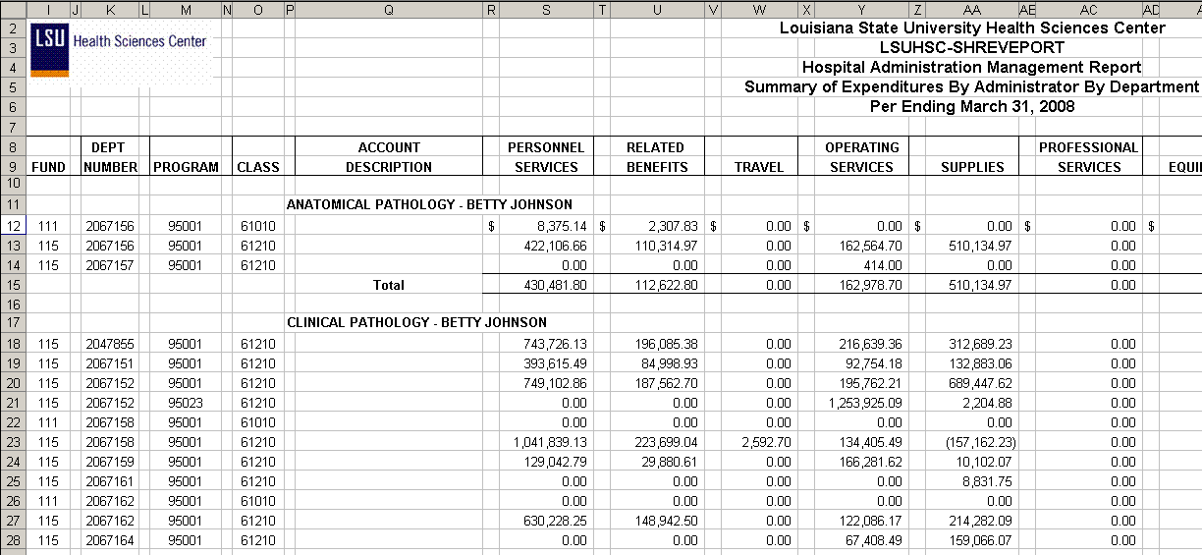

Query Fields
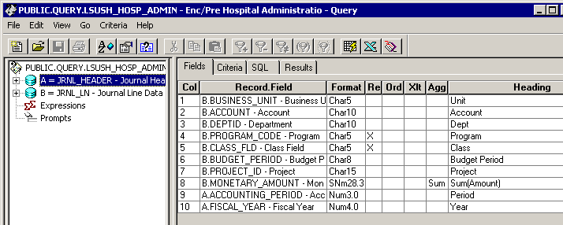

Query Criteria
