LSUHSC nVision Reports Catalog

Business Unit: LSUSH
Report Description: Fiscal Year Activity Minus 2 Years
2-tier Layout: LSUSH – Fiscal Year – Current Year Minus Two.xnv
Web Layout: W LSUSH – Fiscal Year – Current Year Minus Two.xnv
Report Request: FISCAL02
Web Report Request: WFSCAL02
Dashboard Page/Button: LSUSH/ Fiscal Year Report 2006 – with Budget Ledger Table
nVision Scope: N/A
Report As of Date: Specify e.g. 06/30/2006

The report produces a fiscal year activity of revenues and expenses nploded by account for current year minus two. The columns display budget, year to date actuals, encumbered and pre-encumbered amounts. The available balance is calculated by subtracting actuals from the budget. The data for the Budget column displays the Posted Total Amount and is derived from the SHR_AJ_BUDGET query that pulls information from the LEDGER_KK table. This query specifies that the data comes from the ORG_BD, REV_EST_BD or PROJ_GR_BD ledgers in addition to the criteria below that are common to all of the queries used in this layout. The Fiscal Year column in the report is nploded and references the query SHR_AJ_JRNL (JRNL_HEADER and JRNL_LINE tables), which specifies the ACTUALS Ledger group and prompts on the same fields as the Budget column. The Encumbered Column is written based on the query SHR_AJ_BUDGET_EN. This query is written on the LEDGER_KK table and specifies that the ledger is DETAIL_ENC. The Pre-Encumbrance column is written on the AHR_AJ_BUDGET_PR query and specifies the ledger of DETAIL_PRE. All of the queries in this report prompt on Deptid, Fund code, Program code, Class field, and project id. There is also a prompt that the accounting period cannot be greater than the entered value. The queries specifically pull data for the LSUSH and LSUSE business units. This query also specifies that the accounts begin with 4 or 5. The queries also exclude period 999 from any values. The Available Balance column subtracts the Fiscal Year column values from the Budget column values. The rows of the report layout are divided into Revenues and Expenditures. Within each section are rows designated as specific groupings of accounts based on the ACCTROLLUP tree. Each grouping will be nploded when the report is produced.

The web based nVision report utilizes the queries called WSHR_AJ_BUDGET, WSHR_AJ_BUDGET_EN, WSHR_AJ_BUDGET_PR, and WSHR_AJ_JRNL. These queries each include the ZZNVISIONPROMPT table. The prompt criteria lines in each query are replaced with expressions to enable web based prompting.

Report Example:
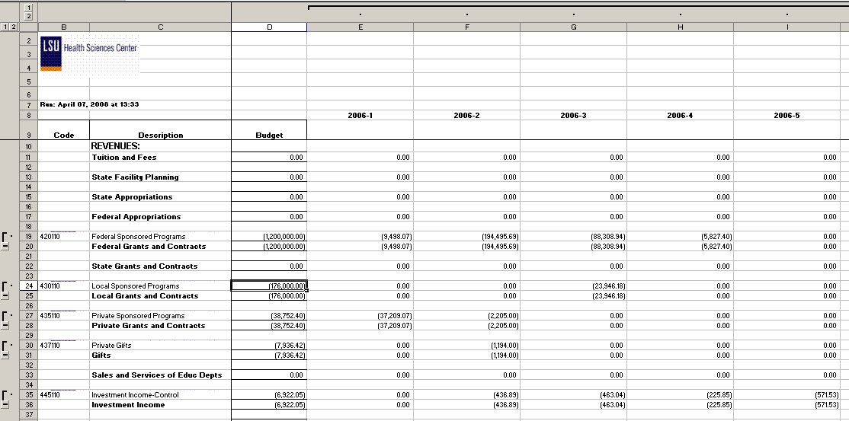
Query Fields – SHR_AJ_JRNL
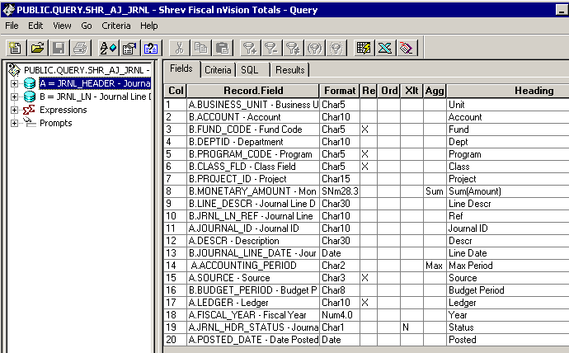

Query Criteria
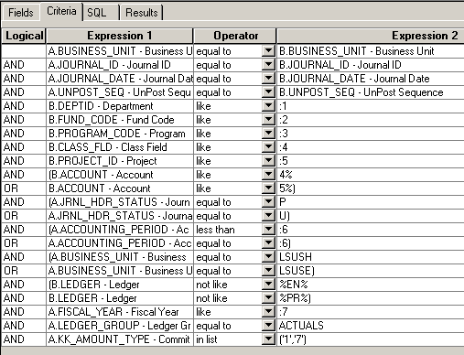

Query Fields – SHR_AJ_BUDGET
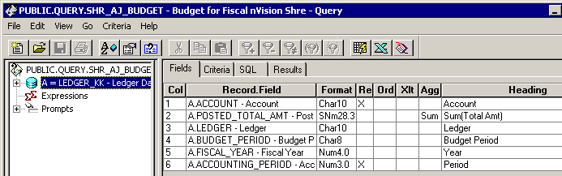
Query Criteria
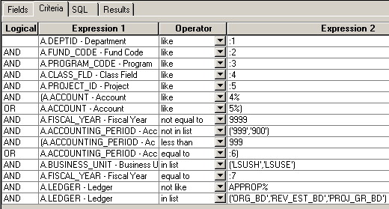

Query Fields –SHR_AJ_BUDGET_EN
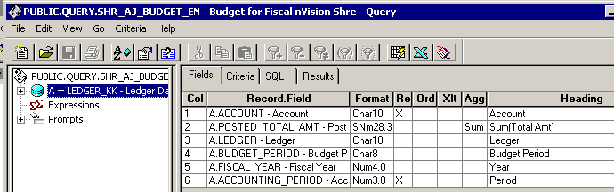
Query Criteria
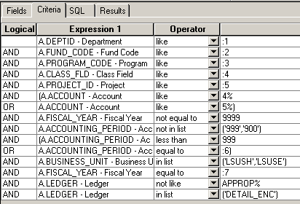

Query Fields – SHR_AJ_BUDGET_PR
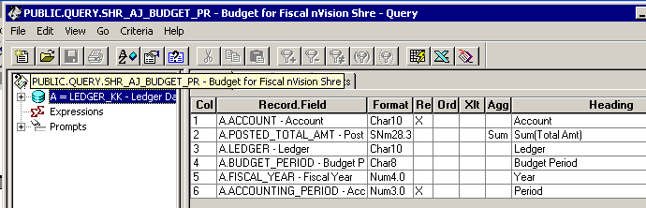

Query Criteria
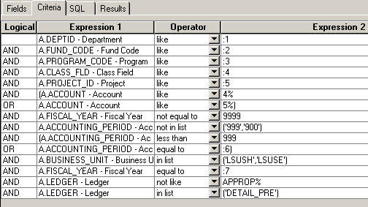

Modified Query Criteria WSHR_AJ_BUDGET
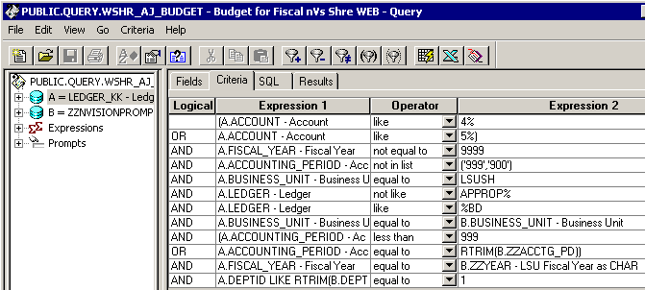

Modified Query Criteria WSHR_AJ_JRNL
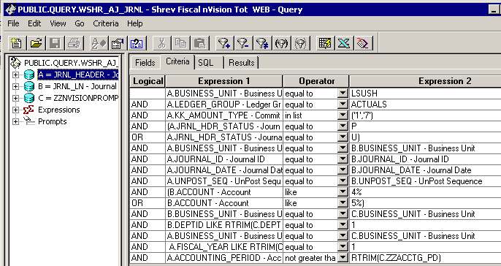

Modified Query Criteria WSHR_AJ_BUDGET_EN
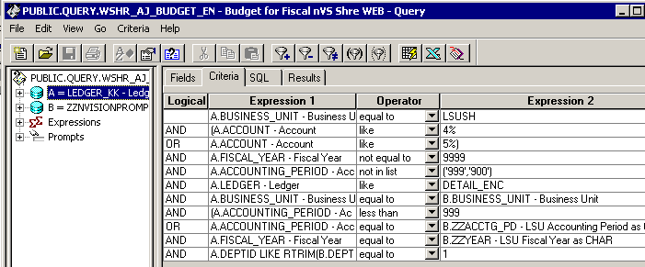

Modified Query Criteria WSHR_AJ_BUDGET_PR
