LSUHSC nVision Reports Catalog

Business Unit: LSUSH
Report Description: Inventory Report by Department
2-tier Layout: LSUSH – Inventory Transactions by Dept.xnv
Web Layout: W LSUSH – Inventory Transactions by Dept.xnv
Report Request: INVDEPT
Web Report Request: WINVDEPT
Dashboard Page/Button: LSUSH/ Inventory Detail Transactions
nVision Scope: N/A
Report As of Date: As of Business Unit Table

The report produces a Summary of Inventory Transactions by Department. The report produces results based on the LSUSH_INV_ACCTG_DETAIL query. The columns display the Item Number, the Description, Warehouse, Transaction Group, Order Number, Transaction Date, Issue Quantity, Issue UOM, Unit Cost, Monetary Amount, Customer Name, Shipping Customer, and Location. The query that the report is based on utilizes the CM_DRILL_INV_VW, MASTER_ITEM_TBL, MSR_HDR_INV, and the DEPT_TBL. The criteria specify business units LSAC, LSCS, or LSWHS. Transaction Groups allowed in the query are group 030 Issues and 052 Shipping Adjustments. The query prompts on fund code, department, program, class field, project id, and accounting date between ranges of dates. The account numbers allowed in the report begin with a 5. The setid for the query is LSUSH. Note: This report/query takes a long time to run because there are generally a fairly large amount of transactions included in the prompted date ranges.

The web based nVision report uses the query called WLSUSH_INV_ACCTG_DETAIL that includes the additional table ZZNVISIONPROMPT to each selection within the query. This additional table allows the prompt criteria to be replaced with expressions for web prompting.

Report Example:
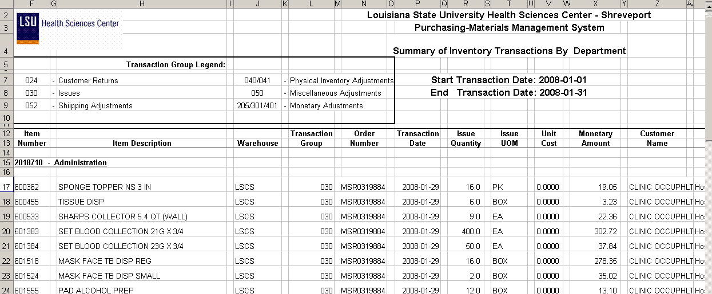
“Original” Query based on CM_ACCTG_LN table Selection 1
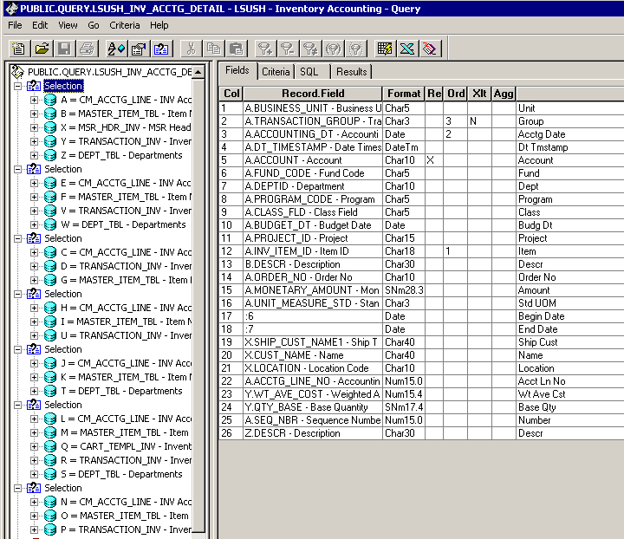

“Original” Query Criteria Selection 1
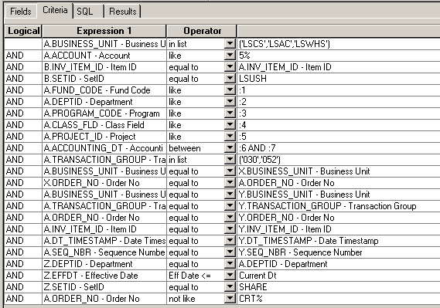

Web Based Query based on CM_DRILL_INV_VW Query Fields from Selection 1
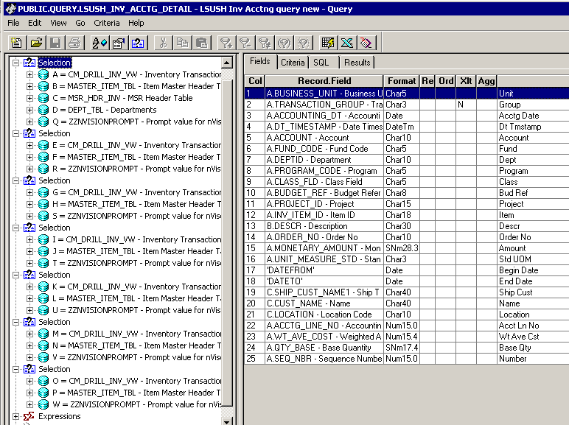

Web Query Criteria from Selection 1
