LSUHSC nVision Reports Catalog

Business Unit: LSUSH
Report Description: Journal Detail
2-tier Layout: AM091 LSUSH.xnv
Web Layout: W AM091 LSUSH.xnv
Report Request: SHR_JRNL
Web Report Request: WSH_JRNL
Dashboard Page/Button: LSUSH/FY JRNL
nVision Scope: N/A
Report As of Date: Default from Business Unit

This is the Journal Line Detail Report and provides all pertinent data for the journal lines. The 2-tier report uses the AJ_SHR_JRNL_DETAIL query that pulls data for the LSUSH business unit. The query is written against the JRNL_HEADER and JRNL_LN tables. The query lists business unit, account, fund code, department id, class, project id, journal id, journal description, journal line description, line date, line reference, source, and amount, fiscal year, accounting period, budget period, ledger, journal header status, and posted date. The query used in the report prompts on deptid, fund code, program code, class field, project id, and fiscal year and accounting period. For the web based nVision report, the query used is WAJ_SHR_JRNL_DETAIL. The ZZNVISIONPROMPT is joined to the other tables in the query. The criteria has been modified to enable prompting on the web through the use of an expression.

Report Example:
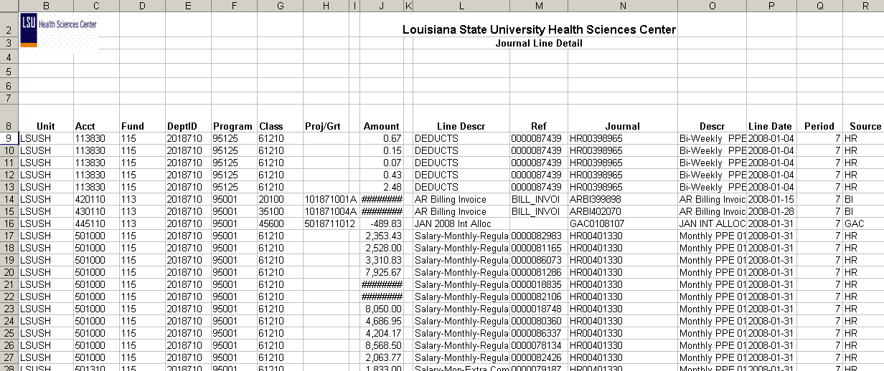

2-tier Query Fields
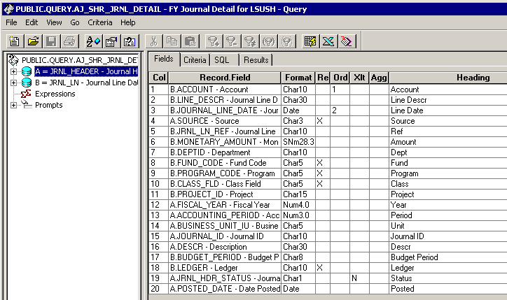

Query Criteria
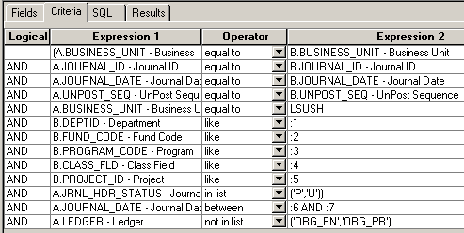

Web Query Criteria:
