LSUHSC nVision Reports Catalog

Business Unit: LSUSH
Report Description: LSUSH – All Fiscal Years
2-tier Layout: LSUSH –All Fiscal Years.xnv
Web Layout: W LSUSH –All Fiscal Years.xnv
Report Request: ALLFISC
Web Report Request: WALLFISC
Dashboard Page/Button: LSUSH/Fiscal Year Report – All Years with Actuals Ledger
nVision Scope: N/A
Report As of Date: Default from Business Unit

This report provides a detail of revenues and expenditures by account category for multiple fiscal years. The columns of the report begin with the descriptive information for Account and Account Category. The next 3 columns to the right are grouped for Budget data. The first is Prior Years Budget that uses the query LSUSH_ALL_ACCOUNTS, the Budget amount, and the BALFORCY timespan. The next column is Current Year Budget, (LSUSH_ALL_ACCOUNTS query, Budget Amount, YTD timespan). The third column is Budget ITD. This column is calculated by adding the two prior columns. Next there are the three columns for Actuals. The Prior Years Actuals uses the LSUSH_ALL_ACCOUNTS query, BALFORCY timespan, and Monetary Amount. The Current Year Actuals column uses the same query and amount but selects the YTD timespan. This column is nploded by period. The third column, Actuals ITD is calculated by adding the value from both of the Actuals columns. The Open Orders column utilizes the ITD-CY timespan. The values in this column are derived from the LSUSH_ALL_ACCOUNTS query. The Balance Available column is calculated by subtracting the Actual total and the Open Order amount from the Budget. The final column is a calculated value for the Percent Used. The query that is used in the columns, LSUSH_ALL_ACCOUNTS is written on the ZZGL_TRANS_DETAIL table. The query selects the fields Business Unit, Account, Fund, Department, Class, Program, Project id, Budget Period, Monetary Amount, Pre-encumbered amount, Encumbered amount, Budget amount, “Open Orders” (Expression to combine Encumbered and Pre-encumbered amounts), Ledger and Accounting Period. The criteria for this query specify the LSUSH business unit. The query prompts on Deptid, Fund , Program, Class, Project, and Journal Date between 2 dates. The criterion specifies that the accounting period cannot be 999. The rows of the report are grouped by Revenues and Expenditures. Within each of these groups there are rows specified by Account Group. The criteria on each row specify nploding the account field to the details of that group from the ACCTROLLUP tree. An example is the Tuition and Fees row that is included in the Revenues section of the report. This row specifies the node 4TUITION_AND_FEES. At the bottom of each group is a total and the last row of the report is a Total Surplus or Deficit row. The web based report utilizes the query called WLSUSH_ALL_ACCOUNTS that includes the ZZNVISIONPROMPT table. The prompt criteria are replaced with expressions to enable web based prompting.

Report Example:
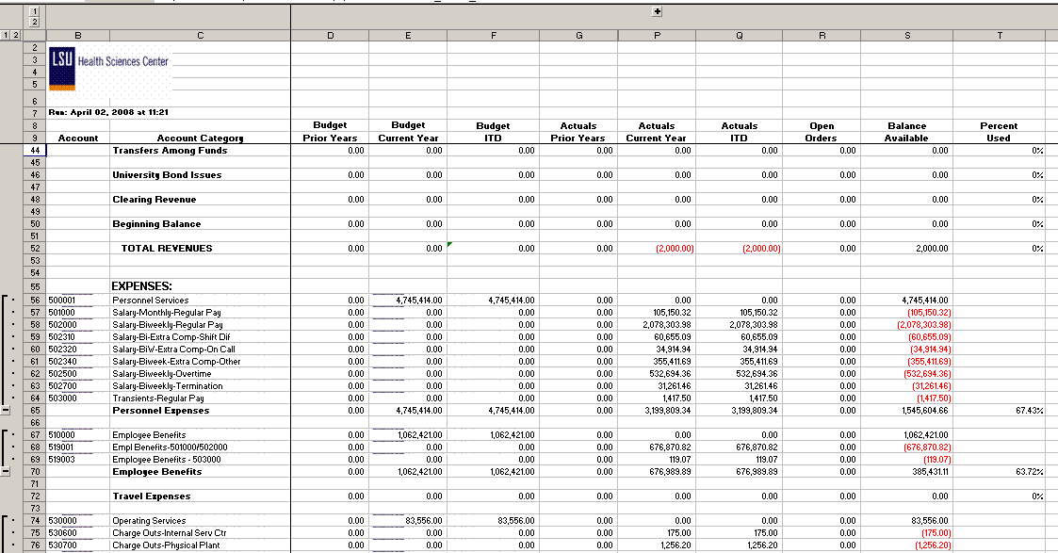

Query Fields
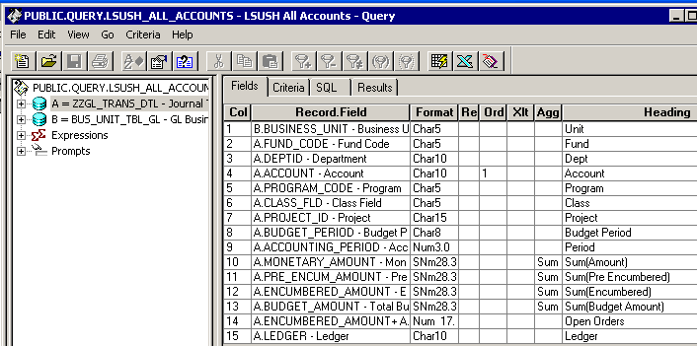

Query Criteria
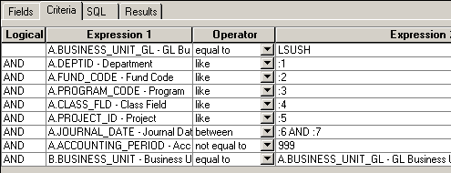

Modified Query Criteria WLSUSH_ALL_ACCOUNTS
