LSUHSC nVision Reports Catalog

Business Unit: LSUSH
Report Description: LSUSH – Operations Budget
2-tier Layout: LSUSH – SHR OP with BUDGET.xnv
Web Layout: W LSUSH – SHR OP with BUDGET.xnv
Report Request: OPSBUD
Web Report Request: WOPSBUD
Dashboard Page/Button: LSUSH_MANAGEMENT/
Analysis of Operating Budget by Program
nVision Scope: N/A
Report As of Date: Default from Business Unit

The report produces a fiscal year activity of expenses for LSUSH. The columns display budget, Fiscal Year Activity, Encumbered and Pre-encumbered amounts. The available balance is calculated by subtracting the values in the Fiscal Year, Encumbered and Pre-encumbered amounts from the budget. The data for the Budget column displays the Posted Total Amount and is derived from the SHR_BUD_OP query that pulls information from the LEDGER_KK table. This query specifies that the data comes from the ORG_BD, REV_EST_BD or PROJ_GR_BD ledgers in addition to the criteria below that are common to all of the queries used in this layout. The Fiscal Year column in the report is nploded (YTD timespan) and references the query SHR_JRNL_OP (JRNL_HEADER and JRNL_LINE tables), which specifies the ACTUALS Ledger group, KK_AMOUNT_TYPE and prompts on the same fields as the Budget column. The Encumbered Column is written based on the query SHR_ BUD_OP_EN. This query is written on the LEDGER_KK table and specifies that the ledger is DETAIL_ENC. The Pre-Encumbrance column is written on the SHR_BUD_OP_PR query and specifies the ledger of DETAIL_PRE. All of the queries in this report prompt on Program code, Fiscal Year and Accounting Date (between). The queries specifically pull data for the LSUSH business unit. This query also specifies that the accounts are between 400000 and 599999. Funds specified by the criteria include 111, 114, and 115. The queries also exclude period 999 and fiscal year 9999 from any values. The last columns in the report are the Balance Available and Percent Used. The rows of the report layout are divided into Expense rows. Within each section are rows designated as specific groupings of accounts based on the ACCTROLLUP tree. Each row also requires funds 111, 114, and 115. Each account grouping will be nploded when the report is produced.

The web based report utilizes the queries called WSHR_BUD_OP, WSHR_JRNL_OP, WSHR_BUD_OP_EN, and WSHR_BUD_OP_PR. These queries each join in the table called ZZNVISIONPROMPT. The prompt criteria in each query are replaced by expressions to enable web based prompting.

Report Example:
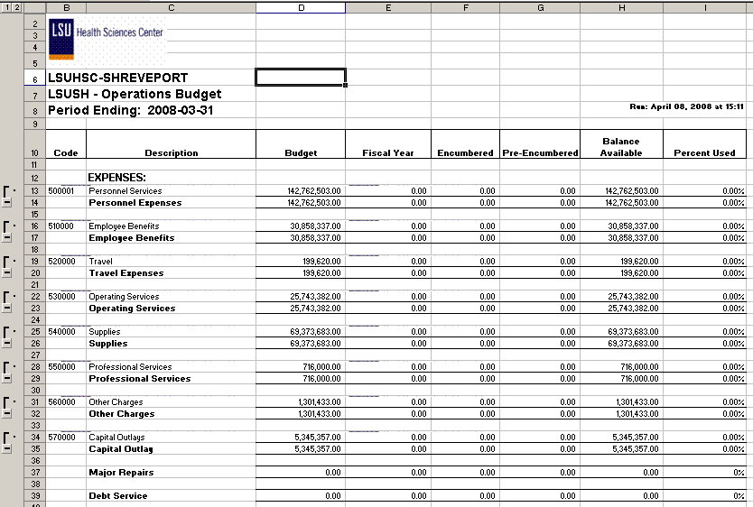

Query Fields – SHR_BUD_OP
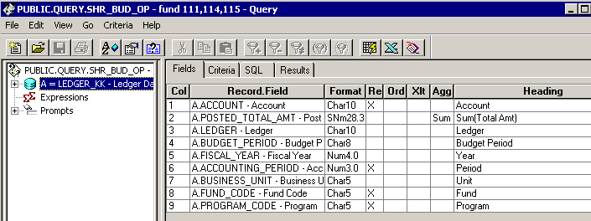

Query Criteria
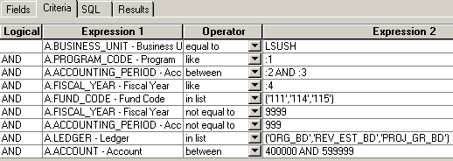

Query Fields – SHR_JRNL_OP
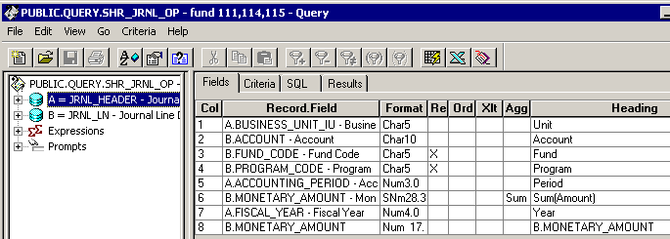

Query Criteria
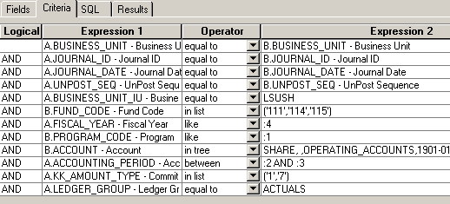

Query Fields – SHR_BUD_OP_EN
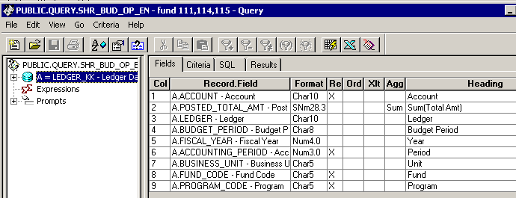

Query Criteria
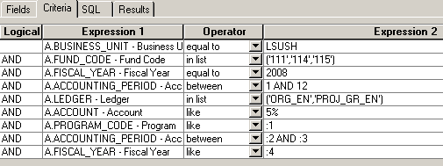

Query Fields – SHR_BUDGET_OP_PR
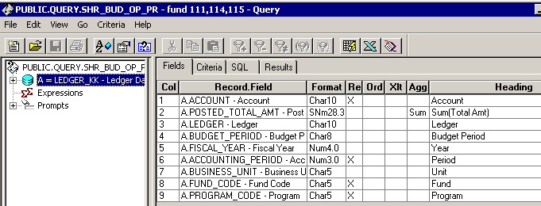

Query Criteria
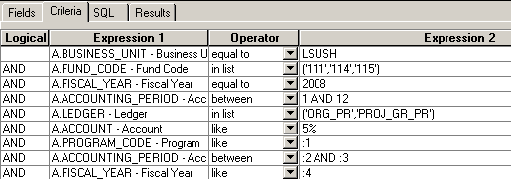

Web Query Criteria WSHR_BUD_OP
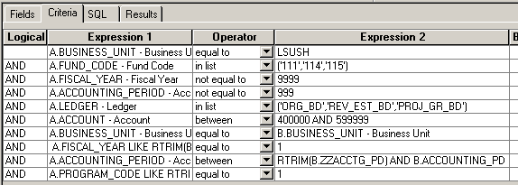

Web Query Criteria WSHR_BUD_OP_EN
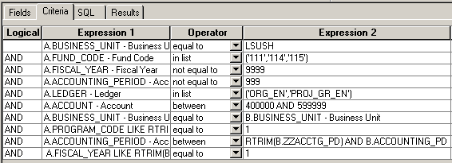

Web Query Criteria WSHR_BUD_OP_PR
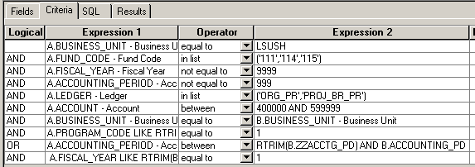

Web Query Criteria WSHR_JRNL_OP
