LSUHSC nVision Reports Catalog

Business Unit: LSUSH
Report Description: LSUSH – WIP Clearing
Layout: LSUSH –WIP Clearing.xnv
Report Request: WIPCLR
Dashboard Page/Button: N/A
Report As of Date: Specify, e.g. 06/30/2006

The report produces an analysis to use in preparing the journal entry to allocate physical plant work in progress to the hospital and medical school maintenance costs. The layout uses the query LSUSH_WIP_CLEARING in the first column to pull data from the JRNL_HDR and JRNL_LINE tables. The query specifies business unit LSUSH, fiscal year 2006, fund code 115, account greater than 400000, ledgers not encumbrance or pre-encumbrance, for departments 1692000, 1697000, and 2059155. The first row specifies that the account comes from the ACCOUNT_RANGES tree, fund 115 and department 1692000. The second row specifies department 2059155 instead. The second column of the report is calculated as a percentage of the total in the first column. The bottom of the report, starting in row 19 includes row criteria to nplode the accounts, EXPENSES form the ACCOUNT_RANGES tree, fund code 115 and department 1697000. Cells G19 and I19 calculate the amount to allocate per account. Due to the nplosion in the report, this is the section is the basis for the allocation journal entry.

Report Example:
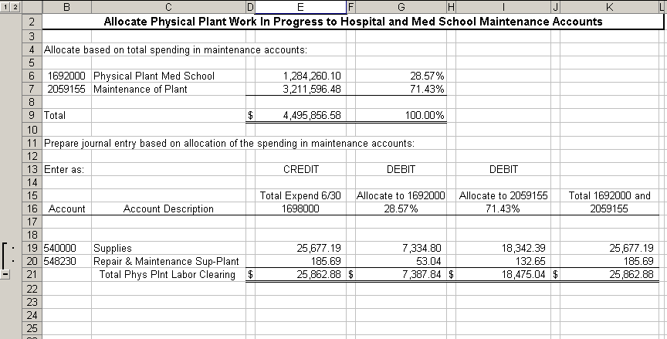
Query Fields
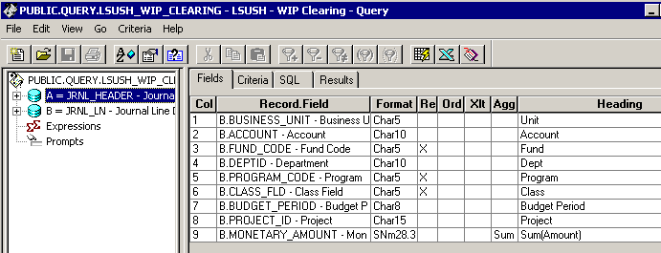

Query Criteria
