LSUHSC nVision Reports Catalog

Business Unit: LSUSH
Report Description: Operating Funds by Function
2-tier Layout: LSUSH – SHR OP.xnv
Web Layout: W LSUSH – SHR OP.xnv
Report Request: SHR_OP
Web Report Request: WSHR_OP
Dashboard Page/Button: LSUSH_MANAGEMENT/ OPS by Function
nVision Scope: N/A
Report As of Date: Default from Business Unit

The report produces a fiscal year activity of revenues and expenses for LSUSH. The columns display budget, Fiscal Year Activity Posted and Unposted, a calculated column Unposted Accounts Payable Transactions, Total Activity Posted and Unposted (calculated), Encumbered and Pre-encumbered amounts. The available balance is calculated by subtracting the value in the Total Activity Posted and Unposted column from the budget. The data for the Budget column displays the Posted Total Amount and is derived from the SHR_BUD_OP query that pulls information from the LEDGER_KK table. This query specifies that the data comes from the ORG_BD, REV_EST_BD or PROJ_GR_BD ledgers in addition to the criteria below that are common to all of the queries used in this layout. The Fiscal Year Activity Posted and Unposted column in the report is nploded (YTD timespan) and references the query SHR_JRNL_OP (JRNL_HEADER and JRNL_LINE tables), which specifies the ACTUALS Ledger group, KK_AMOUNT_TYPE and prompts on the same fields as the Budget column. The Unposted Accounts Payable Transactions column is a calculated value from two hidden columns immediately to its left. The first hidden column is derived from the query called LSUSH_AP_NOT_JRNL_GEN. This query is based on the VCHR_ACCTG_LINE table and selects the criteria of LSUSH, funds 111, 114, and 115, GL_DISTRIB_STATUS is not D or I, and accounting date not greater than 06/30/2008. The second hidden column is written on the query LSUSH_UNPAID_AP. This query utilizes the VENDOR, VOUCHER and DISTRIB_LINE table. The Total Activity Posted and Unposted is calculated by adding the values in the Fiscal Year Activity column to the value in the Unposted Accounts Payable Transactions column. The Encumbered Column is written based on the query SHR_ BUD_OP_EN. This query is written on the LEDGER_KK table and specifies that the ledger is DETAIL_ENC. The Pre-Encumbrance column is written on the SHR_BUD__OP_PR query and specifies the ledger of DETAIL_PRE. All of the queries in this report prompt on Program code, Fiscal Year and Accounting Date (between). The queries specifically pull data for the LSUSH business unit. This query also specifies that the accounts are between 400000 and 599999. Funds specified by the criteria include 111, 114, and 115. The queries also exclude period 999 and fiscal year 9999 from any values. The last columns in the report are the Balance Available and Percent Used. The rows of the report layout are divided into Revenues and Expenditures. Within each section are rows designated as specific groupings of accounts based on the ACCTROLLUP tree. Each grouping will be nploded when the report is produced.

The web based report utilizes the queries called WSHR_BUD_OP, WSHR_JRNL_OP, WSHR_BUD_OP_EN, WSHR_BUD_OP_PR, WLSUSH_AP_NOT_JRNL_GEN, and WLSUSH_UNPAID_AP. These queries each join in the table called ZZNVISIONPROMPT. The prompt criteria in each query are replaced by expressions to enable web based prompting.

Report Example:
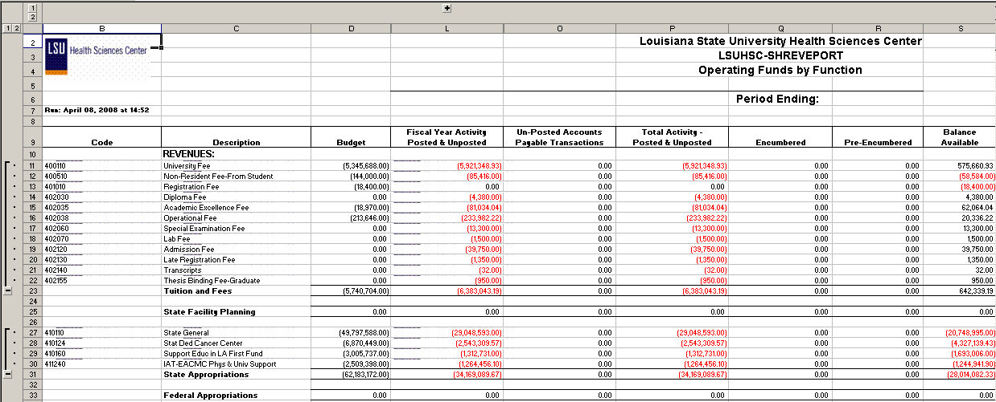

Query Fields – SHR_BUD_OP
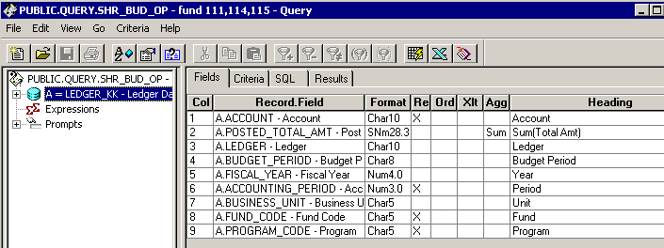

Query Criteria
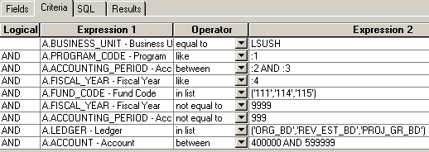

Query Fields – SHR_JRNL_OP
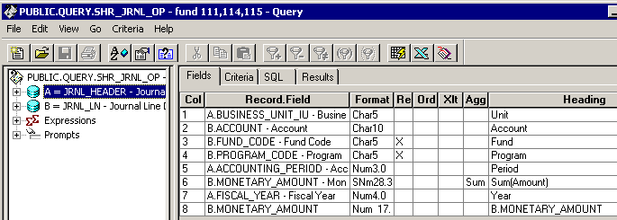

Query Criteria
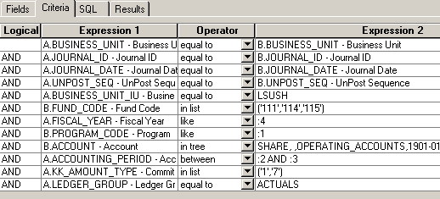

Query Fields – SHR_BUD_OP_EN
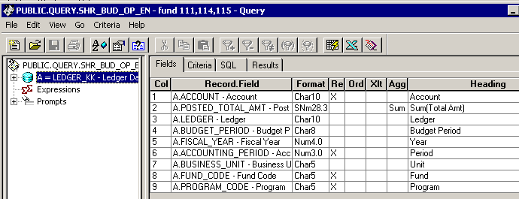

Query Criteria
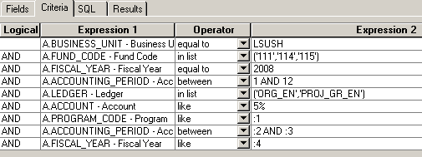

Query Fields – SHR_BUDGET_OP_PR
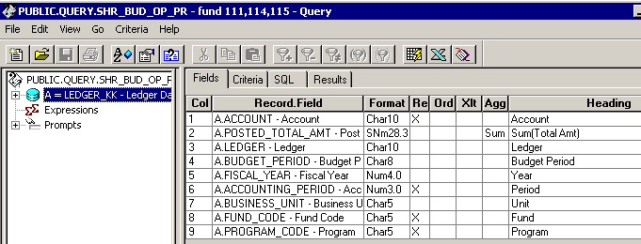

Query Criteria
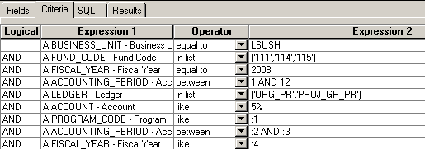
Query Fields – LSUSH_AP_NOT_JRNL_GEN
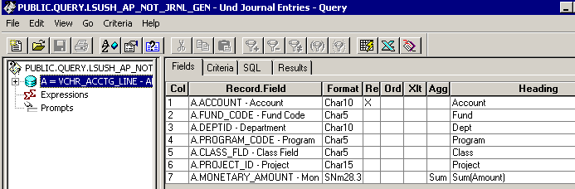

Query Criteria
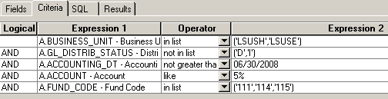

Query Fields – LSUSH_UNPAID_AP
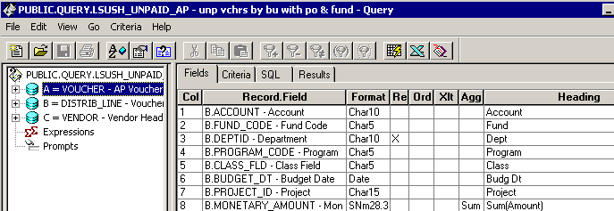

Query Criteria
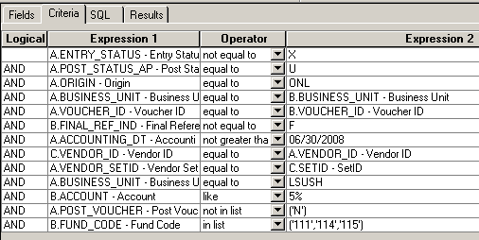

Web Query Criteria WSHR_BUD_OP
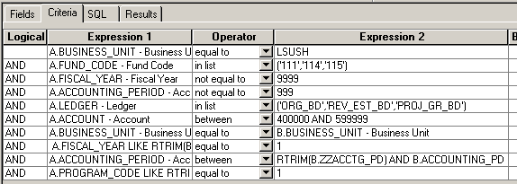

Web Query Criteria WSHR_BUD_OP_EN
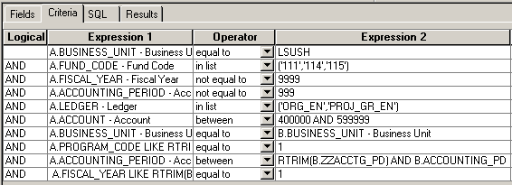

Web Query Criteria WSHR_BUD_OP_PR
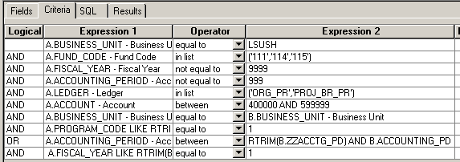

Web Query Criteria WLSUSH_AP_NOT_JRNL_GEN
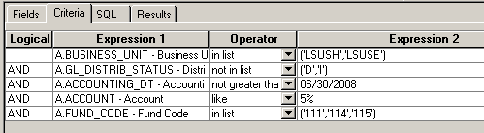

Web Query Criteria WLSUSH_UNPAID_AP
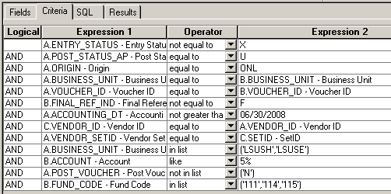

Web Query Criteria WSHR_JRNL_OP
