LSUHSC nVision Reports Catalog

Business Unit: LSUSH
Report Description: Project to Date Activity Shreveport
2-tier Layout: LSUSH – Project to Date.xnv
Web Layout: W LSUSH – Project to Date.xnv
Report Request: SHR_PROJ
Web Report Request: WSHRPROJ
Dashboard Page/Button: LSUSH/
Project/Grant Summary for a Fiscal Year with Period 0 as Prior Fiscal Year(s) Activity
nVision Scope: N/A
Report As of Date: Main As of Date from Business Unit

The report produces a Project to Date Activity listing of Revenues and Expenditures for Shreveport. This report is based on the query called SHR_AJ_ITD that is written against the Ledger table. The report column uses nplosion to display each period using the ITD timespan. Period 0 displays the prior year(s) activity. The query assigned to the column includes the fields Project Id, Account, Fund, Department Id, Program, Class, Fiscal Year, Accounting Period and Amount. The query used as the basis of the report prompts on Project Id and requires that the business unit is LSUSH or LSUSE, the fiscal year is 2008, and accounting period is not equal to 999. The rows of the report are grouped by Revenues and Expenditures. Within each group are detailed account rows. The rows nplode and are assigned the criteria of a particular Account node from the ACCTROLLUP tree. The bottom of the report includes a calculated Surplus (Deficit) row. The web based report utilizes the query called WSHR_AJ_ITD. This query adds in the table called ZZNVISIONPROMPT and replaces the prompt criteria with expressions to enable web based prompting.

Report Example:
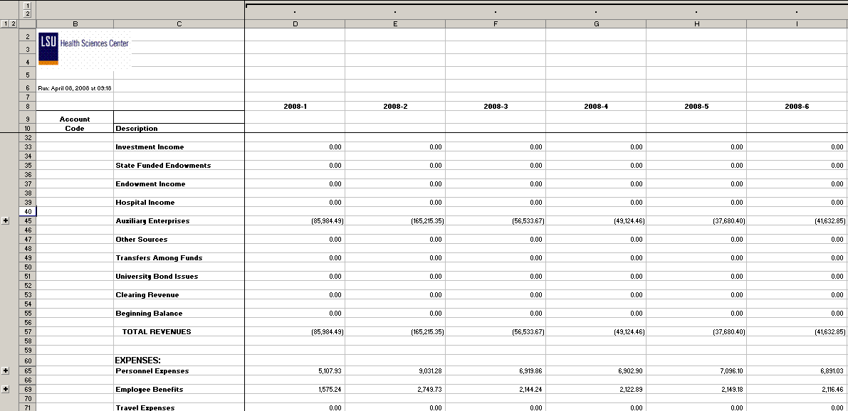
Query Fields
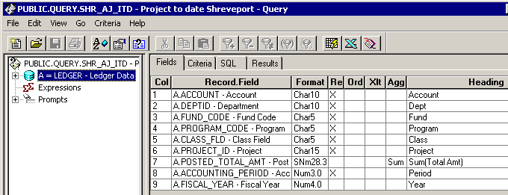

Query Criteria
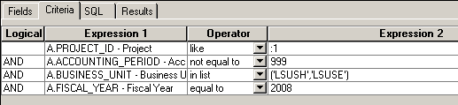

Web Query Criteria

