LSUHSC nVision Reports Catalog

Business Unit: LSUSH
Report Description: Reporting on All Funds
2-tier Layout: LSUSH_Financial_Activity_All_Funds.xnv
Web Layout: W LSUSH_Financial_Activity_All_Funds.xnv
Report Request: ALLFUNDS
Web Report Request: WALFUNDS
Dashboard Page/Button: N/A
Report As of Date: Default from Business Unit or Specify, e.g. 06/30/2007

The report produces a detailed report of Budget and Actual Revenues and Expenses for all funds for LSUSH. The columns of the report are Budget and Actual. The columns specify the YTD timespan and are based on the query LSUSH_FUNDS_ALL2. The query is written on the ZZGL_TRANS_SUM1 table. The Budget column field selected is the Budget Amount. The Actual column selects the Summed Period Total Amount and nplodes to the year to date periods. The rows of the report are divided into Revenues, Expenses and a calculated Surplus or Deficit. Within each section are defined accounts. These rows are defined based upon the ACCTROLLUP tree. Each row nplodes at run-time to the accounts that are included in that account group. Examples of some of the account rows included in the report are: Tuition and Fees, State Grants and Contracts, Supplies and Major Repairs. The query used in the layout includes criteria that prompt on several chartfields. These include: Department, Fund, Program, Class, Project and As of Period and Fiscal Year. The web based report utilizes the query called WLSUSH_FUNDS_ALL2. The ZZNVISIONPROMPT table is joined in to the query and the prompt criteria is replaced with an expression to enable web based prompting.

Report Example:
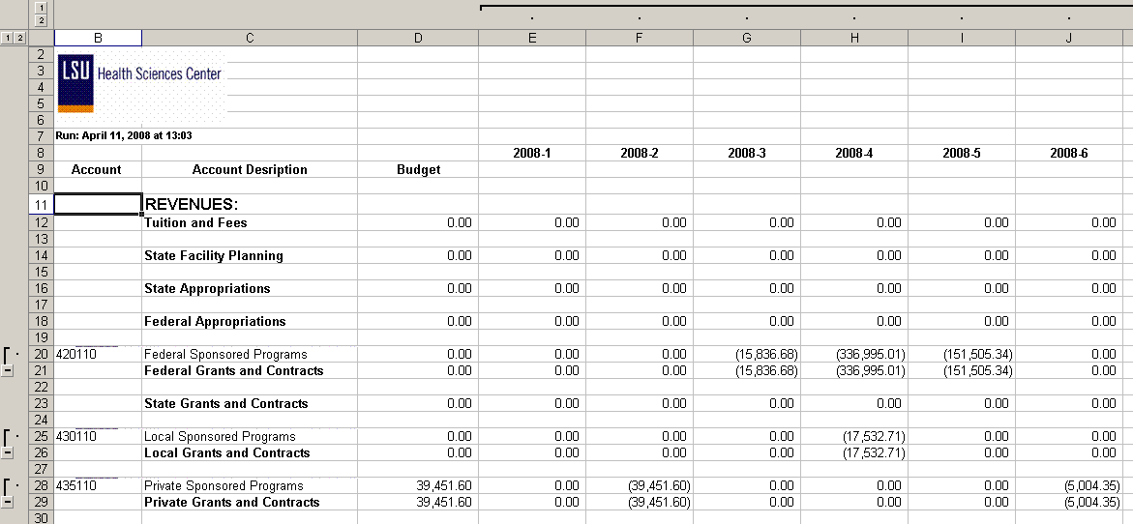
Query Fields
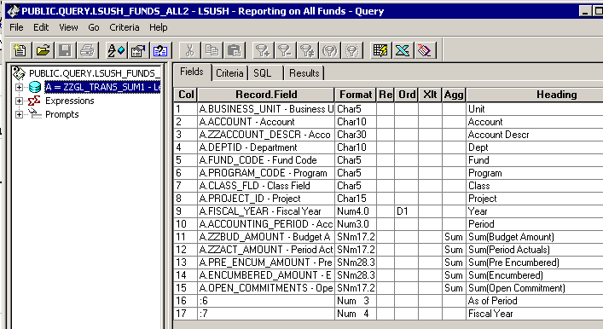

Query Criteria
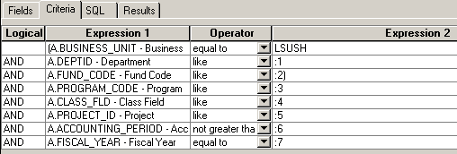

Web Query Criteria
