LSUHSC nVision Reports Catalog

Business Unit: LSUSH
Report Description: Revenue and Expenditures
Layout: Sch of Revenue and Expense CM & YTD.xnv
Report Request: REVEXP
Dashboard Page/Button: N/A
nVision Scope: N/A
Report As of Date: Default from Business Unit

The report produces a fiscal year schedule of revenue and expense activity nploded by account. The columns display current month actual, year to date actual, encumbered and pre-encumbered amounts. The data for each column is derived from several queries built using the LEDGER_KK table and pull in the Posted Total Amount field. The fields are: Business Unit, Posted Total Amount (summed), Ledger, Fund Code, Account, Department, Program Code, Class Field, Budget Period, Project Id, Affiliate, Currency Code, Statistics Code, Fiscal Year, Accounting Period, Posted Base Amount, Date Time Stamp, Base Currency and Process Instance. The only field used in the nVision report from the query is Posted Total. The criteria specified for each of the queries is used to differentiate the queries by specifying the Ledger names that the data is allowed/disallowed to be pulled from. The queries and the pertinent details of each are: AM090_ACTUALS_ALL, data from Actuals Ledger, AM090_ACTUALS_ALL_EN, data from encumbrance ledgers that include _EN as part of the name, and AM090_ACTUALS_ALL_PR , data from pre-encumbrance ledgers that include _PR as part of the name. All of the columns in the report specify the PER (current period) timespan except the year to date column that uses YTD as the time span. The rows of the report are grouped into the major breakdowns of Revenues and Expenses. Within each of these categories, there are several account groupings defined. These groupings are nodes from the ACCTROLLUP tree. Each of these account groupings nplodes when the report is produced to display the detailed information. At the bottom of the report is a calculated Surplus/Deficit Row. Note: LSUNO also uses this report.
Report Example:
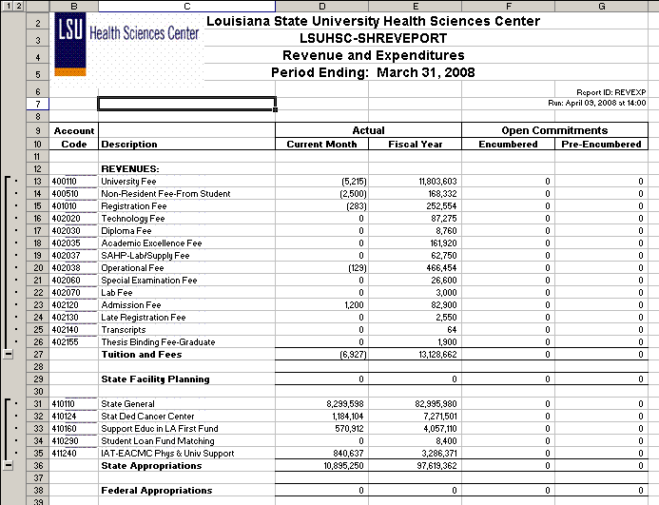

Query Fields – AM090_ACTUALS_ALL

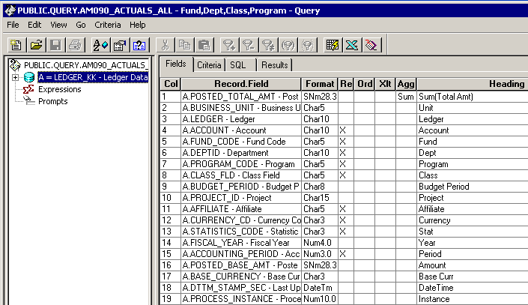

Query Criteria
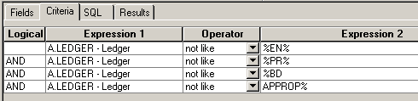

Query Fields – AM090_ACTUALS_ALL_EN
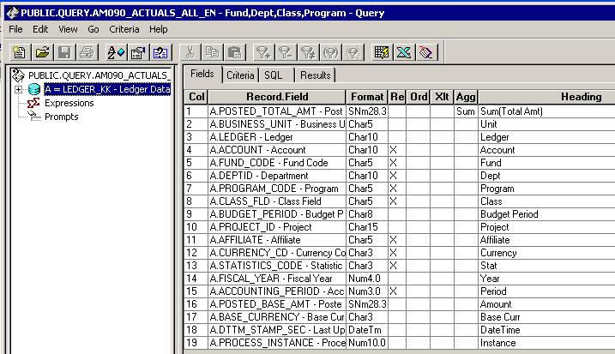

Query Criteria
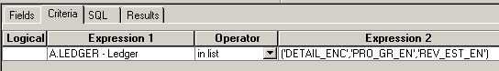

Query Fields – AM090_ACTUALS_ALL_PR
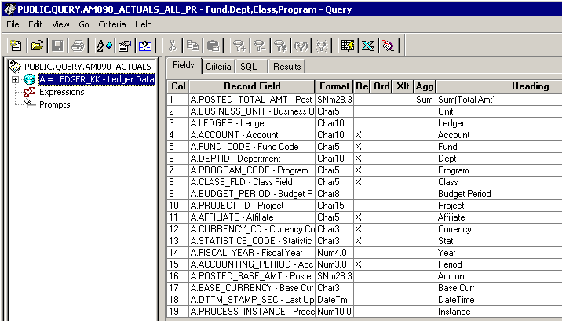

Query Criteria
